Characterization of a Geiger-mode Avalanche Photodiode

Christopher W. Maloney
Department of Electrical and Microelectronic Engineering, 79 Lomb Memorial Dr., Rochester, NY 14623. Email: cwm3854@rit.edu

Geiger-mode avalanche photodiodes (APDs) are ideal candidates for light detection and ranging (LIDAR) imaging systems as a result of their sensitivity. MIT’s Lincoln Laboratories has recently fabricated a 32 by 32 array of bump bonded Geiger-mode APDs for exactly this purpose. This detector has been characterized at the Rochester Imaging Detector Laboratory (RIDL) at RIT. In order to operate this device to be most efficient and effective as a LIDAR imaging detector, key parameters were extracted from specific experiments.
First, the current voltage characteristics of diodes on a wafer similar to those in the packaged detector were measured. The reverse diode curve (Fig. 1) shows a breakdown voltage of ~28 V and a dark current density of ~1 nA/cm². The significance of knowing the breakdown voltage of the device is that the APD needs to be biased at or just above breakdown in order to be in Geiger-mode. The forward diode characteristic may be seen in Fig. 2. An ideality factor of 1.0 was calculated for the ideal region of the curve. Also, there is no recombination/generation region in the forward characteristic, meaning there are a minimal amount of traps in these diodes. In addition, a series resistance of ~2 kΩ has been calculated. This is consistent with the design requirement that the diodes should have high series resistance in order to reduce crosstalk between pixels.
Next, IDL code was written to perform certain tests within the LIDAR system. The first test that was performed was to determine if there was a relationship between the dark count rate and the gate width. The gate width is the amount of the time that the detector is able to detect photons and avalanche. The dark count rate is calculated using Poisson’s statistics, and is expected to stay constant when varying the gate width. The measured data showing a relatively constant dark count rate can be seen in Fig. 3.
After that, information extracted from the previous tests made it possible to further test the device. Knowing an approximate breakdown voltage made it possible to safely test the array of Geiger-mode APDs. The dark count rate was measured as the bias was increased, resulting in a plot analogous to the reverse diode characteristic. In this case, Fig. 4 shows how the average breakdown voltage of the array is ~32 V. In order to operate the detector in Geiger-mode while limiting the dark count rate, it must be biased at or just above 32 V.
In addition, an afterpulsing model was applied and modified to account for this specific LIDAR system [1]. Eq. 1 shows the model that is used to calculate dark count rate (λ) as a function of dead time (t_{dead}). Dead time is the amount of time between gate widths. If this value is too short, one could see an increase in dark count rate due to the release of trapped charge. R_{dark} is the measured dark count rate when the detector is not experiencing afterpulsing. The probability that the releasing of a trapped charge will cause a complete avalanche is represented as P_{a}. N_{ft} represents the number of filled traps and τ_{trap} is the trap lifetime. Deep level traps, such as sodium are not major contributors to afterpulsing, instead traps with lower activation energies contribute to afterpulsing as seen in Fig. 5 (model generated from Equation 1). The experimental data shows no afterpulsing (Fig. 6), this can be for one of two reasons; either there are no traps in the detector or the trap lifetime is too long or short that its effect on the device is insignificant.
After looking at all of the parameters that were extracted from various tests, a few conclusions can be made. First, the diode current voltage characteristic is close to ideal, meaning the diode was designed well for this application. Also no recombination/generation current was seen, resulting in no measurable afterpulsing. The ideal bias voltage for Geiger-mode operation was also measured to be 32 V. RIDL now has the means to test afterpulsing in devices that MIT will be sending them in the future.

References
- K.E. Jensen, “Afterpulsing in Geiger-mode avalanche photodiodes for 1.06 μm wavelength” Lincoln Laboratory, MIT 2006.

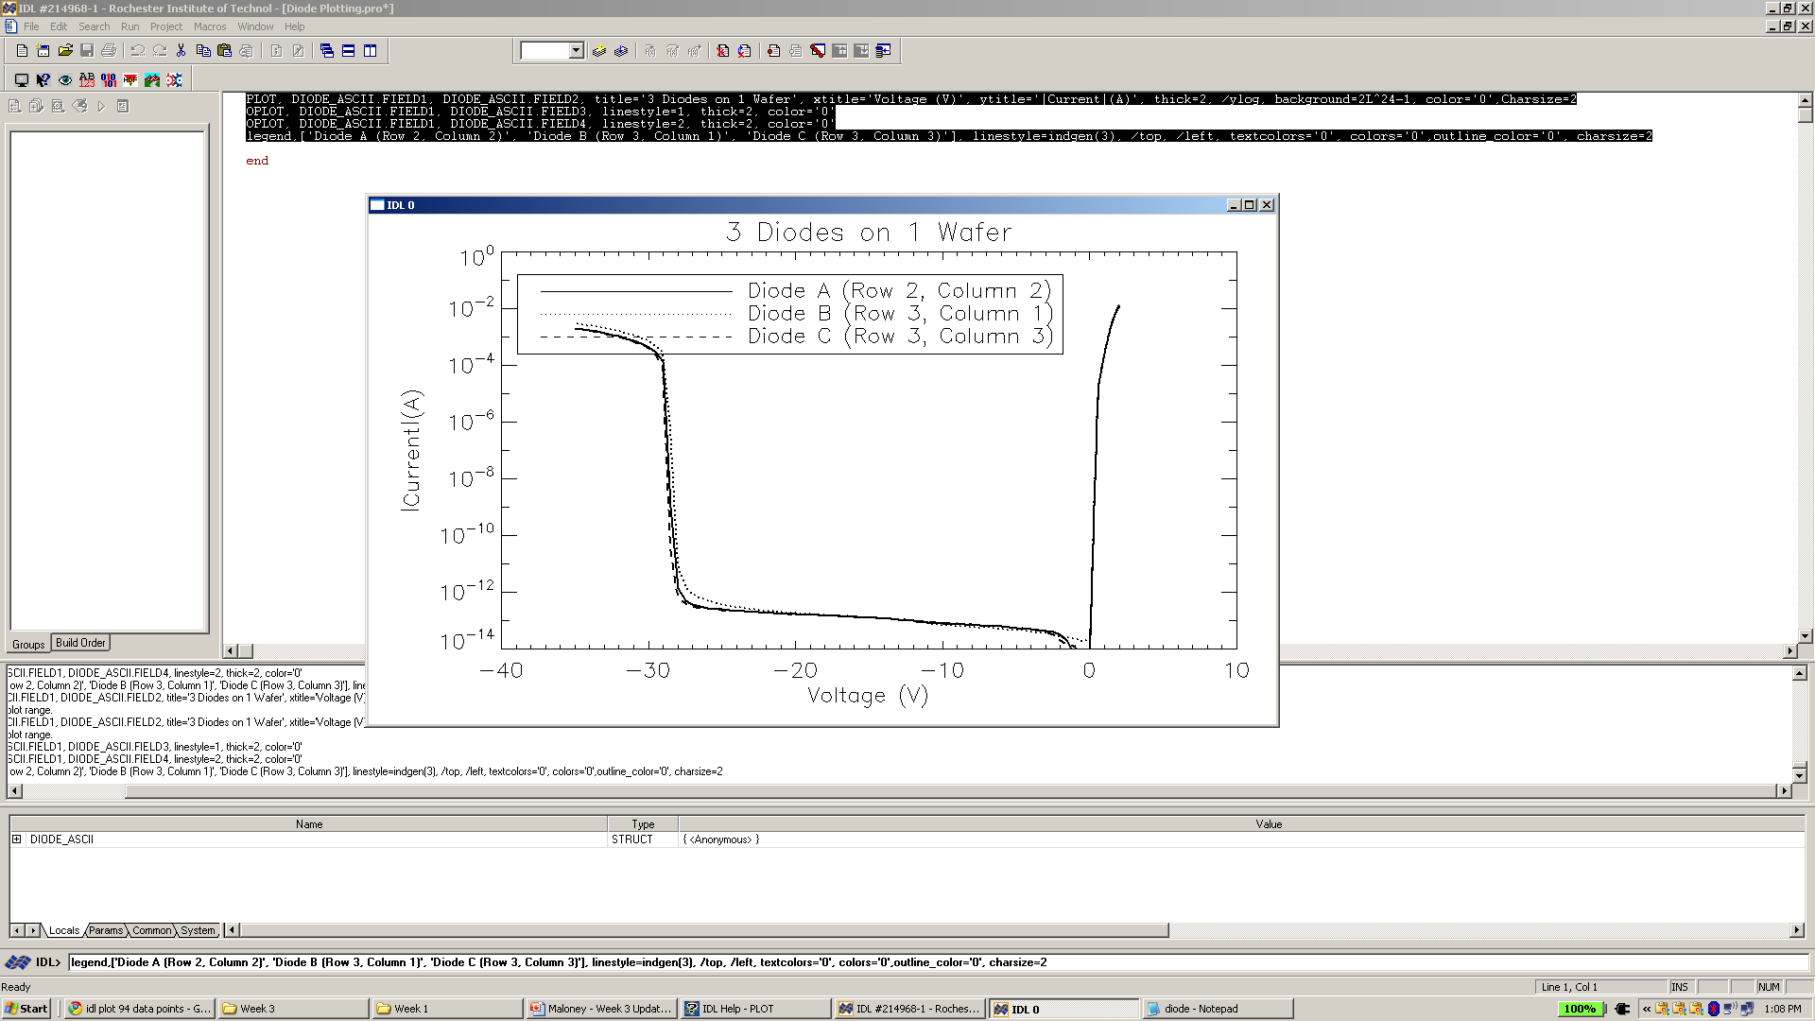
Fig. 1 Measured reverse diode characteristic.

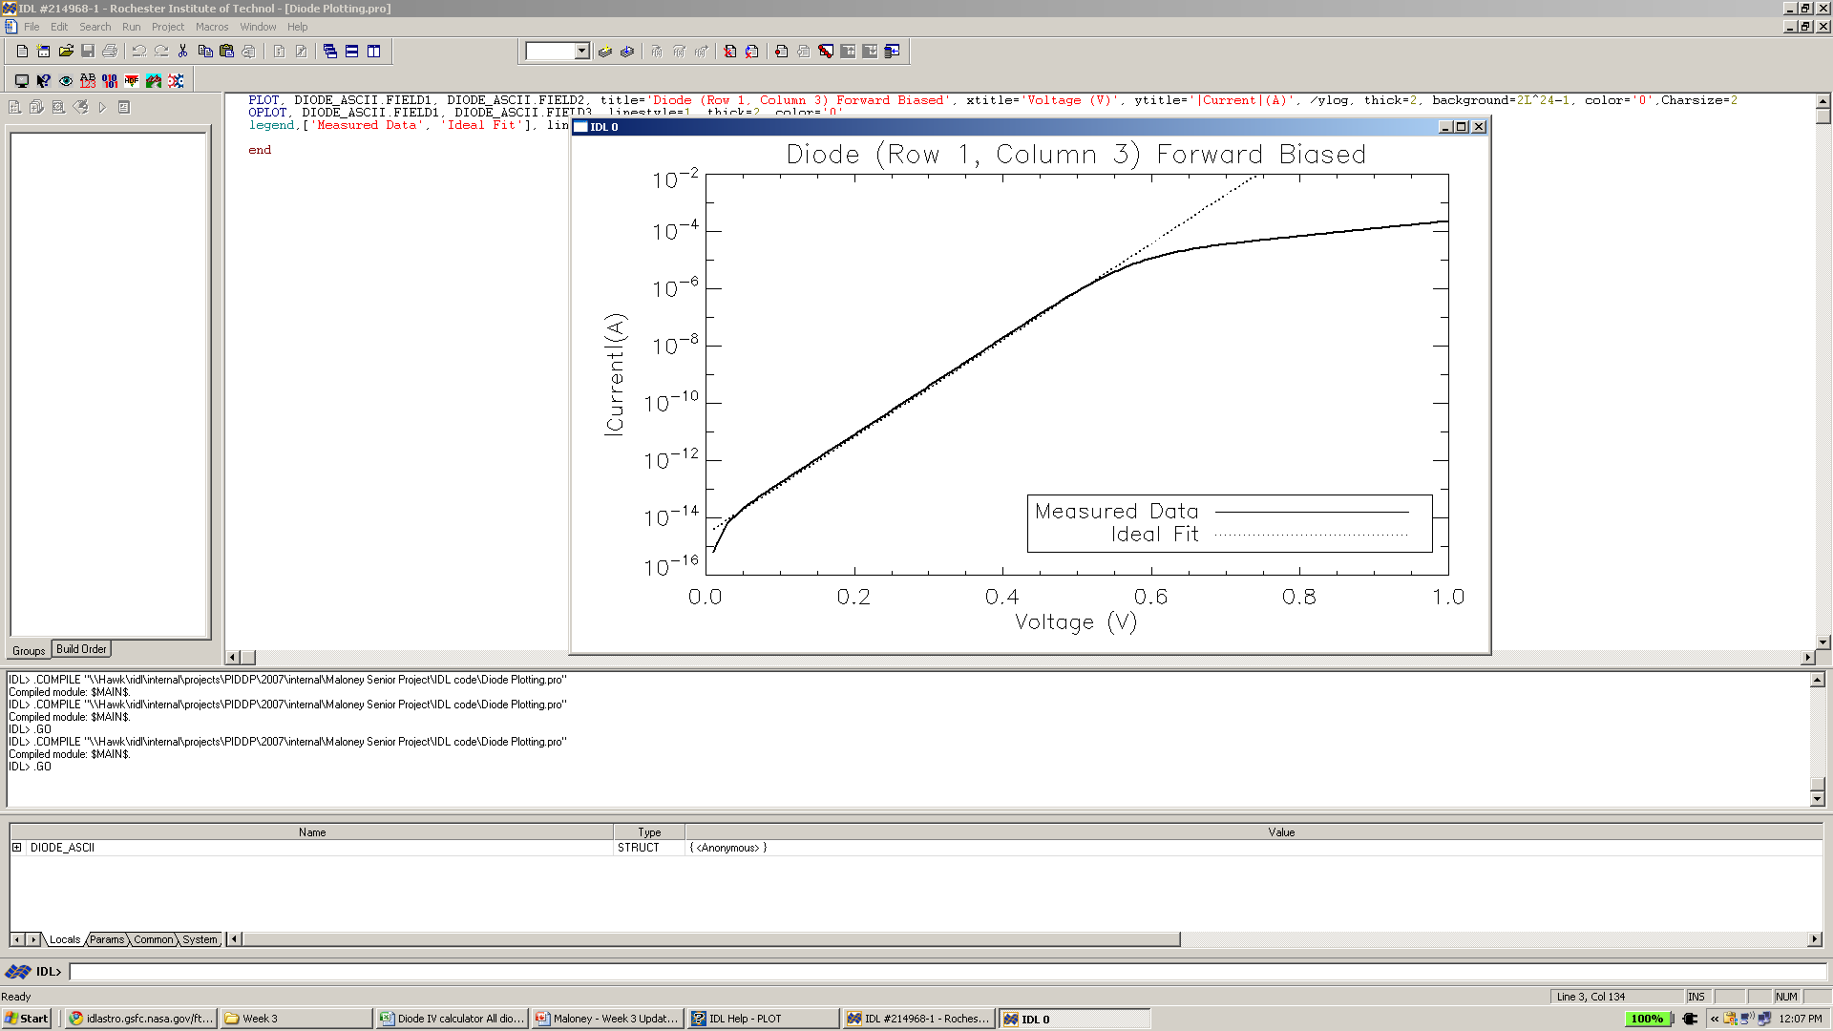
Fig. 2 Measured forward diode characteristic.

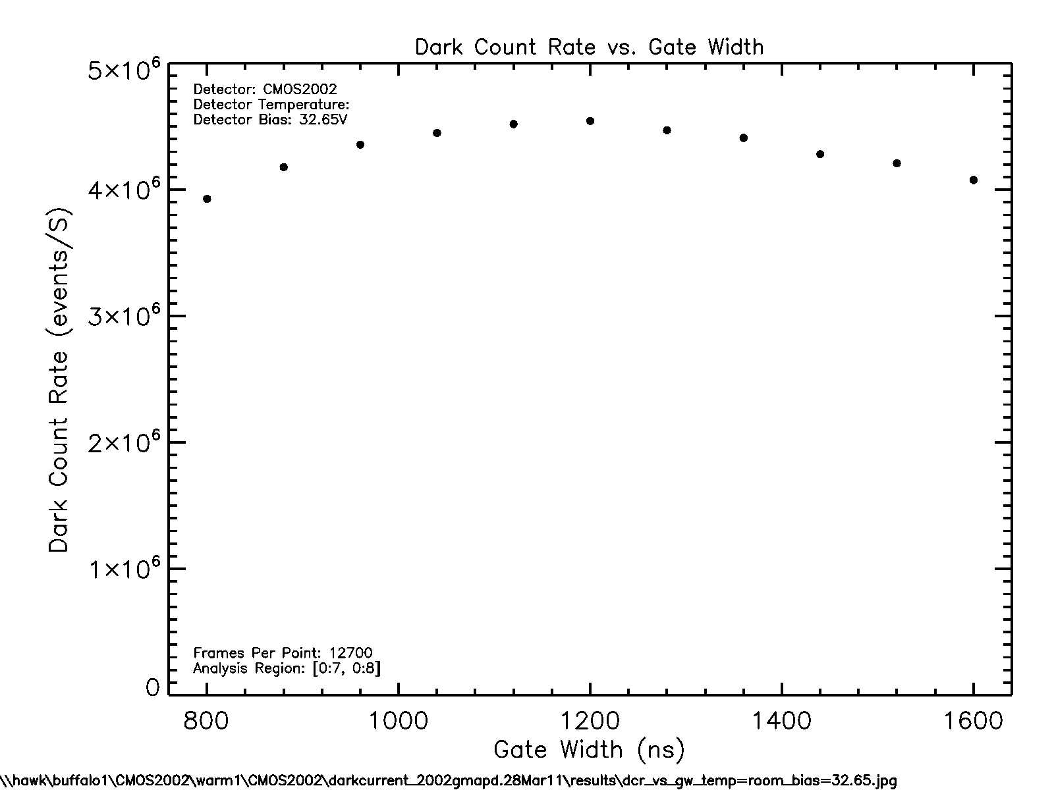
Fig. 3. Measured dark count rate vs. gate width.

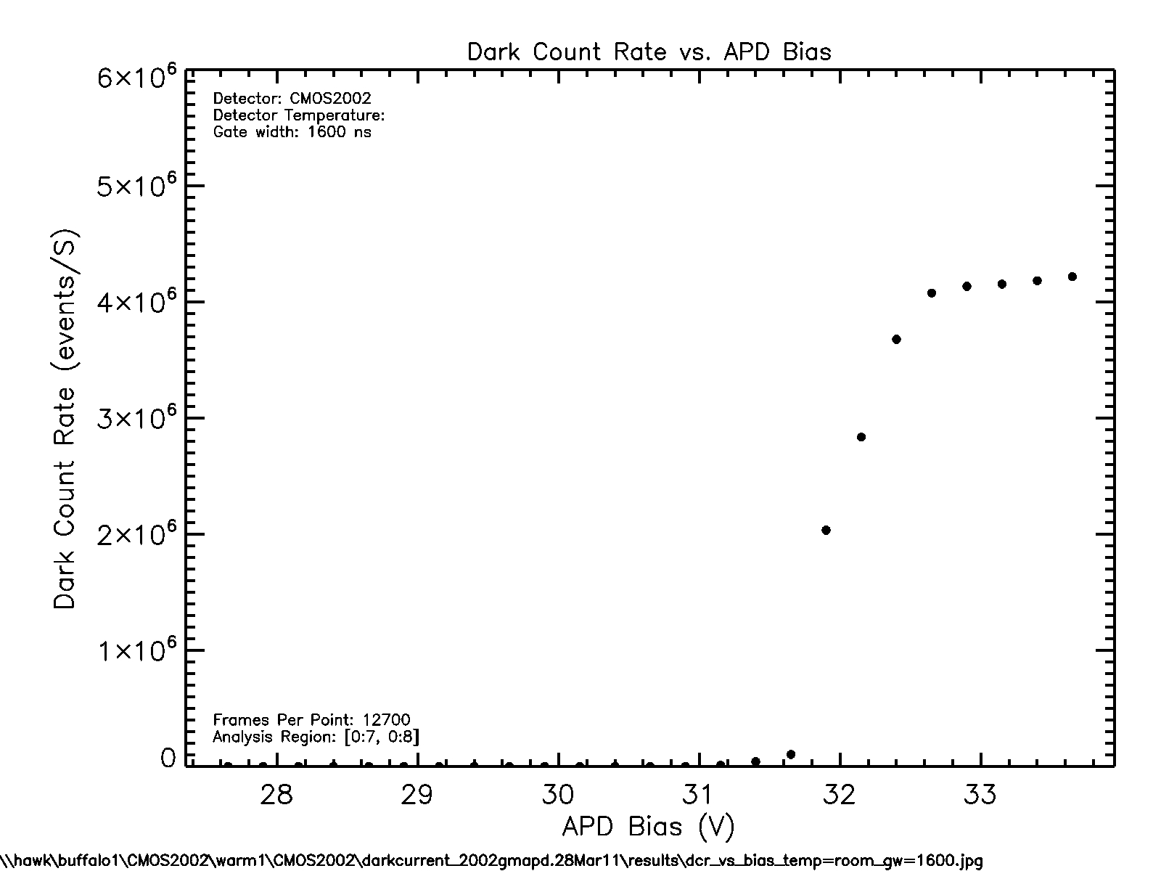
Fig. 4 Dark count rate vs. gate width.

$$λ(t_{\text{dead}})=R_{\text{dark}}+P_{a}\frac{N_{\text{ft}}}{τ_{\text{trap}}}\text{exp}\left(−\frac{t_{\text{dead}}}{τ_{\text{trap}}}\right)$$
Eq. 1 Dark count rate vs. dead time.

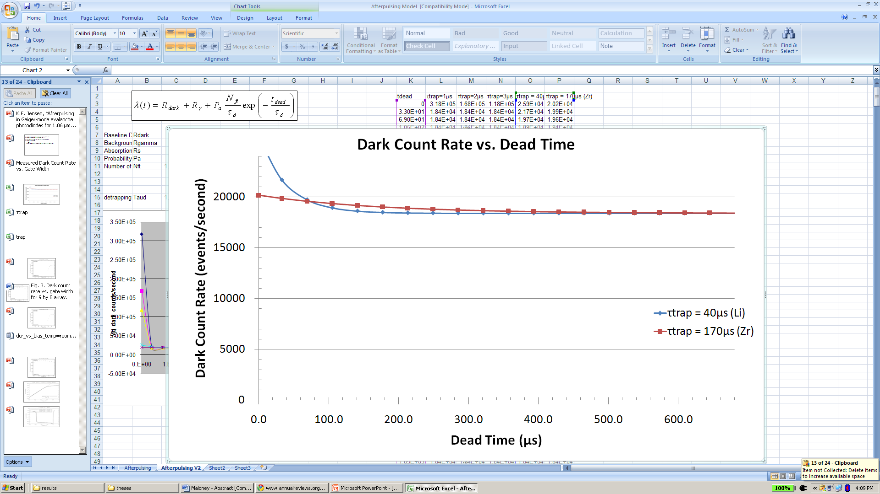
Fig. 5 Afterpulsing model plotted from Eq. 1.

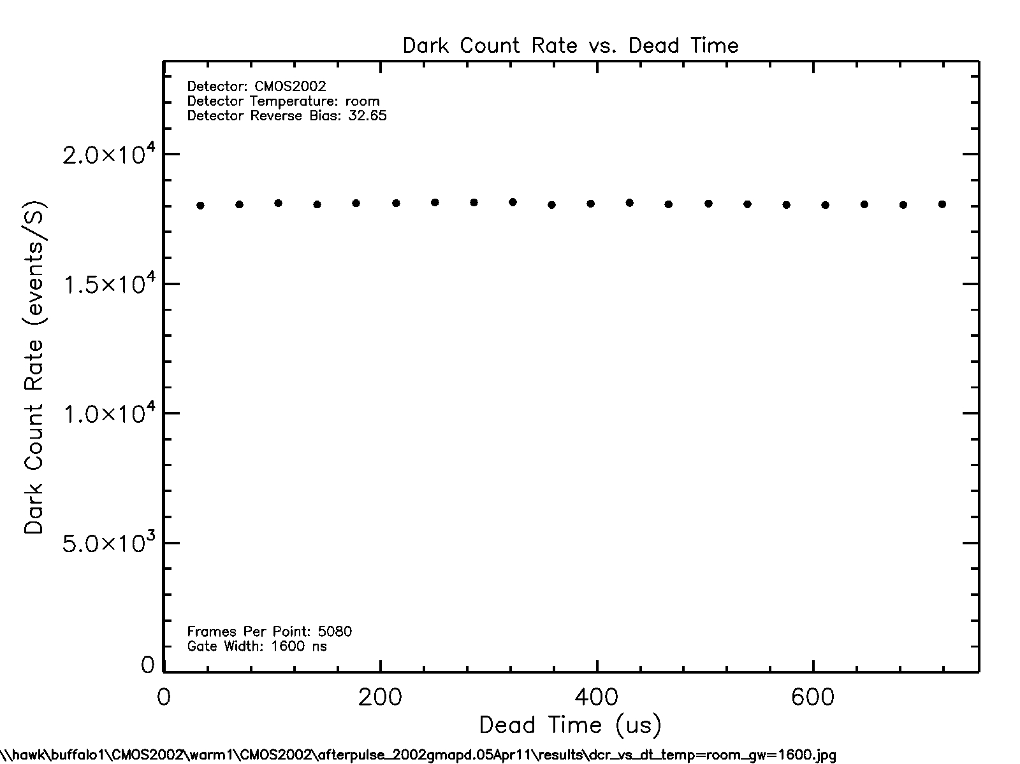
Fig. 6 Measured afterpulsing.

