Abstract—Given a cross-section and functionality requirements for a photodiode designed for application as the focal plane array on SNAP (SuperNova Acceleration Probe), a proposed satellite in the Joint Dark Energy Mission by NASA and the DOE, a process has been developed to fabricate the device in the most efficient and reliable manner. The photodector is to be hybridized with a ROIC (Read-Out Integrated Circuit) that interprets the individual pixel signals and converts the electrical information into an image. After several versions of the process based on simulations, efficiency of sequence, and research, a test run of key process steps was completed to evaluate chosen process values and their final results, including well profile and I-V characteristics. The results from the test run were used to create a preliminary process flow for device wafer fabrication. The process was implemented in full on a small lot of device wafers with some monitor wafers, with the entire process (not including test) requiring about 100 hours. The results from this device run were used to create a new revised version of the process flow in order to attain better functionality from the device. After this device run was completed, the results were analyzed and used to update the process flow again to address deficiencies in the resulting devices and processing difficulties.
Process Development for the Fabrication of a Double-Sided Photodiode
Kimberly E. Manser

Index Terms—Photodetector, ROIC, Dark Current, Diode Ideality

Introduction

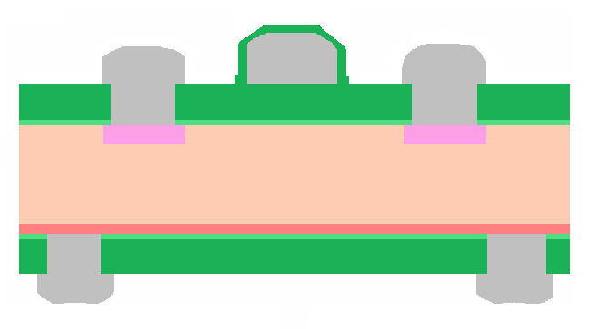
SNAP (SuperNova Acceleration Probe) is a deep space observatory that will measure the expansion of the universe by tracking supernova as markers. This information will also help scientists understand the nature of dark matter and its role in the acceleration of the expansion of the universe. It is a part of the Joint Dark Energy Mission (JDEM), included in the Beyond Einstein program: an initiative by the scientific community to better understand the universe. The photodetector described here will act as the focal plane array for this observatory in its final revision. Fig. 1 above shows a final cross-section of the device. The bump bonding sites will be the point of communication between the detector pixels and the ROIC circuit. The backside of the wafer has a metal frame to introduce a bias across the whole wafer via a heavily doped region of silicon. Fig. 2 shows the top-down views for both the front and back of the wafer. There is a metal grid that runs between the pixels which will act as a field effect gate to
Bump Bonding Sites
P++
N++
5000 ohm-cm n-Si
Silicon Dioxide
Aluminum
Fig. 1. Cross-Sectional View of the final device

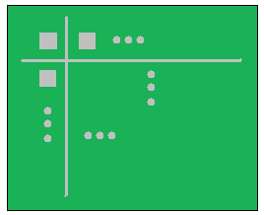
Frontside (Bonds to Multiplexer) Backside (Collects Radiation)
Fig. 2. Top-Down View of the final device (front and back)
decrease cross-talk between the pixels by creating a slightly N-type accumulation. The design of the device stipulated that there was to be minimal shadowing (which implies that the metal layer must be tightly controlled), the implant well junctions were to be less than a micron each (more specifically, less than 0.75μm for the n-well and less than 0.5μm for the p-well), and the pixel pitch was 15μm. The surface concentration of the wells was to be also aggressively high to make a good ohmic contact between the silicon and the aluminum: 1x10¹⁸cm⁻³ for the N+ implant and 1x10¹⁹cm⁻³ for the P+ implant. The goal for the dark current (the limiting factor in the resolution of the resulting image) was 0.1^{pA}/_{cm}² at the operating conditions for the device (200K at a 50V reverse bias), which translates to 15^{nA}/_{cm}² at the testing conditions of 300K with the same bias.

Challenges and Solutions

“Backside” Contamination
In normal CMOS fabrication, the devices are made on only one side of the wafer, and while the backside of the wafer is exposed to contaminants and vulnerable to scratching, this is generally ignored (and perhaps encouraged to aid in gettering). For the fabrication of this device, however, the backside must be as device-ready as the front side. To make sure that both sides of the wafer remain as pristine as possible, protective coatings, proximity bakes, and careful sequencing were used so that neither side the wafer was ever subjected to the contamination usually seen by a standard CMOS process wafer.

Limited Thermal Budget
Due to the need for shallow junctions (to decrease surface recombination velocity, a parasitic that decreases the signal to noise ratio in a photodiode), little to no diffusion of the implanted species could occur. Since this diffusion occurs at high temperature (like temperatures seen during thermal oxide growth steps), these high temperature steps were eliminated as much as possible. Since the final device requires an anti-reflective layer (silicon dioxide) 5000Ǻ thick, the decision was made to use LTO for the majority of the film thickness, but still grow 100Ǻ of thermal oxide for a good interface between the oxide and the silicon. These oxide growths also served to activate the implanted species since they occur after each implant step in the process flow. Rapid thermal anneals were also done after the implants to anneal out damage due to implant.

Front to Back Alignment
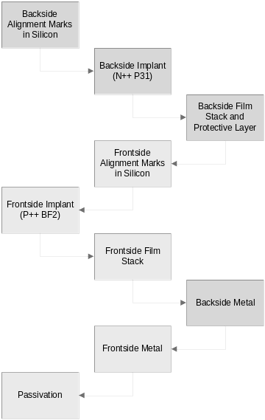
Double-sided alignment is a challenge at RIT due to the availability of tools only designed for single-sided alignment. A process needed to be found that would facilitate the alignment of the front die and the back die to within a reasonable shift. Alignment was done by first aligning the side that would not be exposed to a mask, then affixing the wafer to the mask by using water droplets to create adhesion. The wafer and mask were then flipped, and the second mask was aligned to the first mask by use of marks outside the design area and the backside of the wafer was exposed, now aligned to the front side.
Fig. 4. Generalized Process Flow

Selectivity / Over-Etching
Because the implanted wells are so shallow, selectivity and over-etching became an issue. Dry etching is more anisotropic, which leads to better contact etching, but has poorer selectivity, meaning that the etching gases will not stop on the desired layer. Instead, they will continue into the silicon layer after etching the oxide layer and consume the highest doped portion (the surface) of the doped well. End point detection can be used to gauge the transition from oxide to silicon by monitoring the spectra emitted in the chamber, but slight over-etching would result in dopant loss and poorer contacts, which result in more parasitic resistance and poorer device performance. For these reasons, wet etches, though isotropic in nature, were chosen for their selectivity (ratio of more than 500:1) and therefore reliability.

Simulations
Once a preliminary process flow had been completed, simulations were done using Silvaco Athena to ensure that assumptions that were made incurred good results (as per the goals listed previously). The entire process was simulated save for the passive steps (such as RCA cleans) and then the final well profiles were analyzed to determine the defining characteristics. Fig. 3 shows the front and back-side well profiles (P+ and N+, respectively).
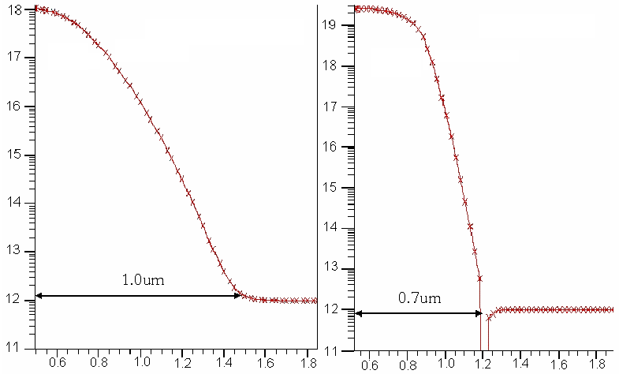
μm
Atoms per cm³
Phosphorus Implant
Boron Implant
1x10¹⁸ cm⁻³
2x10¹⁹ cm⁻³
Fig. 3. Well Profiles from Silvaco Athena after Full Process Simulation
As seen in the figure, the surface concentrations are correctly obtained, but the junction depths are about 0.25μm too deep. Since all of the thermal steps had already been reduced and the P+ implant species changed from B₁₁ to BF₂ (for shallower initial junction), these values were deemed acceptable and the project moved forward, knowing that the goals were aggressive to begin with. Should the simulations prove correct at the end of fabrication, more steps would be taken to decrease them.

Testing Run
A truncated version of the full process (which excluded photolitho-graphy steps and metal layers) was run to verify that the designed process parameters would result in the desired junction depths and sheet resistance of the implanted areas.
Blanket implants were used for ease of testing, and all of the thermal steps were included to achieve the most accurate profiles. The testing wafers were characterized using a groove and stain method to record junction depth and a four-point probe measurement was used to procure the sheet resistance of the implants. After completion of the truncated fabrication, some of the process values needed adjustment, and so changes were made to the process and then verified. These changes included phosphorus implant dose, boron implant screening oxide thickness, and deposition time for the LTO steps based on a newly calculated deposition rate. Fig. 4 to the left shows a generalized process flow for the device fabrication.

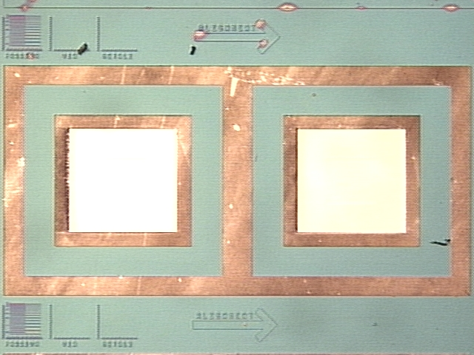
1965 μm
2010 μm
Fig. 6. Testing Structure

Device Fabrication and Results

Fabrication
The device run was done with three device wafers and two monitors (one for implant measurements and one to monitor metal deposition). There were 55 steps total in the last version of the process, requiring approximately 96 tool hours. During the course of fabrication, there was a problem with LTO uniformity, even though the testing run had much better quality of oxide with the same settings. This led to difficulties in etching the films, which then led to a degradation of the surface (scratches and plasma damage), which would then affect device performance.

Results
A series of tests were done on the implant wafer and device wafers to ascertain well profile characteristics and I-V characteristics (both reverse and forward biased). Table 1 shows the well characteristics from the implant monitor wafer. The sheet resistance and junction depth were taken as measurements, with the surface concentration derived from those two values using Irvin’s Curves.

Table 1. Well Profile Characteristics (Measured)
3x10¹⁸ cm⁻³
Surface Concentration
0.76 μm
Junction Depth
994 ^{Ω}/□
Sheet Resistance
N-Implant
2x10¹⁹ cm⁻³
Surface Concentration
0.44 μm
Junction Depth
1085 ^{Ω}/□
Sheet Resistance
P-Implant
Fig. 5 below shows the forward bias condition for all three of the device wafers, tested on the test die shown in Fig. 6.
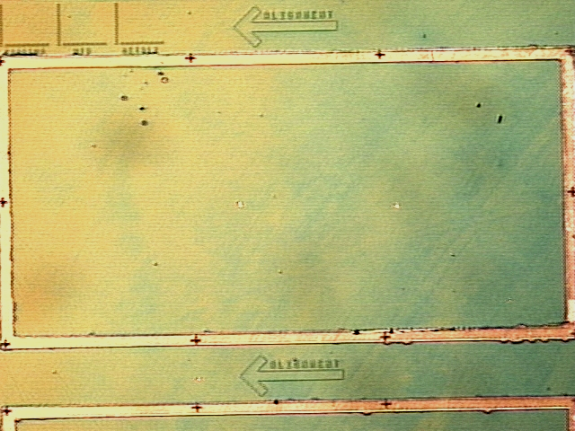
Fig. 9. Backside View
Fig. 5. Forward Bias Characteristic

The test die is larger than the actual pixel size so that hand probes could be placed with ease. From the curves in Fig. 5, the ideality factor for each device wafer’s test diode can be obtained. The ideality factor refers to how closely the diode performance coincides with ideal assumptions. The number always falls between one and two and is represented as ‘n’ in Eq. 1
$I_{D}=I_{S}(e^{\left({V_{D}}/{{\text{nV}}_{T}}\right)}−1)$, Eq. 1
where I_{D} is the diode current, I_{S} Table 2. Ideality Factors
is the leakage current (or dark current for a photodiode), V_{D} is the voltage placed on the diode, and V_{T} is the turn-on or threshold voltage for the device. Table 1 to the right shows the ideality factors for all three device wafers, the average being 1.31.
Sample | Ideality Factor (n)
D1 | 1.36
D2 | 1.26
D3 | 1.31
A reverse bias curve was also obtained from the device wafers and the data is reported below in the graph in Fig. 7.
I-V Characteristic Curve
Current (^{A}/_{cm}2)
D2 (light)
Fig. 7. I-V Characteristic Curve, Reverse Bias
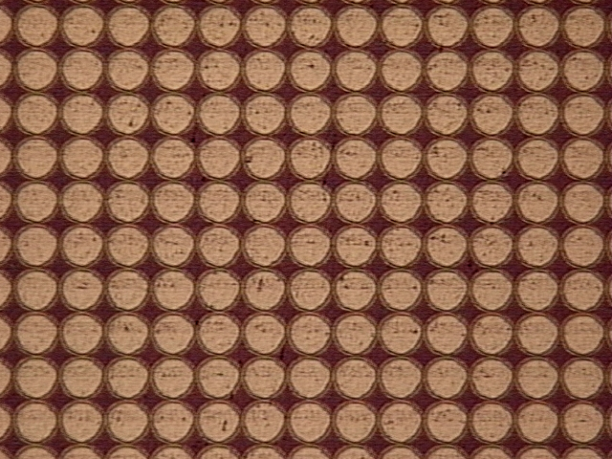
The average dark current at a 50V reverse bias is on the order of 1x10⁻⁶ ^{A}/_{cm}², three orders of magnitude higher than the goal. This is likely due to insufficient anneals and the surface damage described earlier. There is one curve that represents one device wafer (D2) with the light on, showing that the diode functions as a photodetector.
Fig. 8. Frontside View
Figures 8 and 9 show the top down views for the frontside and backside (in comparison with Fig. 2), respectively. It may be seen that while the wet etching worked sufficiently on the backside patterning (due to the relatively large and isolated features), the wet etch was not sufficient for the frontside due to the dense features and therefore resulted in over-etching of the oxide contact cuts (note the round shape as opposed to the on-mask square shape). The metal was also under-etched due to the dense features as well, resulting in larger than desired contact pads, encroaching on the metal grid pad.

Conclusions and Future Work
The process was an overall success, with the exception being the contact etching parameters. Based on results from the full process run, changes were made to increase the total tool time to 100 hours and 59 steps.
For future work, dry etches will be looked into for the contact etches. Etch rates, possible changes to the gas flows, and endpoint detection will be investigated to provide the optimum etch with minimal over-etching.
In addition to the dry etch experiments, the anneals will be optimized to decrease the damage remaining from the implant, resulting in lower dark current. Also, since the area of the test die is much larger than that of the individual pixels, the perimeter parasitics will be larger in theory. Characterization of perimeter to area ratios and the resulting dark current (for the same implants that will have the same bulk dark current) will help to eliminate the parasitics’ contribution to the dark current.

Photomask Improvement Suggestions
There were some problems with testing and also need for additional testing capabilities, and so some improvements to the photomask set will be suggested.
The first suggestion is to make the metal frame on the backside of the test die thicker so that “light on” measurements can be taken on the correct side with hand probes. In addition to making the testing structures easier to probe, they should be incorporated across the whole wafer array of die so that areas of functionality can be characterized to see the effects of film uniformity (comparing to data taken during fabrication).
Test structures should also be added: Van der Pauw structures (see Fig. 10) and contact resistance characterization (see Fig. 11) would help in analysis of causes of less-than-ideal functionality of the devices. For instance, if higher dark current existed in die that also had higher contact resistance and / or higher sheet resistance, then changes will have to be made to the implant and / or anneal steps.
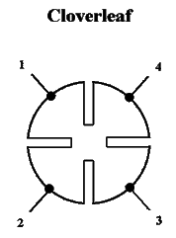
Fig. 10. Cloverleaf Form of a Van der Pauw structure; measurements are taken and then evaluated using Eq. 2

Equation 2 shows the equation used to find the sheet resistance (R_{S}) of the structure and thus the doped layer. R_{A} is the voltage between points 4 and 3 divided by the current between points 1 and 2. R_{B} is the voltage between points 1 and 4 divided by the current between points 2 and 3.
$e^{−\frac{{πR}_{A}}{R_{S}}}+e^{−\frac{{πR}_{B}}{R_{S}}}=1$ Eq. 2
Contact resistance can be measured by using the structure shown in Fig. 11, which measures the resistance between a doped layer and a metal contact.
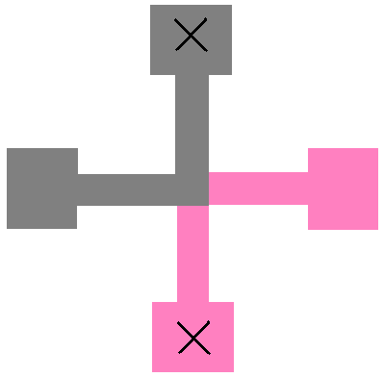
Fig. 11. Contact Resistance Measurement Structure; the grey material is aluminum, and the pink region is the diffused area; measurements are taken by measuring the resistance between the two X marks

Appendix
Final full process flow below: (DW = Device Wafers, IMP = implant monitor, ET = metal monitor)
Step | Process | Details | Include | Record
1 | RCA Clean | RCA Wetbench | DW | -
2 | Protective Oxide Growth | Bruce Furnace, Tube 1, Recipe #311 | DW | Oxide Thickness
3 | Coat Frontside with Photoresist | CEE Hand Coater, 120C for 60s | DW | -
4 | Etch Backside Oxide | 10:1 BOE, 2 minutes (586 A/min) (be sure that it pulls dry) | DW | -
5 | Remove Photoresist | PRS-2000 Bench | DW | -
6 | Photo 1 - Backside Alignment marks | Coat HMDS on CEE Hand Coater | DW | -
6 | Photo 1 - Backside Alignment marks | Bake at 90C for 30s | DW | -
6 | Photo 1 - Backside Alignment marks | Coat Resist on CEE Hand Coater | DW | -
6 | Photo 1 - Backside Alignment marks | Bake at 90C for 60s | DW | -
6 | Photo 1 - Backside Alignment marks | Expose on KarlSuss MA56 | DW | -
6 | Photo 1 - Backside Alignment marks | Bake at 140C for 90s | DW | -
6 | Photo 1 - Backside Alignment marks | Develop on CEE Hand Developer | DW | -
7 | Etch Silicon Alignment Marks | DryTech Quad, use carrier wafers, recipe "polysilicon", 1 min | DW | -
8 | Strip Photoresist | Branson Asher, 4" Normal Ash | DW | -
9 | Etch Remaining Oxide | HF Wetbench, 10:1 BOE, 2 minutes (586 A/min) | DW | -
10 | RCA Clean, RCA Wetbench | RCA Wetbench | DW | -
11 | Backside Screening Oxide Growth | Bruce Furnace, Tube 4, Recipe #458 | DW + IMP | Oxide Thickness
12 | Backside Phosphorus Implant | Varian 350D Implanter, Dose = 5e14, Energy = 33keV, P31 | DW + IMP | -
13 | Strip Oxide, BOE Chemical Bench | HF Wetbench, 10:1 BOE, 1 minute (586 A/min) | DW + IMP | Junction Depth
14 | Anneal | AG610A/B RTA, 1000C, 3 minutes | DW + IMP | -
15 | RCA Clean | RCA Wetbench | DW + IMP | -
16 | Backside Oxide Growth | Bruce Furnace, Tube 4, Recipe #450 | DW + IMP + ET | Oxide Thickness
17 | Backside LTO Deposition | LPCVD Upper Tube, 425C LTO recipe, 53 min. | DW + IMP + ET | Oxide Thickness
18 | Backside Protection Silicon Nitride Growth | LPCVD Tube #2, Factory Nitride Recipe, 23 minutes | DW + IMP + ET | Nitride Thickness
19 | Backside Photoresist Protective Coating | Coat Resist on CEE Hand Coater | DW + IMP + ET | -
20 | Dry Etch of Nitride on the frontside of the wafer | Bake at 120C for 90s | DW + IMP + ET | -
20 | Dry Etch of Nitride on the frontside of the wafer | DryTech Quad, Nitride Recipe, 2.5min (stop on LTO) | DW + IMP + ET | -
21 | Oxide Etch frontside oxide | HF Wetbench, 10:1 BOE, 4 min (1600 A/min, 586 A/min-Th) | DW + IMP + ET | -
22 | Strip Photoresist | Branson Asher, 4" Normal Ash | DW + IMP + ET | -
23 | Photo 2 - Frontside Alignment marks | Coat HMDS on CEE Hand Coater | DW | -
24 | Etch Silicon alignment marks | Bake at 90C for 30s | DW | -
24 | Etch Silicon alignment marks | Coat Resist on CEE Hand Coater | DW | -
24 | Etch Silicon alignment marks | Bake at 90C for 60s | DW | -
24 | Etch Silicon alignment marks | Expose on KarlSuss MA56 | DW | -
24 | Etch Silicon alignment marks | Bake at 140C for 90s | DW | -
24 | Etch Silicon alignment marks | Develop on CEE Hand Developer | DW | -
24 | Etch Silicon alignment marks | DryTech Quad, use carrier wafer, recipe "polysilicon",1.5 min | DW | -
25 | Strip Photoresist | Branson Asher, 4" Normal Ash | DW | -
26 | RCA Clean | RCA Wetbench | DW + IMP | -
27 | Frontside Screening Oxide Growth | Bruce Furnace, Tube 4, Recipe #456 | DW + IMP | Oxide Thickness
28 | Photo 3 - Frontside Well Definition | Coat HMDS on CEE Hand Coater | DW | -
29 | Frontside Boron Well Implant | Bake at 90C for 30s | DW + IMP
29 | Frontside Boron Well Implant | Coat Resist on CEE Hand Coater | DW + IMP
29 | Frontside Boron Well Implant | Bake at 90C for 60s | DW + IMP
29 | Frontside Boron Well Implant | Expose on KarlSuss MA56 | DW + IMP
29 | Frontside Boron Well Implant | Bake at 140C for 90s | DW + IMP
29 | Frontside Boron Well Implant | Develop on CEE Hand Developer | DW + IMP
29 | Frontside Boron Well Implant | Varian 350D Implanter, Dose = 1e15, Energy = 33keV, BF2 | DW + IMP
30 | Strip Photoresist | Branson Asher, 4" Normal Ash | DW | -
31 | Etch Oxide (damaged from implant) Frontside | HF Wetbench, 10:1 BOE, 2 minutes (586 A/min) | DW + IMP | Junction Depth, rs
32 | Anneal | AG610A/B RTA, 1000C, 3 minutes | DW + IMP | -
33 | RCA Clean, RCA Wetbench | RCA Wetbench | DW + IMP | -
34 | Frontside Oxide Growth | Bruce Furnace, Tube 4, Recipe #450 | DW + IMP | Oxide Thickness
35 | Frontside LTO Deposition | LPCVD Upper Tube, 425C LTO recipe, 53 min. | DW + IMP
36 | Coat Frontside with Photoresist | CEE Handspinner, 120C for 60s | DW + IMP
37 | Backside Oxide Etch (remove any oxide on the nitride) | 10:1 BOE Cup Etch, 5 minute (586 A/min) | DW + IMP | -
38 | Strip Photoresist | Branson Asher, 4" Normal Ash | DW + IMP
39 | Strip Backside Silicon Nitride | Hot Phosphorus Bench, 45 min | DW + IMP | -
40 | Coat Frontside with Photoresist | CEE Hand Coater, 120C for 60s | DW + IMP
41 | Photo 4 - Backside Contact Etch | Coat HMDS on CEE Hand Coater | DW | -
42 | Etch Oxide (backside contacts) | Bake at 90C for 30s (Proximity Bake) | DW + IMP | Junction Depths, rs
42 | Etch Oxide (backside contacts) | Coat Resist on CEE Hand Coater | DW + IMP | Junction Depths, rs
42 | Etch Oxide (backside contacts) | Bake at 90C for 60s (Proximity Bake) | DW + IMP | Junction Depths, rs
42 | Etch Oxide (backside contacts) | Expose on KarlSuss MA56 | DW + IMP | Junction Depths, rs
42 | Etch Oxide (backside contacts) | Bake at 140C for 90s (Proximity Bake) | DW + IMP | Junction Depths, rs
42 | Etch Oxide (backside contacts) | Develop on CEE Hand Developer | DW + IMP | Junction Depths, rs
42 | Etch Oxide (backside contacts) | 10:1 BOE Etch, 3.5 minutes (1600 A/min, 586 A/min) | DW + IMP | Junction Depths, rs
43 | Strip Photoresist | PRS-2000 Bench | DW + IMP | -
44 | Backside Aluminum Deposit | CVC601 Sputter, 15sccm Argon, Power = 1500W, 5mT, 930s | DW + ET | Al Thickness
45 | Photo 5 - Backside Aluminum Etch | Coat HMDS on CEE Hand Coater | DW | -
46 | Wet Etch of Backside Aluminum | Bake at 90C for 30s | DW + ET | -
46 | Wet Etch of Backside Aluminum | Coat Resist on CEE Hand Coater | DW + ET | -
46 | Wet Etch of Backside Aluminum | Bake at 90C for 60s | DW + ET | -
46 | Wet Etch of Backside Aluminum | Expose on KarlSuss MA56 | DW + ET | -
46 | Wet Etch of Backside Aluminum | Bake at 140C for 90s | DW + ET | -
46 | Wet Etch of Backside Aluminum | Develop on CEE Hand Developer | DW + ET | -
46 | Wet Etch of Backside Aluminum | Aluminum Etch Bench, 1 minute 20 seconds | DW + ET | -
47 | Strip Photoresist | PRS-2000 Bench | DW | -
48 | Backside Photoresist Protective Coating | CEE Hand Coater, 120C for 60s | DW | -
49 | Photo 6 - Frontside Well Contact | Coat HMDS on CEE Hand Coater | DW | -
50 | Etch Oxide - Frontside Contacts | Bake at 90C for 30s (Proximity Bake) | DW + IMP | -
50 | Etch Oxide - Frontside Contacts | Coat Resist on CEE Hand Coater | DW + IMP | -
50 | Etch Oxide - Frontside Contacts | Bake at 90C for 60s (Proximity Bake) | DW + IMP | -
50 | Etch Oxide - Frontside Contacts | Expose on KarlSuss MA56 | DW + IMP | -
50 | Etch Oxide - Frontside Contacts | Bake at 140C for 90s (Proximity Bake) | DW + IMP | -
50 | Etch Oxide - Frontside Contacts | Develop on CEE Hand Developer | DW + IMP | -
50 | Etch Oxide - Frontside Contacts | 10:1 BOE, 3.5 minutes (1600 A/min, 586 A/min) | DW + IMP | -
51 | Strip Photoresist | PRS-2000 Bench | DW | -
52 | Frontside Aluminum Deposition | CVC601 Sputter, 15sccm Argon, Power = 1500W, 5mT, 930s | DW + ET | Al Thickness
53 | Photo 7 - Frontside Contact Etch | Coat HMDS on CEE Hand Coater | DW | -
54 | Wet Etch of Frontside Aluminum | Bake at 90C for 30s (Proximity Bake) | DW + ET
54 | Wet Etch of Frontside Aluminum | Coat Resist on CEE Hand Coater | DW + ET
54 | Wet Etch of Frontside Aluminum | Bake at 90C for 60s (Proximity Bake) | DW + ET
54 | Wet Etch of Frontside Aluminum | Expose on KarlSuss MA56 | DW + ET
54 | Wet Etch of Frontside Aluminum | Bake at 140C for 90s (Proximity Bake) | DW + ET
54 | Wet Etch of Frontside Aluminum | Develop on CEE Hand Developer | DW + ET
54 | Wet Etch of Frontside Aluminum | Aluminum Etch Bench, 1 minute 20 seconds | DW + ET
55 | Strip Photoresist, PRS 2000 | PRS-2000 Bench | DW | -
56 | Frontside Passivation Layer Deposition of LTO | LPCVD Upper Tube, 425C LTO recipe, 4 min. | DW + ET | Oxide Thickness
57 | Photo 8 - Passivation Layer Trim | Coat HMDS on CEE Hand Coater | DW | -
58 | Etch Passivation Layer, BOE Chemical Bench | Coat Resist on CEE Hand Coater | DW + ET | -
58 | Etch Passivation Layer, BOE Chemical Bench | Bake at 90C for 60s | DW + ET | -
58 | Etch Passivation Layer, BOE Chemical Bench | Expose on KarlSuss MA56 | DW + ET | -
58 | Etch Passivation Layer, BOE Chemical Bench | Bake at 120C for 60s | DW + ET | -
58 | Etch Passivation Layer, BOE Chemical Bench | Develop on CEE Hand Developer | DW + ET | -
58 | Etch Passivation Layer, BOE Chemical Bench | "Pad Etch", 15 minutes (38 A/min) | DW + ET | -
59 | Strip Photoresist, PRS 2000 | PRS-2000 Bench | DW | -
End

Acknowledgment
Advisor Dr. Lynn Fuller, Dr. Karl Hirschman, Dr. Don Figer, Dr. Jingjing Zhang, Dr. Sean Rommel, Tom Grimsley, Bruce Tolleson, Sean O’Brien, Dave Yackoff.
References
- Robert F. Pierret, “Semiconductor Device Fundamentals,” Addison-Wesley Publishing Company, 1996
- Robert F. Pierret, “Advanced Semiconductor Fundamentals,” Prentice Hall, 2002
- http://electron.mit.edu/~gsteele/vanderpauw/

 
http://people.rit.edu/lffeee/backside%20alignment.pdf

