The Rochester Imaging Detector Laboratory Presents:

“Infrared Detectors”
Dr. Paul R. Norton

Consultant for the U.S. Army Night Vision and Electronic
Sensors Directorate, Fort Belvoir, VA

Thursday, April 22, 2010
4:00 – 5:00 PM
Building 76, Auditorium

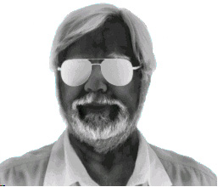

Presentation will be broadcast at: https://connect.rit.edu/ridl

Dr. Norton’s talk will include the following:
1. Norton’s law of infrared detectors.
2. Status of cooled infrared detectors:
a. HgCdTe
b. Type II strained-layer superlattices
c. MWIR and SWIR detectors
3. The origin of 1/f noise
4. NE∆T for dummies

Speaker Bio:
1999-present – Senior Fellow, U.S. Army Night Vision Laboratory
1979-99 - MTS, Manager of Semiconductor Engineering, Manager of Advanced Development Laboratory, Program Manager, Santa Barbara Research Center
1976-79 - Principal Research Scientist, Honeywell Technology Center
1973-76 - Member of Technical Staff, Bell Telephone Laboratories;
1970 - Ph.D. solid state physics, 1970, Syracuse University, Syracuse, New York. Student of Professor Henry Levinstein

