The Rochester Imaging Detector Laboratory Presents:

“Infrared Detectors”
Dr. Paul R. Norton

Consultant for the U.S. Army Night Vision and Electronic
Sensors Directorate, Fort Belvoir, VA

Thursday, April 22, 2010
4:00 – 5:00 PM
Building 76, Auditorium

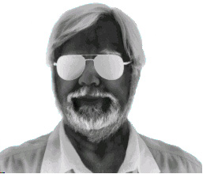

Presentation will be broadcast at: https://connect.rit.edu/ridl

