The RIT Center for Detectors Presents:

Astrophotonics
Dr. Joss Bland-Hawthorn

Federation Fellow, Professor of Physics, School of Physics, University of Sydney
Associate Director, Institute of Photonics & Optical Science
Adjunct Professor, Australia National University

Monday, October 25, 2010
2:00 – 3:00 PM
Xerox Auditorium, 09-2580

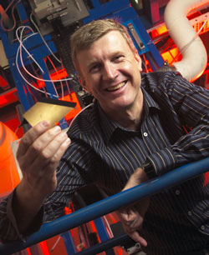
Presentation will be broadcast at: https://connect.rit.edu/ridl
Abstract: Astrophotonics—the interface of photonics and astronomy—will revolutionize astronomical instrumentation in the coming decade. Recent developments include the PIMMS multimode photonic spectrograph which is arguably the most radical development in spectroscopy in almost a century.
Speaker Bio: Joss Bland-Hawthorn is an astrophysicist and specializes in galactic research and instrumentation. In 1986, he obtained his PhD in astrophysics from the Royal Greenwich Observatory prior to taking up appointments in Hawaii and Texas. In 1993, he moved to the Anglo-Australian Observatory where he was Head of a highly successful group that pioneered astronomical concepts with names like Nod & Shuffle, Dazle, Starbugs, Honeycomb, and so on. In 1995, he developed TTF, the first general user tunable filter in astronomy. In 2002, he wrote papers on the prospect of optical lasers being used to communicate data from satellites back to Earth. The concept was finally demonstrated by the MESSENGER satellite in 2006 on its way to Mercury. In 2003, he proposed the new field of astrophotonics that sits at the interface of astronomy and photonics. In Feb 2009, this field was featured in the Focus Issue of Optics Express. With Ken Freeman, he developed the field of Galactic Archaeology and they lead the new HERMES project to obtain 8D chemical information on 1-2 million stars at the AAT over the next decade. His group at the University of Sydney is now close to solving three longstanding problems: (i) how to suppress the bright infrared sky; (ii) how to build miniature spectrographs; (iii) how to image the sky simultaneously at hundreds of distinct locations over a wide field. Joss is a recipient of the 2008 Muhlmann Award and is this year’s Leverhulme Professor to Oxford. In 2011, he is the Brittingham Scholar at the University of Wisconsin.

