CfD | The Center for Detectors presents

Frontiers in Astrophysics and the Federal Budget Landscape

Jon Morse

Associate Vice President for Research/Physical and Engineering Sciences, RPI
Friday, Nov 11, 2011, 12:00 pm – 1:00 pm, 76-1275
Pizza will be provided
Presentation will be broadcast at: https://connect.rit.edu/cfd
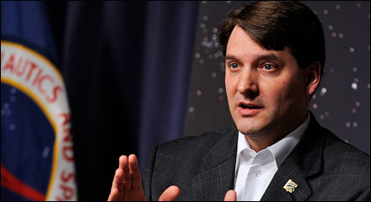

Abstract
Research in astronomy and astrophysics has produced a rich bounty of recent discoveries ranging from exploring the fundamental laws of nature, to the origins of stars and galaxies, to the search for Earth-like planets and life in the Universe. I discuss emerging opportunities in space astronomy and astrophysics, spurred by the deployment of powerful on-orbit capabilities during the past several years. I also review the federal budget process, the fiscal environment for federal funding in the physical sciences, and NASA's potential programmatic outlook in the context of the most recent decadal survey.

About the Speaker
Morse was Director of the Astrophysics Division at NASA Headquarters from 2007-2011, leading one of the world’s largest space astrophysics programs. The $1.1 billion astrophysics portfolio includes over a dozen flight projects and grant programs for hundreds of researchers around the country. He has had overall management responsibility for major research missions with international scientific significance, such as the Hubble Space Telescope, Chandra X-ray Observatory, and the Spitzer Space Telescope. He has also overseen the successful launches of the Fermi Gamma-ray Space Telescope, Kepler observatory, Wide-field Infrared Survey Explorer (WISE), and Servicing Mission 4 to Hubble, to be followed soon by future observatories like the Stratospheric Observatory for Infrared Astronomy (SOFIA) and the Nuclear Spectroscopic Telescope Array (NuSTAR) Explorer mission. He became associate director of the internationally renowned Center for Astrophysics and Space Astronomy at the university in 2000. He earned his bachelor’s degree in astronomy from Harvard University and his master’s degree and doctorate in astrophysics from the University of North Carolina, Chapel Hill. He began his academic career as a postdoctoral research fellow at the Space Telescope Science Institute in Baltimore, Md.

About the Center for Detectors
The Center for Detectors designs, develops, and implements new advanced sensor technologies through collaboration with academic researchers, industry engineers, government scientists, and university/college students. The CfD operates four laboratories and has approximately a dozen funded projects to advance detectors in a broad array of applications, e.g. astrophysics, biomedical imaging, Earth system science, and inter-planetary travel.

