 | The Center for Detectors presents a talk in the Detector Virtual Workshop | 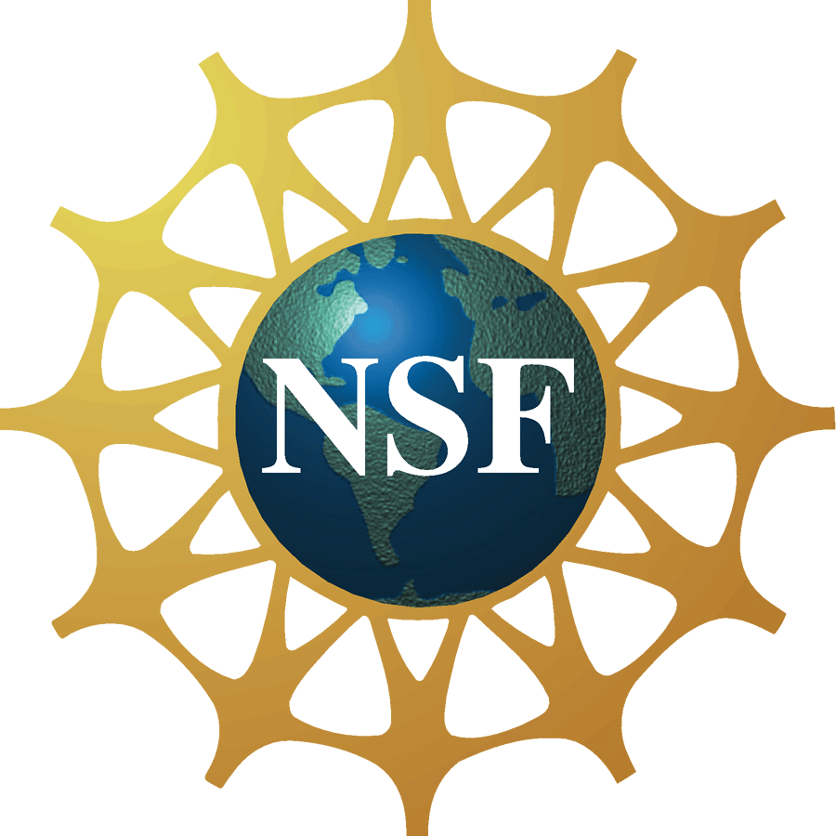

The Infrared Retina: Ushering in the Fourth Generation of Infrared Detectors
Dr. Sanjay Krishna
Professor, Department of Electrical and Computer Engineering
University of New Mexico, Albuquerque, NM
(Please note that Dr. Krishna’s presentation will be shown virtually at this location; the actual presentation will not take place on the RIT campus.)
Monday, May 14, 2012, 11:00 am – 12:00 pm, Innovation Center, Room 1600
Cookies & Coffee at 10:30 am
Presentation will be broadcast at: https://connect.rit.edu/dvw


Abstract
In this talk, I will try to look into the crystal ball to make predictions about the fourth generation of infrared detectors. Using the concept of a bio-inspired infrared retina, I will make a case for an enhanced functionality in the pixel. The key idea is to engineer the pixel such that it not only has the ability to sense multimodal data such as color, polarization, dynamic range and phase but also the intelligence to transmit a reduced data set to the central processing unit. I will use two material systems, which are emerging as promising infrared detector technologies as prototypes to highlight this approach. These are InAs/InGaAs self-assembled quantum dots in well (DWELL) heterostructure, and InAs/(In,Ga)Sb strain layer superlattices (SLS) Detectors. Various approaches for realizing the infrared retina, such as plasmonic resonators, will be discussed. In addition to the applications of infrared imaging for defense application, I will highlight the role of infrared imaging in non-invasive medical diagnostics. In particular, I will highlight some work on using infrared imaging in the early detection of skin cancer.

About the Speaker
Sanjay Krishna is the Associate Director of the Center for High Technology Materials and a Professor in the Department of Electrical and Computer Engineering at the University of New Mexico. He received his MS from the Indian Institute of Technology (IIT), Madras, and an MS in Electrical Engineering in 1999 and PhD in Applied Physics in 2001 from the University of Michigan. He joined the University of New Mexico (UNM) as a tenure track faculty member in 2001. His present research interests include growth, fabrication, and characterization of nanoscale quantum dots and type_II InAs/InGaSb based SLS for mid infrared detectors. He has published more than 200 peer-reviewed journal articles (h-index=29), two book chapters, five patents, and has recently been elected as a SPIE Fellow.

About the Detector Virtual Workshop
The Detector Virtual Workshop is a year-long NSF-funded program dedicated to the advancement of UV/O/IR detectors. It brings together people from around the world to discuss detector technologies. For more information, visit http://ridl.cfd.rit.edu/ and click on the DVW tab.

