 | The Center for Detectors presents a talk in the Detector Virtual Workshop | 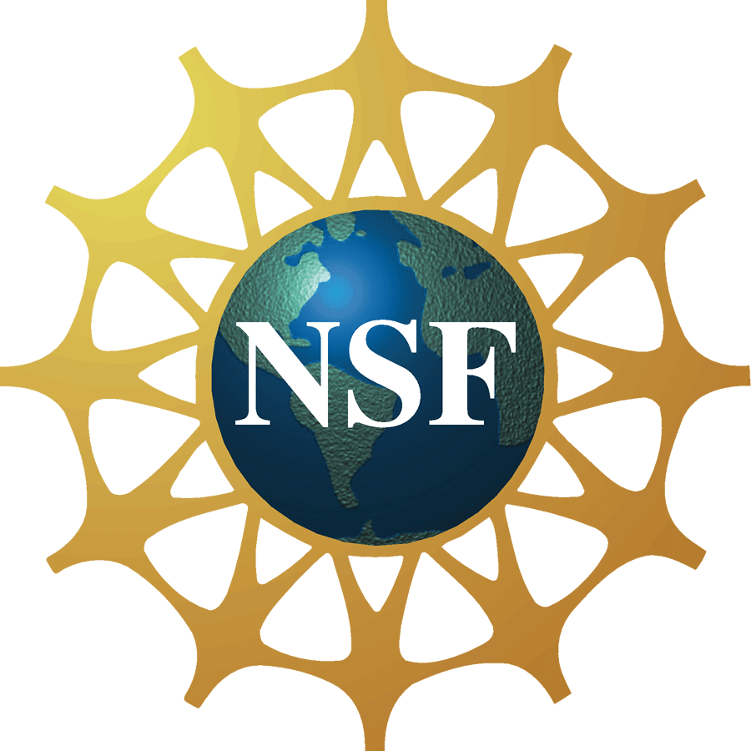

Infrared Superconducting Single-Photon Detectors

Dr. Robert Hadfield

Reader in Physics and Royal Society University Research Fellow

Heriot-Watt University, Edinburgh, United Kingdom
Wednesday, Sept 28, 2011, 1:00 – 2:00 pm, Building 76, Room 1275
Cookies & Coffee at 12:30 pm
Presentation will be broadcast at: https://connect.rit.edu/dvw


Abstract
Single-photon detectors are a key enabling technology for a host of applications at the frontiers of science, from imaging and ranging to quantum information processing. These advanced photon counting applications place exacting demands on detector performance, spurring the development of new detector technologies. A new class of single-photon detector, based on a superconducting nanowire, holds particular promise for time-correlated single-photon counting at infrared wavelengths. These detectors offer wide spectral sensitivity (visible to mid-infrared) combined with low dark counts, short recovery times and exquisite timing resolution. These low temperature detectors can now be integrated into practical cryogen-free refrigerator systems. I will discuss the impact of these high performance detectors in applications ranging from quantum cryptography to time-of-flight depth imaging. I will also give an outlook on future developments in this emerging photon-counting technology.

About the Speaker
Dr Robert Hadfield is an expert in infrared single photon detectors based on superconducting materials. He received his PhD from the University of Cambridge, UK in 2003 for work on nanoscale superconducting devices. He spent four years as a postdoctoral guest researcher at the US National Institute of Standards and Technology in Boulder, CO. Working together with Dr Sae Woo Nam, he implemented superconducting nanowire single-photon detectors into practical systems for use in quantum cryptography experiments over record distances. He joined Heriot-Watt University as a Royal Society University Research Fellow in 2007 and was promoted to Reader in Physics in 2009. His research team is pursing the development of next generation superconducting detectors and their implementation in new photon –counting applications. He has published over 40 peer-reviewed papers, 11 as first author, including a major topical review for Nature Photonics.

About the Detector Virtual Workshop
The Detector Virtual Workshop is a year-long NSF-funded program dedicated to the advancement of UV/O/IR detectors. It brings together people from around the world to discuss detector technologies. For more information, visit ridl.cfd.rit.edu and click on the DVW tab.

