 | The Center for Detectors presents a talk in the Detector Virtual Workshop | 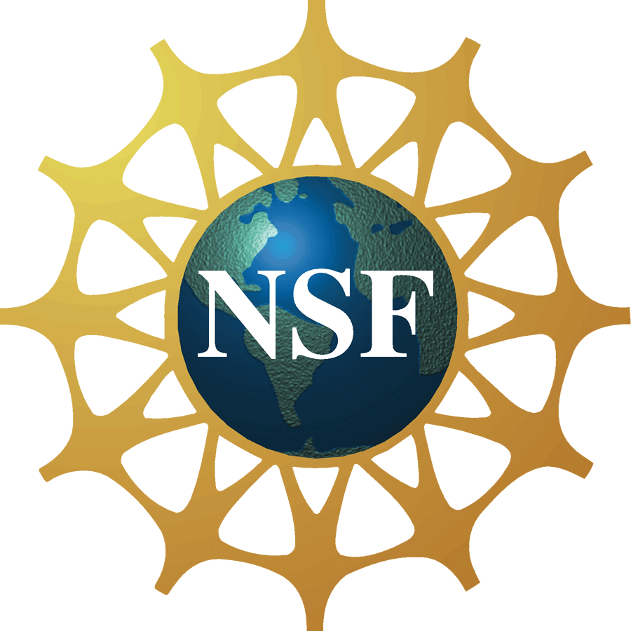

Microwave Kinetic Inductance Detectors for optical and near-IR astronomy

Dr. Kieran O'Brien
Research Scientist in the Department of Physics
University of California Santa Barbara
Monday, February 27th 2012, 11:00 am – 12:00 pm, Innovation Center, Room 1600
Cookies & Coffee at 10:30 am
Presentation will be broadcast at: https://connect.rit.edu/dvw
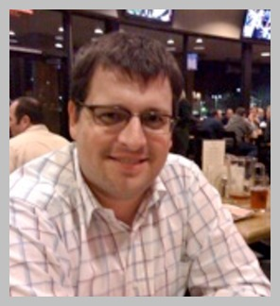

Abstract
In this talk I will describe our ongoing work in the development of Microwave Kinetic Inductance Detectors (MKIDs) for optical and infra-red astronomy. These super-conducting devices represent an important step towards the development of the 'ultimate detector'; one that can measure the position, energy and arrival time of a photon. I will describe the operating principles of the devices, their capabilities and their current status. I will describe ARCONS, the first MKID-based optical/IR instrument and the results of our recent commissioning run at the Palomar observatory. Finally, I will discuss the future promise of the technology for a broad range of astrophysical programs ranging from large scale surveys to the characterization of transient sources discovered by current and future synoptic surveys.

About the Speaker
Dr. Kieran O'Brien gained his PhD from the University of St Andrews, UK in 2000. His thesis entitled 'X-ray and optical observations of X-ray Binaries' pioneered the technique of echo-tomography in X-ray Binaries. After a short post-doc at the University of Amsterdam, he joined ESO in 2002. He spent seven years as an Operations Staff Astronomer at the VLT in Chile. He was Instrument Scientist for the FORS spectrographs and deputy group leader of the Calibration group. During his time there he furthered his interest in the development of high-speed instrumentation working with ULTRACAM and ULTRASPEC. He joined UCSB in 2009 and is a Research Scientist in the group of Professor Ben Mazin, working on the development of MKIDs for optical/IR astronomy. They recently commissioned the first optical/IR MKID camera at the Palomar 200-inch telescope. He continues to publish in the field of rapid correlated variability in X-ray binaries.

About the Detector Virtual Workshop
The Detector Virtual Workshop is a year-long NSF-funded program dedicated to the advancement of UV/O/IR detectors. It brings together people from around the world to discuss detector technologies. For more information, visit http://ridl.cfd.rit.edu/ and click on the DVW tab.

