 | The Center for Detectors presents a talk in the Detector Virtual Workshop | 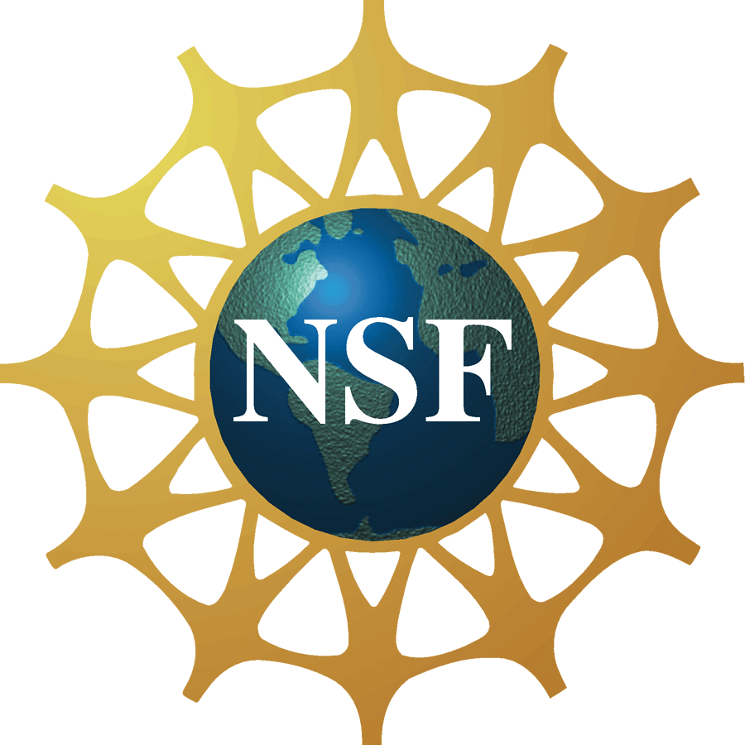

The Fantastical Discoveries of Astronomy made possible by

the Wonderful Properties of II-VI Materials

Dr. Jim Beletic
Senior Director of Space & Astronomy at Teledyne Imaging Sensors
Monday, March 26, 2012, 11:00 am – 12:00 pm, Innovation Center, Room 1600
Cookies & Coffee at 10:30 am
Presentation will be broadcast at: https://connect.rit.edu/dvw


Abstract
The universe is an amazingly huge place. While humankind has directly explored Earth’s sister planets with space probes, we don’t have the means to venture beyond the solar system, and so almost all information about the universe comes from sensing light that happens our way. Astronomy is constantly striving to find better ways to sense the feeble amount of energy from distant stars and galaxies. This quest has led to a new generation of very large telescopes on the ground and the deployment of the 2.4-meter Hubble telescope in space. Ground-based astronomy will soon begin construction on even more ambitious extremely large telescopes (ELTs), and the James Webb Space Telescope’s 6.5-meter mirror will launch by the end of the decade. Possibly more important than the development of bigger telescopes is the rapid advancement in solid state detector technology. The detector revolution was led by silicon CCDs (IV material), but II-VI materials (HgCdTe) developed in the past two decades for sensing infrared light have made the most significant difference in astronomy. Infrared light is the only way to study a wide range of astronomical phenomena. This talk will present the cutting edge astronomy that is made possible by the wonderful properties of II-VI materials.

About the Speaker
Dr. Beletic is Senior Director of Space & Astronomy at Teledyne Imaging Sensors, a strategic business unit of Teledyne Scientific & Imaging, LLC. He has over 25 years of experience in astronomical instrumentation, with specialization in visible and infrared image sensor technologies. His career is a unique combination of international work experience that includes leadership positions at the world’s foremost astronomical observatories and an industry leader in infrared sensors (Teledyne), and scientific positions at major research centers (Harvard University, MIT Lincoln Laboratory, Georgia Tech Research Institute). During his career, his teams have developed and delivered imaging sensors that are used at more than 30 of the most advanced telescopes on ground and in space. In recognition for his work in astronomy, an asteroid has been named after him. Fortunately, that asteroid has minimal chance of hitting the Earth.

About the Detector Virtual Workshop
The Detector Virtual Workshop is a year-long NSF-funded program dedicated to the advancement of UV/O/IR detectors. It brings together people from around the world to discuss detector technologies. For more information, visit http://ridl.cfd.rit.edu/ and click on the DVW tab.

