 | The Center for Detectors presents a talk in the Detector Virtual Workshop | 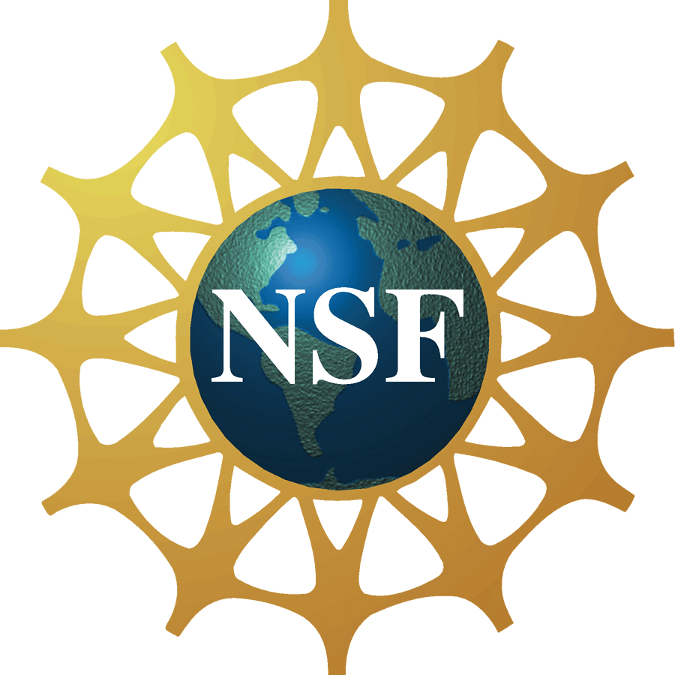

Nano-injection Detectors and Imagers

Hooman Mohseni
Director, Bio-inspired Sensors and Optoelectronics Lab (BISOL)
Northwestern University
Friday, July 13, 2012, 4:00 pm – 5:00 pm, Innovation Center, Room 1600
Cookies & Coffee at 3:30 pm
Presentation will be broadcast at: https://connect.rit.edu/dvw
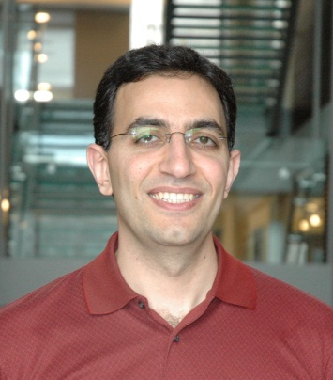

Abstract
Traditional semiconductor photon detectors are based on layered heterostructures without a significant geometrical variation along lateral directions. In contrast, we have developed a detector that exploits the additional degrees of freedom offered by a three-dimensional geometry, and utilized a detection and amplification method that is inspired by single-photon detection mechanism of the rod cells in the eye. In this talk, I present a review of the results we have achieved with our bio-inspired “Nano-injection” detector over the past six years. These include detailed explanation of the concept, evaluation of single-element devices to understand the physics of this device, and demonstration of the first nano-injection imaging arrays. In particular, I will explain the reasons for unusually low noise of the device at a high internal gain, the sub-volt operation, and the source of extremely good timing jitter. The impact of this new detector on infrared imagers will also be presented. Specifically, I will present the superior signal-to-noise ratio of our first imagers, and the anticipated benefits to infrared imagers with very small pixel size and/or high frame rates.

About the Speaker
Hooman Mohseni joined Northwestern University in 2004. He is the director of the Bio-inspired Sensors and Optoelectronics Lab (BISOL), and Northwestern’s Solid-state and Photonics Initiative. Prior to that he was at Sarnoff Corporation, where he led several government, domestic, and international research projects. He is a recipient of the National Science Foundation’s CAREER Award in 2006, and the Young Faculty Award from Defense Advanced Project Agency (DARPA) in 2007. He was selected by NSF as a US delegates in the US-Japan Young Scientist Exchange Program on Nanotechnology in 2006, and the US-Korea Nano-manufacturing Exchange program in 2007. He has served as the Advisory Board, Program Chair and Co-chair in several major conferences including IEEE Photonics, SPIE Optics and Photonics, and SPIE Security and Defense. Dr. Mohseni has published over 110 peer-reviewed articles, and holds 13 issued US and International patents on novel optoelectronic devices and nanoprocessing. He has presented more than 42 invited and keynote talks at different commercial, government, and educational institutes. He is a Fellow of SPIE, and Senior Member of IEEE.

About the Detector Virtual Workshop
The Detector Virtual Workshop is a year-long NSF-funded program dedicated to the advancement of UV/O/IR detectors. It brings together people from around the world to discuss detector technologies. For more information, visit http://ridl.cfd.rit.edu/ and click on the DVW tab.

