 | The Center for Detectors presents a talk in the Detector Virtual Workshop | 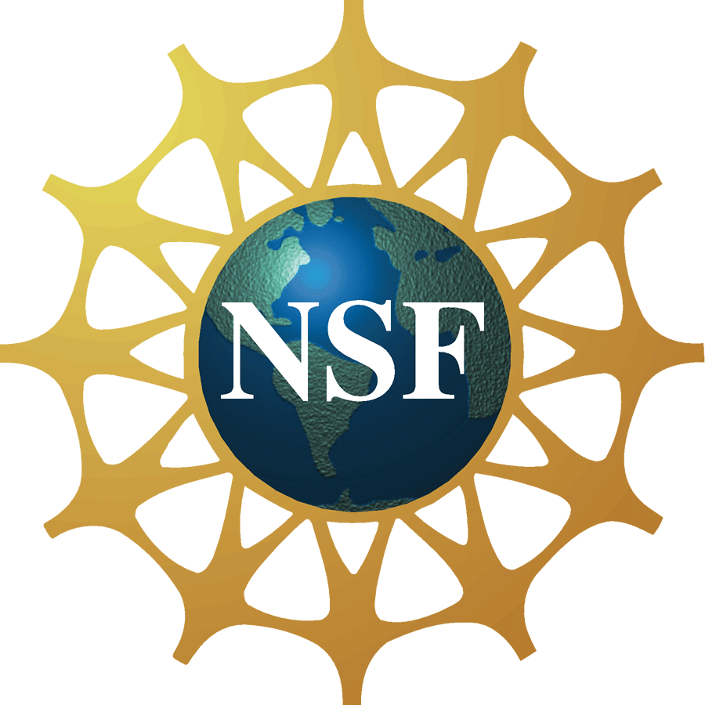

Electron Multiplying Charge Coupled Devices

Professor Craig Mackay

Professor in Image Science in the Institute of Astronomy

University of Cambridge, UK
Monday, Dec 5, 2011, 11:00 am – 12:00 pm, Innovation Center, Room 1600
Cookies & Coffee at 10:30 am (Please note that Dr. Mackay’s presentation will be shown virtually at this location, the actual presentation will not take place on the RIT campus.)
Presentation will be broadcast at: https://connect.rit.edu/dvw
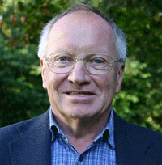

Abstract
Almost as soon as CCDs were invented, astronomers have dreamed of devices with negligible readout noise. Electron Multiplying CCDs (EMCCDs) offer this for the first time even at high read-out speeds and have the potential to count individual photons. These devices have most of the highly desirable characteristics of modern CCDs such as high quantum efficiency, excellent uniformity and freedom from defects. For many applications in astronomy, there remain significant advantages in using standard devices but there are some applications which are beginning to be important where their characteristics offer the chance to design and build new classes of instrument. This talk will look at where these devices should or should not be used and then go on to describe what has to be done to get the very best out of them. There are significant differences between camera systems designed for general application and those which are optimised to give the very best ultralow signal performance in photon counting mode. How the best performance is achieved and what needs to be done to maintain it will be described in this talk. Examples of the data obtained and scientific results achieved with photon counting EMCCDs will be given.

About the Speaker
Craig Mackay has worked in the general area of scientific imaging systems for many years. He was a member of the Hubble Space Telescope Faint Object Camera team and worked for many years with CCD detectors. In 1985 he formed AstroCam Ltd that is now part of PerkinElmer Life Sciences. While in AstroCam, he developed automated DNA sequencers, protein electrophoresis systems, transmission electron microscope and X-ray imaging systems. He has been an innovator and leader in the development of ultra low light imaging systems both in the visible and the infrared. He has been involved in developing Lucky Imaging systems for astronomy that allow diffraction limited imaging to be obtained from the ground for the first time without use of adaptive optics. Most recently he has combined Lucky Imaging with low order adaptive optics to obtain the highest resolution images ever taken in the visible or the infrared either from ground or from space.

About the Detector Virtual Workshop
The Detector Virtual Workshop is a year-long NSF-funded program dedicated to the advancement of UV/O/IR detectors. It brings together people from around the world to discuss detector technologies. For more information, visit http://ridl.cfd.rit.edu/ and click on the DVW tab.

