 | The Center for Detectors presents a talk in the Detector Virtual Workshop | 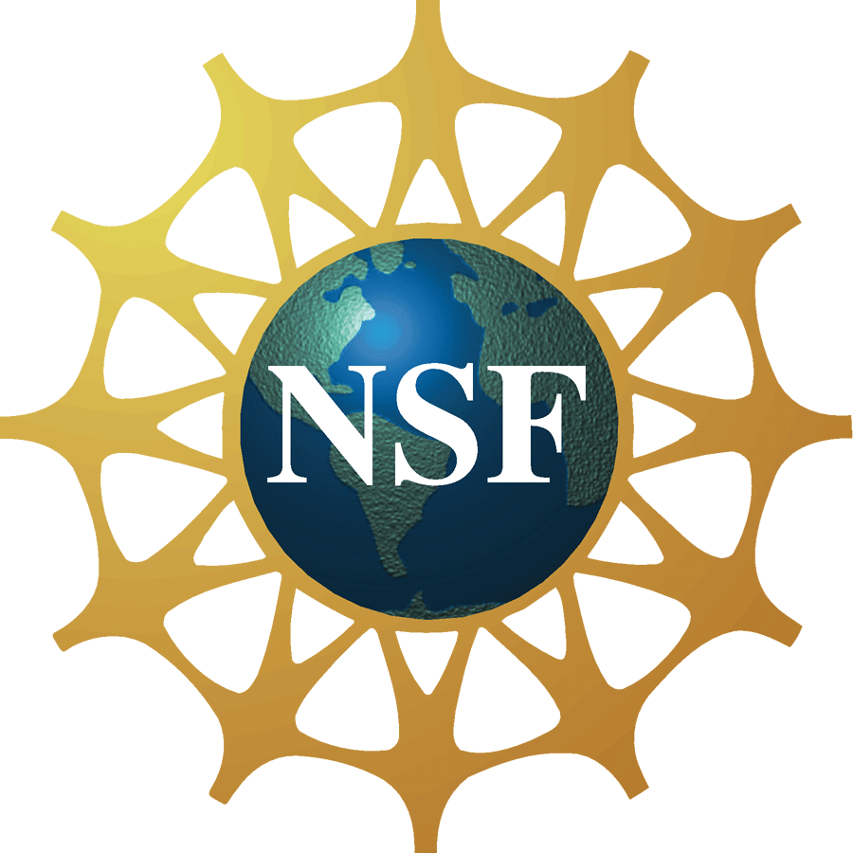

Reducing the Read Noise of the James Webb Space Telescope

Near Infrared Spectrograph Detector Subsystem

Dr. Bernard Rauscher
Astrophysicist, NASA Goddard Space Flight Center

(Please note that Dr. Rauscher’s presentation will be shown virtually at this location, the actual presentation will not take place on the RIT campus.)
Monday, February 6th 2012, 11:00 am–12:00 pm, Innovation Center, Room 1600
Cookies & Coffee at 10:30 am
Presentation will be broadcast at: https://connect.rit.edu/dvw
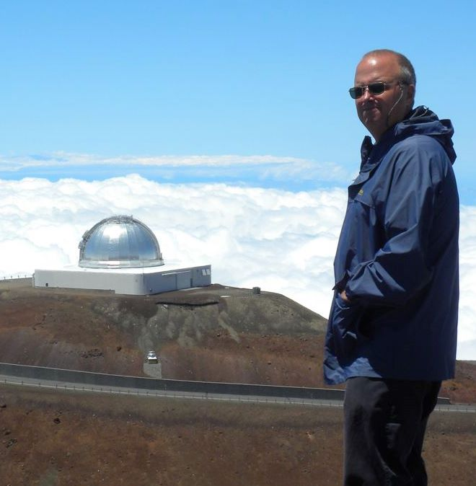

Abstract
We describe a Wiener optimal approach to using the reference output and reference pixels that are built into Teledyne's HAWAII-2RG detector arrays. In this way, we are reducing the total noise per ~1000 second 88 frame up-the-ramp dark integration from about 6.5 e- rms to roughly 5 e- rms. Using a principal components analysis formalism, we achieved these noise improvements without altering the hardware in any way. In addition to being lower, the noise is also cleaner with much less visible correlation. For example, the faint horizontal banding that is often seen in HAWAII-2RG images is almost completely removed. Preliminary testing suggests that the relative gains are even higher when using non flight grade components. We believe that these techniques are applicable to most HAWAII-2RG based instruments.

About the Speaker
Dr. Rauscher is a Civil Service experimental astrophysicist at NASA Goddard Space Flight Center (GSFC) where he is the James Webb Space Telescope (JWST) Detector Scientist, JWST Integrated Science Instruments Module (ISIM) Deputy Project Scientist, and Principal Investigator for the JWST Near Infrared Spectrograph Detector Subsystem. Dr. Rauscher has served as Principal Investigator for numerous sub-orbital projects developing and testing next-generation and photon-counting detectors for space and ground applications. He has over 20 years of experience, including hands-on testing of Teledyne HAWAII-4RG, HAWAII-2RG, HAWAII-1RG, HAWAII-1R, NICMOS-3, NICMOS-2, and 64×64 pixels Rockwell PANIC detectors, and Raytheon SB304, SB290, and ALADDIN detectors. His primary research interests are infrared astronomy instrumentation and the nature of Dark Matter and Dark Energy in the Universe.

About the Detector Virtual Workshop
The Detector Virtual Workshop is a year-long NSF-funded program dedicated to the advancement of UV/O/IR detectors. It brings together people from around the world to discuss detector technologies. For more information, visit http://ridl.cfd.rit.edu/ and click on the DVW tab.

