 | The Center for Detectors presents | 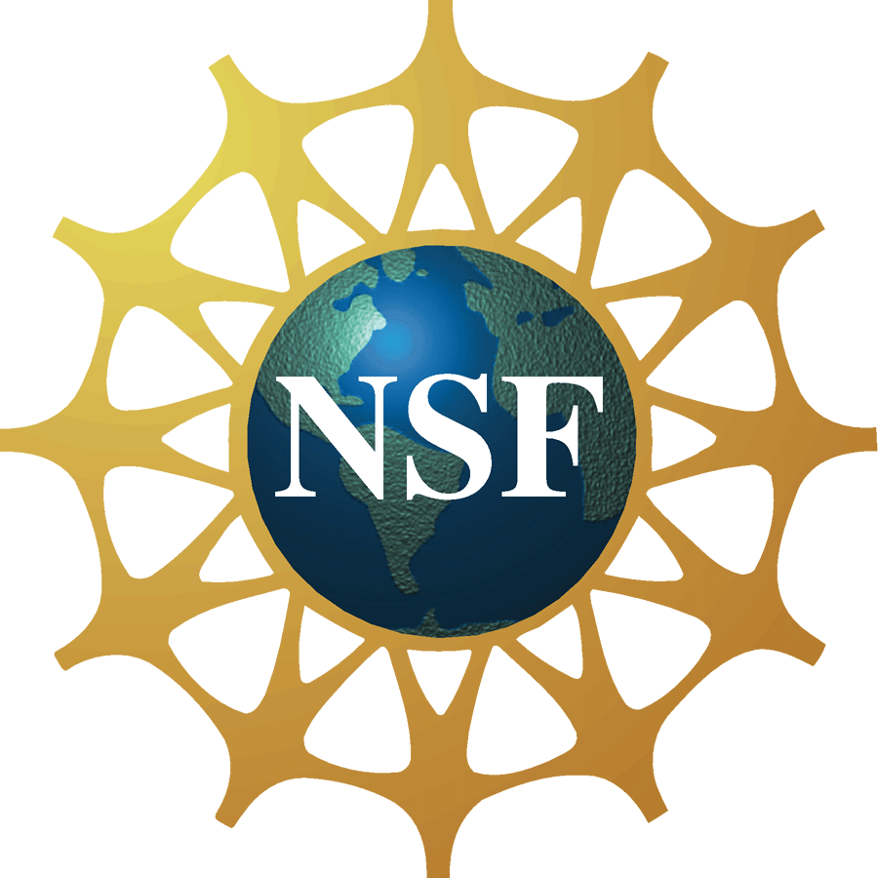

Rise of the machines: Robo-AO and the evolution of adaptive optics

Christoph Baranec
Senior Postdoctoral Scholar in Astronomy
California Institute of Technology
Wednesday, November 7, 2012, 2:00 pm – 3:00 pm
Building 76, Room 1275


Abstract
Robo-AO is the first autonomous laser adaptive optics system and science instrument operating on sky. It is able to robotically execute large scale surveys, monitor long-term astrophysical dynamics and characterize newly discovered transients, all at the visible diffraction limit. The first of many envisioned systems is finishing a 30-night science demonstration period at the Palomar Observatory 1.5-m telescope while supporting 7 other competitively selected programs in the 2012B semester. A low-noise wide field infrared imager and tip-tilt sensor will be added to the system in mid-2013 to widen the spectral bandwidth and increase available sky coverage while enabling deeper visible imaging using adaptive-optics sharpened infrared tip-tilt guide sources. A review of the instrument, capabilities and current science programs will be presented.

About the Speaker
Christoph Baranec is a Senior Postdoctoral Scholar in Astronomy at the Caltech Optical Observatories, California Institute of Technology. He holds a PhD in Optical Sciences from the University of Arizona (2007), and a BS in Astronomy from the California Institute of Technology (2001).

