The RIT Center for Detectors and the
Astrophysical Sciences And Technology PhD Program
Present:
IR Instrumentation as Probes of
AGN & Their Host Galaxies
Dr. Chris Packham

Associate Scientist, Astronomy Department, University of Florida

Monday, December 13, 2010
4:00 – 5:00 PM
Building 76, 1275

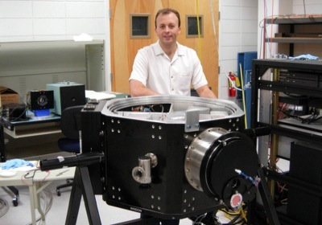
Presentation will be broadcast at: https://connect.rit.edu/ridl

Abstract: In the next decade, IR astronomy is poised to continue its rapid pace of discovery. From planet searches and debris disks to AGN and cosmology, new IR optimized telescopes, instruments and techniques will hasten the pace of progress in these and many other areas. Perhaps one of the most exciting projects in the coming decade is the TMT, and RIT is in an exemplary position to capitalize on their capabilities and reputation in order to help develop outstanding IR instruments for the global TMT community. I discuss recent, near and medium-term future IR instrumentation for large and/or advanced telescopes I am involved in, operating in the 1-25µm wavelength region. The international science team that I lead offers crucial guidance and drive to my instrumentation work, and I present our goals and results as a way to introduce the capabilities afforded by these instruments through close synergies between science and instrument teams.
Speaker Bio: Chris Packham received his Ph.D. from the University of Hertfordshire (UK) based on IR polarimetry of Active Galactic Nuclei (AGN). He then took a short term fellowship at the NAOJ (Tokyo, Japan), working with staff who were constructing instruments for the 8.2m Subaru telescope. He then moved to the Isaac Newton Group of Telescopes (ING, Spain; formally part of the RGO, University of Cambridge, UK) where he was the PI for a 1-2.5µm adaptive optics optimized camera for the 4.2m WHT. In 2000, he moved to the University of Florida, where he has been/is PI or deputy-PI for both near-IR (1-5µm) and mid-IR (7.5-25µm) instruments for Gemini, MMT and the GTC. He is currently working on a TMT-based mid-IR instrument with Japanese and Hawaiian colleagues and pursuing AGN research with an international group of astronomers.

