Searching for Life Beyond Earth with Single-Photon Sensing CMOS Image Sensors
Are we alone in the universe? This age-old question has driven scientific exploration for centuries. If life on other planets evolves similarly to life on Earth, it can imprint its presence in atmospheric spectral signatures, i.e., biosignatures. These include absorption lines in the spectrum produced by oxygen, carbon dioxide, methane, and other constituents. NASA’s next astrophysics flagship mission, the Habitable Worlds Observatory (HWO), will seek to find biosignatures in spectra of exoplanet atmospheres, establishing that we are not alone in the universe.
HWO will need highly sensitive detector technology to do this. The Single-Photon Sensing CMOS (SPSCMOS) image sensor is a promising technology for this application. It detects and resolves photon number, a feat made possible by the use of a low-capacitance floating diffusion sense node. SPSCMOS pixels are at TRL 5, have dark current of <0.0004 e⁻/pix/s below 250 K, a median read noise of 0.2 e⁻, and are radiation tolerant.
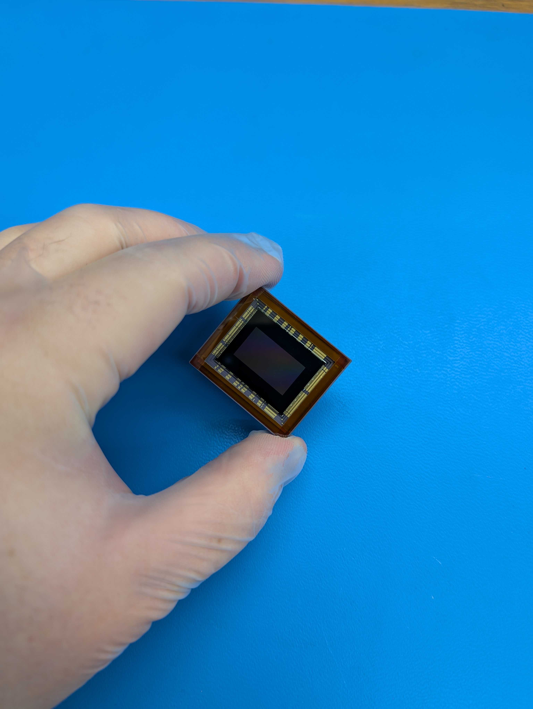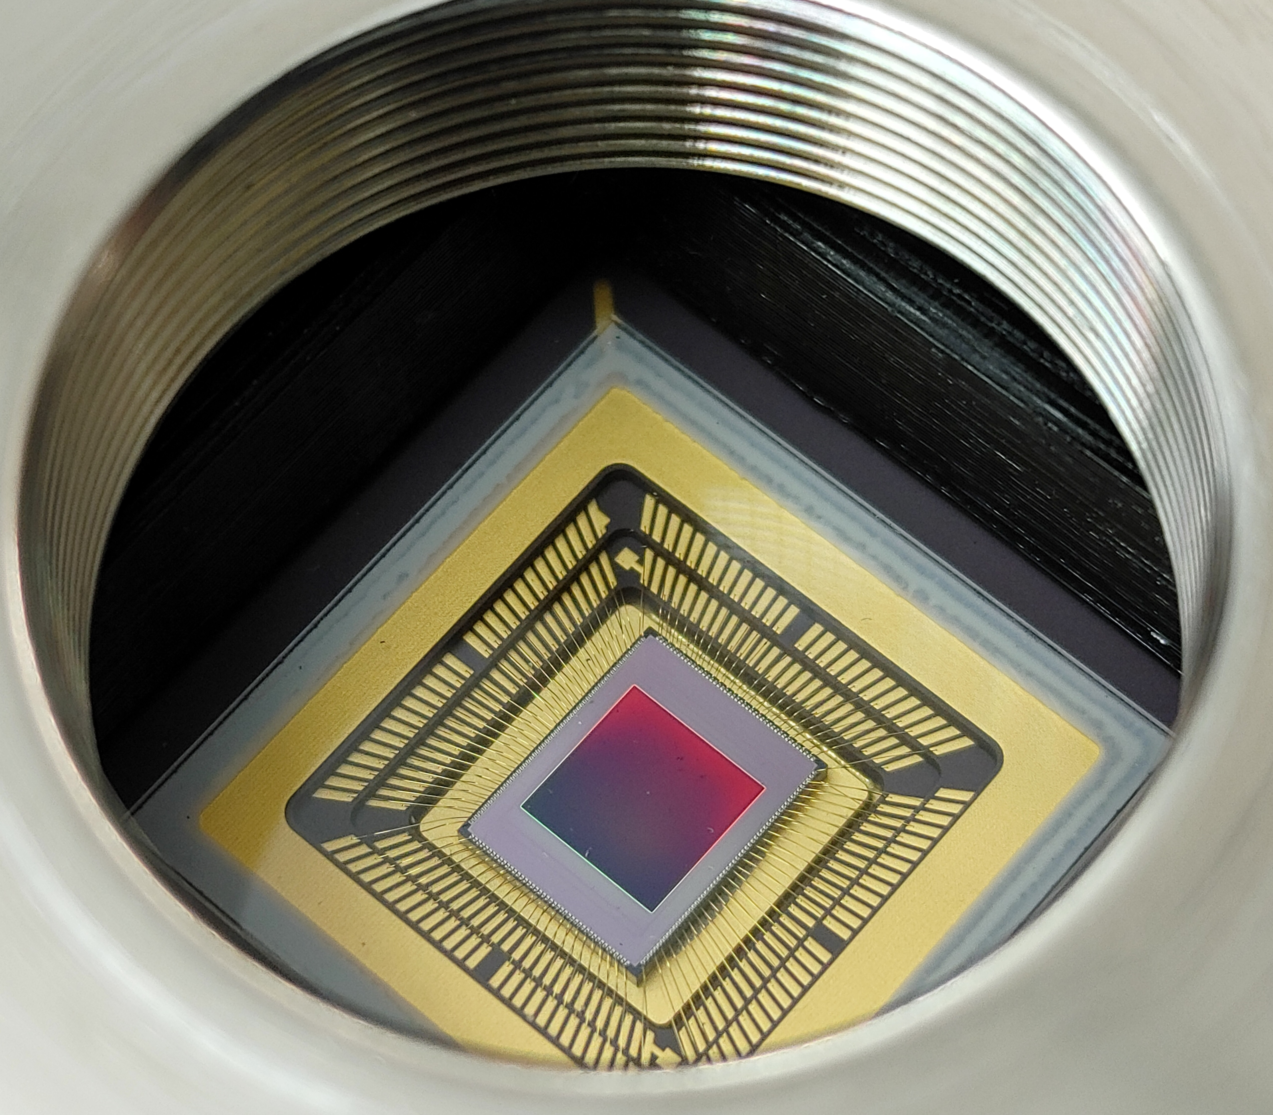
Photos of single-photon sensing and photon-number resolving CMOS image sensors: a 9.4 Mpixel sensor (left) and a 16.7 Mpixel sensor (right). (Image credit: CfD, RIT)
Alt text: Close-up images of two CMOS image sensors. One sensor is held between a researcher’s fingers, while another is mounted inside a camera housing.

Fairchild Imaging and Gigajot Technology are making commercial versions of these sensors, with formats ranging from 1 to 163 megapixels. The manufacturers use a standard CMOS silicon foundry process, such as 45 nm/65 nm stacked 3D integration, and use on-chip digitization to enable compact, lightweight, and power-efficient instruments—key advantages for space missions.
SPSCMOS sensors operate similarly to traditional CMOS active pixel sensors. Incoming photons enter the sensor’s backside, producing free charge that accumulates in a storage well. The charge to a floating diffusion sense node that generates a voltage at the gate of a source-follower FET, which in turn is connected to an amplification and digitization circuit. An inline circuit for correlated multiple sampling is included to eliminate reset noise and 1/f noise.
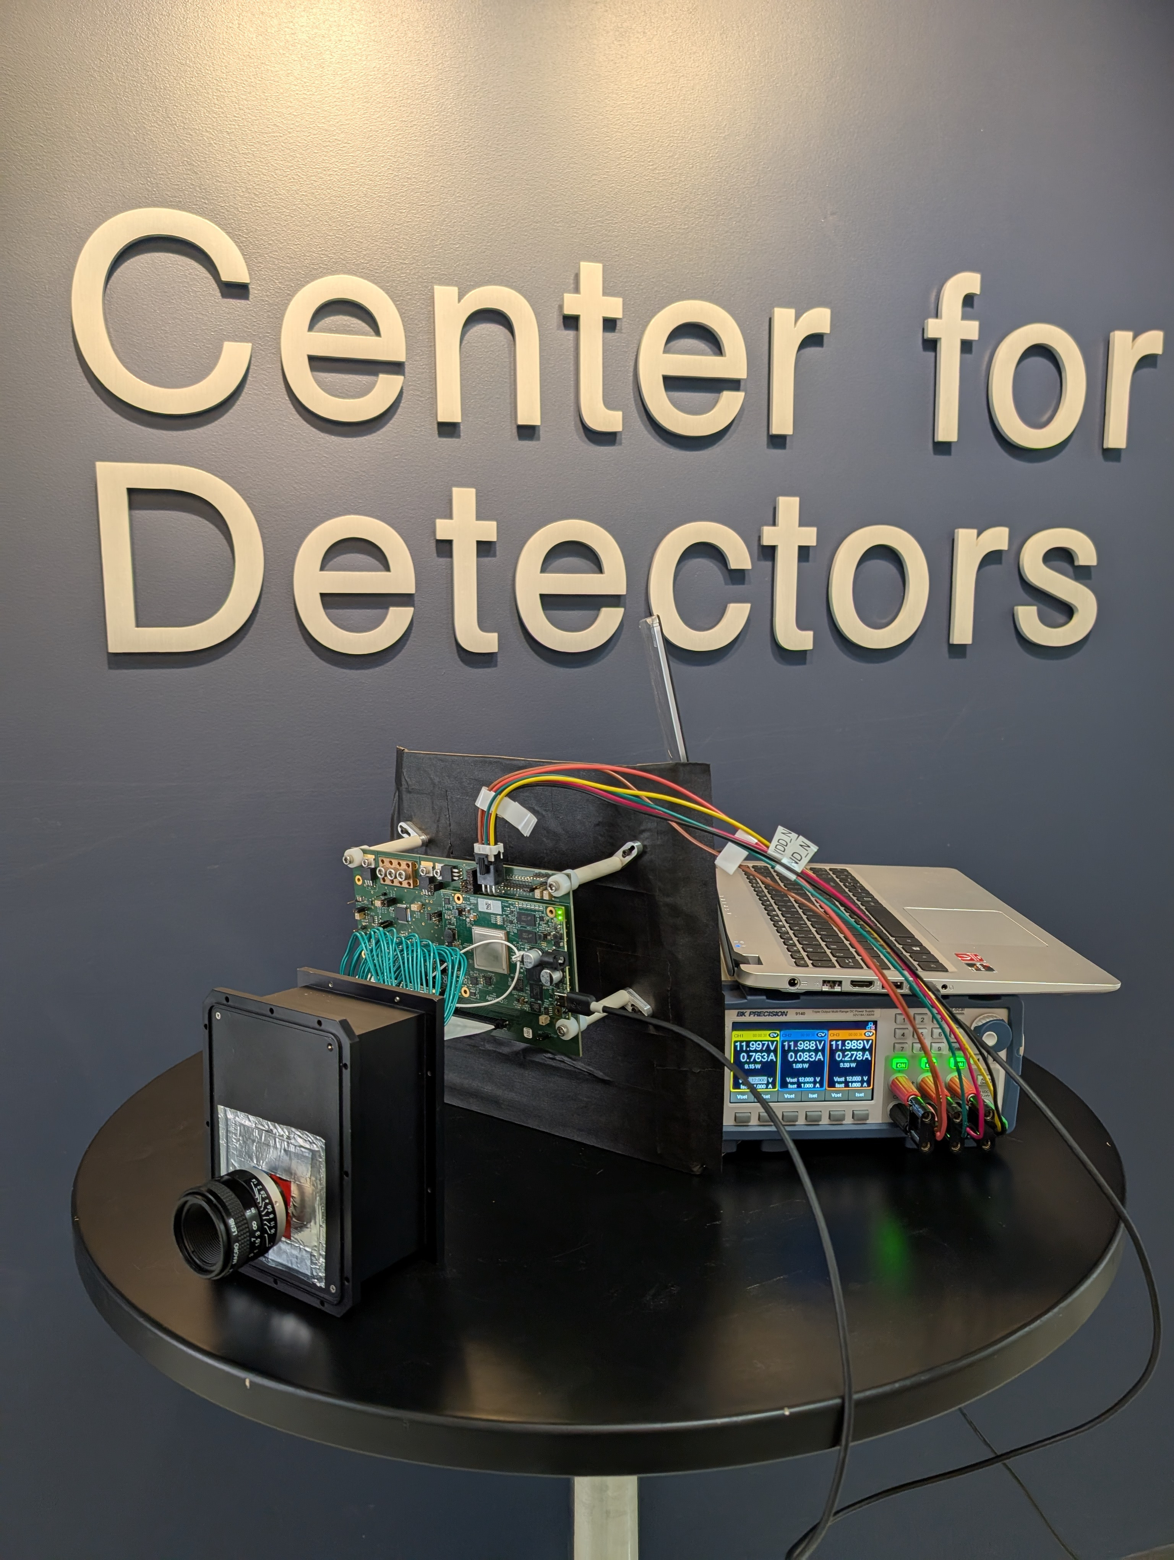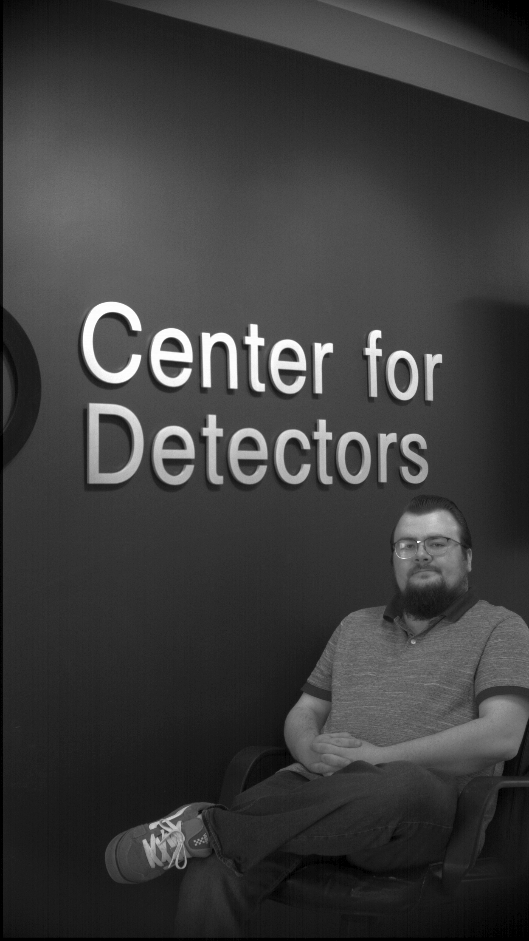
The two figures show one configuration of acquisition electronics system for SPSCMOS devices and digital FPAs (left), and an image captured using this system (right). (Image credit: CfD, RIT)
Alt text: Left: An acquisition electronics system on a table, including a sensor in a black box, a laptop, and interconnected cables. Right: A CfD staff member standing in front of the CfD sign.
A research team at the Rochester Institute of Technology’s Center for Detectors (CfD) is accelerating the readiness of SPSCMOS sensors through a detector technology development program funded by NASA’s Strategic Astrophysics Technology and Early Stage Innovations programs. This development program has multiple components:
- Performance Characterization: measuring critical metrics like dark current, quantum efficiency, and read noise under various temperature conditions
- Radiation Test Programs: exposing sensors to high-energy radiation to assess long-term reliability in sensors and on-chip circuits
- Detector Readout and Operational Enhancements: developing new readout modes to mitigate effects from short-term and long-term radiation damage
- Near-Infrared (NIR) Sensor Prototyping: modeling SPSCMOS devices for NIR wavelengths using TCAD software
- On-Sky Testing: deploying sensors in ground-based telescopes to validate their performance in the field
To evaluate detectors for future space missions, the team will expose detectors to space-like high-energy radiation and measure detector behavior in order to determine how the radiation affects performance. The team has already shown that the devices tested so far have remarkable resilience in space-like conditions. There is little-to-no performance degradation after exposure to 50 krad(Si) of 60 MeV protons, equivalent to ten JWST mission lifetimes. SPSCMOS sensors, unlike electron-multiplying CCDs (EMCCDs), one need one charge transfer to convert the charge to a voltage, and are thus resistant to radiation-induced charge transfer inefficiencies and failures in gain amplification registers, enhancing their robustness for long-duration missions.
The two figures show results for SPSCMOS devices. The figure on the left shows a photon counting histogram with peaks that correspond to photon number. The figure on the right shows the dark current for a SPSCMOS device before and after exposure to 50 krad of 60 MeV protons. (Image credit: CfD, RIT)
Alt text: Scientific graphs analyzing SPSCMOS sensor performance. The left graph illustrates discrete photon detection peaks, while the right graph compares sensor dark current before and after radiation exposure.
In January 2025, a team of researchers led by RIT PhD student, Edwin Alexani, brought an SPSCMOS-based camera to the C.E.K. Mees Observatory for on-sky validation. The team captured data for M36, an open star cluster located 4,100 light-years away using Johnson color filters, and a narrow-band H-alpha filter to take advantage of the camera’s low read noise.
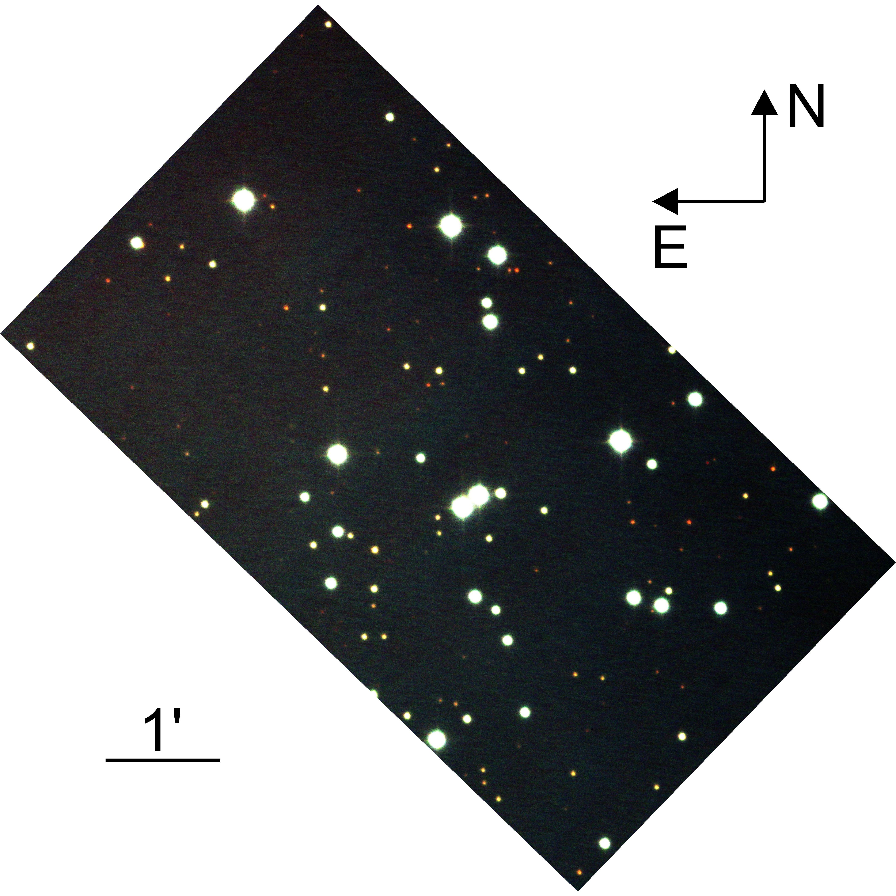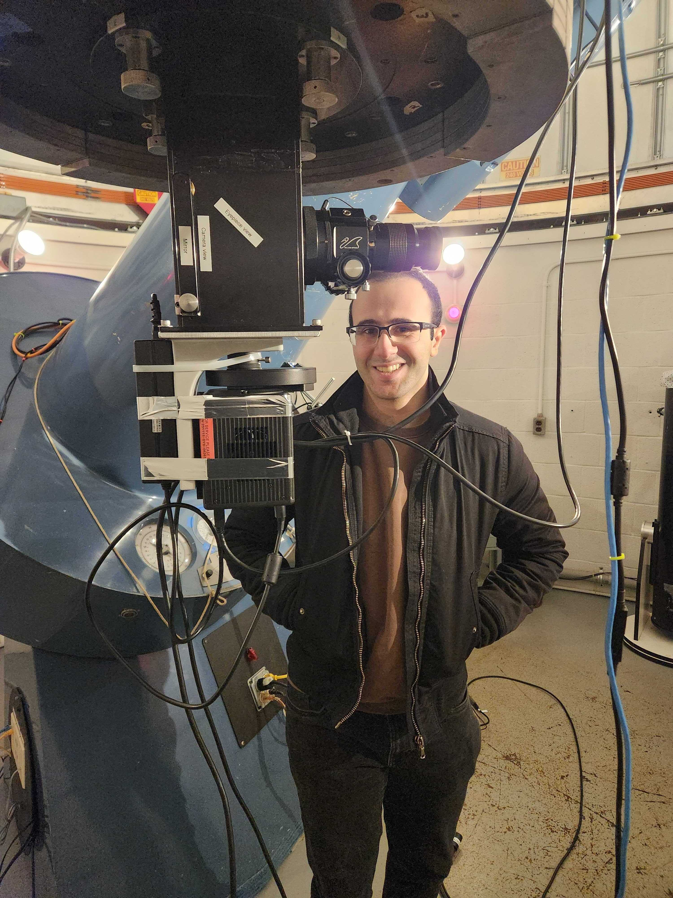
The panels show photos taken at the C.E.K. Mees Observatory. The color image shows M36 in the Johnson B (blue), V (green), and R (red) bands (left). The image on the right shows Edwin Alexani and the SPSCMOS camera (right). (Image credit: CfD, RIT)
Alt text: Left: A star field image of M36, showing bright white and dim red stars, with arrows indicating North and East for orientation. Right: Researcher Edwin Alexani stands behind a black camera with a filter wheel, mounted below a telescope.
As NASA advances the HWO mission concept, SPSCMOS technology stands as a game-changer in exoplanet and general astrophysics research. These sensors will enhance our ability to detect and analyze distant worlds, bringing us one step closer to answering humanity’s greatest question: Are we alone?
For additional details, see the entry for the first completed project on NASA TechPort.

Project Lead(s): Dr. Donald F. Figer, Future Photon Initiative and Center for Detectors, Rochester Institute of Technology (RIT)

Sponsoring Organization(s):
- NASA Science Mission Directorate (SMD), Astrophysics Division, Cosmic Origins Program, Strategic Astrophysics Technology (SAT) Program
- NASA Space Technology Mission Directorate (STMD), Early Stage Innovations (ESI) Program

