CNC control box English manual
(Parallel interface section)
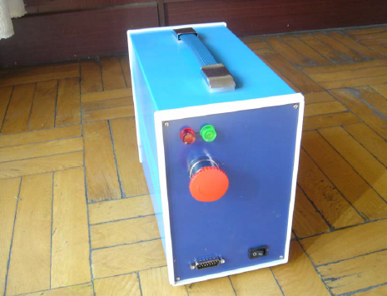

A. Introduction:
The control box includes a TB6560AHQ axis drive board, a 24V5A switching power supply (if drive current is too big, it can be replaced 24V10A switching power supply), the machine transformer + 1 set rectifier bridge.
You can control the following drive current 3A stepper motor and 200W spindle or spindles under 200W , and this can support the use of our small engraving machines. Control by MACH or KCAM software system.

NOTE: Only after the control box connected to the computer parallel port cable , then you can power the machine up and test it.Forbid turning the power on before connecting the parallel line, so the motor may work by no malfunction rules.

B.External interface function:
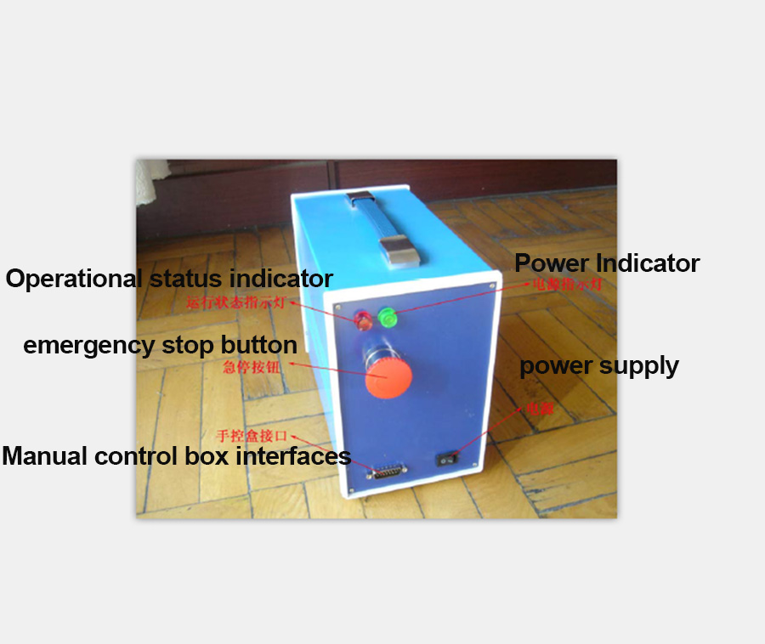

1. Power switch: Press the "-" Turn on the power position, "O" position to turn off the power,
Recommend turn off the power in time when engraving machine is not running.

2. Hand control interface: You can access our shop selling hand control box, attention when using the hand control box, because of the automatic half current function does not work, so the stepper motor will heat in a high temperature,when computer control automatic half current function, the stepper motor heat is much smaller. So the manual control box can’t open for a long time,remember to turn it off when you don’t use it.
3. the power indicator: When the power switch on, the lights shine, after turned off the power switch,the LED off.

4. Working indicator: When using a parallel port, the light does not shine, only when use USB connection it will shine.

5. emergency stop button: When engraving machine work, occur ing abnormal situation, press the button , then engraving machine can immediately stop working, but the processing of the workpiece is generally no longer continue to work. Just press the stop button once, the software receives the signal can stop,the stop Button itself is not self-locking.
Warning: Press the "stop button" or click the "emergency stop"on the software interface,remember turning off the power switch, and then do the manual operation within the scope of the table, so as to avoid each motor malfunction and cause personal injury!

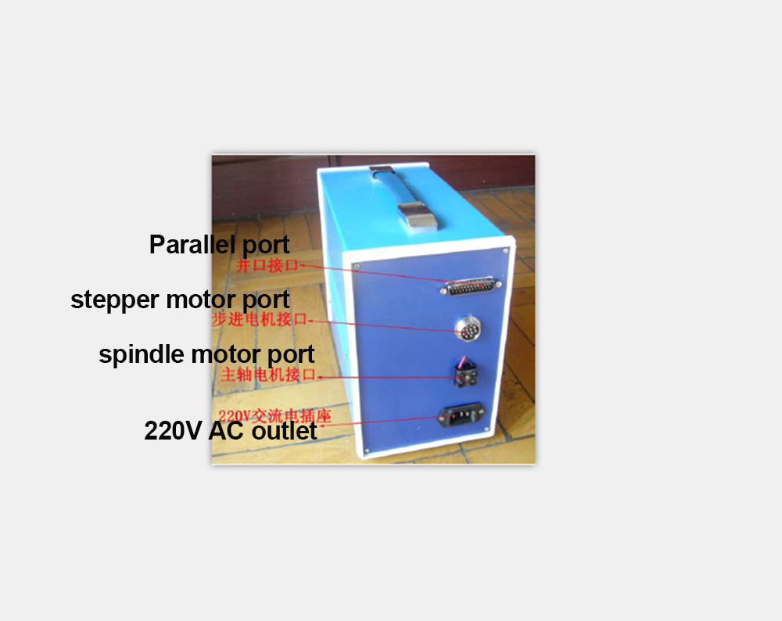

6.220V AC outlet: use a common three-pin D-type power supply socket, then connect AC 220V Power supply to the control box.

7.Spindle motor interface: Loosen the two screws below, insert the spindle motor wire and tight it,if the motor rotation direction is wrong, you can swap the two thread about the motor
,it reversed the direction of rotation.

- Stepper motor interface: Using high-reliability 12-core plug, connect to three under 3A drive current of the stepping motor, aviation plug 1,2 feet to the X-axis motor A +, A-,3,4 feet to B +, B-; 5,6 feet to the Y-axis motor A +, A-, 7,8 feet to B +,B-; A 9,10 feet to the Z-axis +, A-, 11,12 feet to B +, B-.

- Parallel Interface: Using refined parallel lines, connected to a computer parallel port (parallel definitions of each foot can refer to page 6 )

C.Internal boards Description
TB6560AHQ 3-axis stepper motor driver board Instructions

The board appearance chart as shown below:

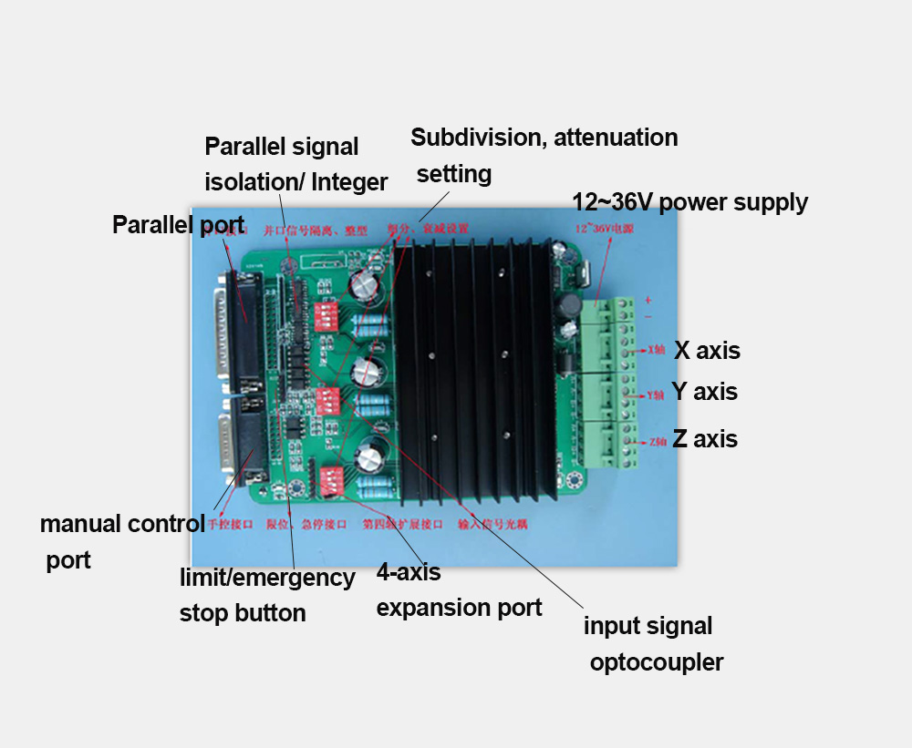

Basic functions:
1, All double bridge MOSFET driver, the maximum pressure is 40V, maximum drive current is 3A, peak :3.5A,Built-in temperature protection and overcurrent protection.

2, The output of a standard three-axis drive, and a 4-axis expansion interface, so user can expand 4-axis freely.

3, Equipped with a 15-pin manual control interface, you can easily connect the manual handle.

4, Semi-automatic flow control function, motor semiflow locked in the absence of a driving pulse, which can effectively protect the Stepper motor, save energy and prolong the life of the stepper motor.

5, Four gear subdivision settings: full step, 1 / 2,1 / 8,1 / 16, three DIP switches can be set separately
Step number of three axes is subdived.

6, limit expansion interface, you can connect the limit switch, when it reaches the limit position in each axis, stop automatically, so you can ease of use it, instesd of worrying about damaging the engraving machine.

- The spindle control interface, you can control the opening and closing of the spindle relay to control spindle start and stop.

- Single power input, just enter a 12 ~ 40V power supply for operation, on-board 5V power conversion integrated circuit.

Special equipments:
1.The computer parallel port signal drive capability is weak, the output level of instability, and the high voltage output of a different motherboard is not uniform. Our driver board has 74HC14 chip parallel signal shaping, make the output level to unify and improve the driving ability, avoid stepping motor lose step and unresponsive and other problems.
2.7414 isolation between PC parallel port and drive power, to prevent damaging the computer drive power flowing into the computer motherboard, CPU, hard disk and so on.
3.Black genuine large heatsink, which can effectively solve the heating problem TB6560 chip.
- Polarized capacitors except three large-capacity, all the rest tantalum capacitors to ensure stability and life.
D.Interface and their definitions:

1、25 pin parallel port control is defined as follows:
PIN1： CKE E axis pulse
PIN2： CKA A axis pulse
PIN3： CWA A axis direction
PIN4： CKB B axis pulse
PIN5： CWB B axis direction
PIN6： CKC C axis pulse
PIN7： CWC C axis direction
PIN8： empty
PIN9： empty
PIN10： DIN1 limit 1
PIN11： DIN2 limit 2
PIN12： DIN3 limit 3
PIN13： DIN4 limit 4
PIN14： CWE E axis direction
PIN15： E-Stop
PIN16： EN All axis enable
PIN17： RLY Relay control
PIN18~25： GND to ground

- Hand control 1 ~ PIN15 is defined as follows
PIN1： CKA A axis pulse
PIN2： CWA A axis direction
PIN3： CKB B axis pulse
PIN4： CWB B axis direction
PIN5： CKC C axis pulse
PIN6： CWC C axis direction
PIN7~8： empty
PIN9： CKE E axis pulse
PIN10： CWE E axis direction
PIN11： EN enable
PIN12： MOTO motor control
PIN13： VCC Power Positive
PIN14： E-Stop
PIN15： GND ground

3, the stepper motor drive suggest using 12 ~ 36V power supply , standard board has marked power of positive and negative.
- The 4-axis expansion interface, from top to bottom is defined as: EN, CW, CK, VCC, GND, spindle relay control, VCC. Spindle control interface to access "Spindle relay control, VCC" These two pins.
- Limit interface definition: 5 feet pin close to hand control interface is 1 foot away respectively from 2 to 5 feet. Wherein a pin is GND, 2 ~ 5 feet parallel port 13,12,11,10 respectively.

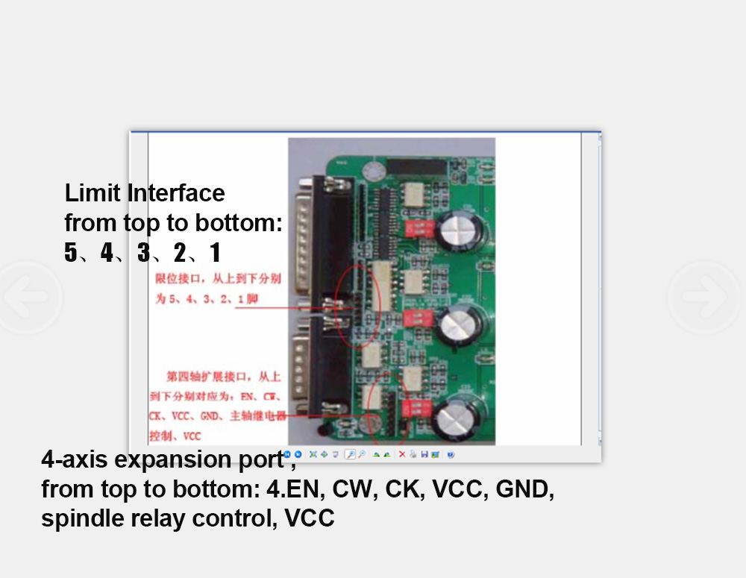

Subdivision settings:
DIP switch 1/2: ON / ON full step, ON / OF 1/2, OF / ON 1/16,
OF / OF 1/8.
Attenuation manner:
DIP switch 3/4: ON / ON fast decay, ON / OFF 25% fast decay, OFF / ON 50%
Fast attenuation, OFF / OFF slow decay.

Settings of Mach3:it can refer to the other manual:2020B encarving machine settings steps English manual.

Dear friends,
we try to translate it word by word according to the Chinese manual, and the picture is Chinaese, but I hope you can understand,
If there any mistakes,pls inform me and I will correct it , thanks in advance.

