The Instructions of the TB6560AHQ Three-axial Stepper Motor Drive Board

Surface Structure:
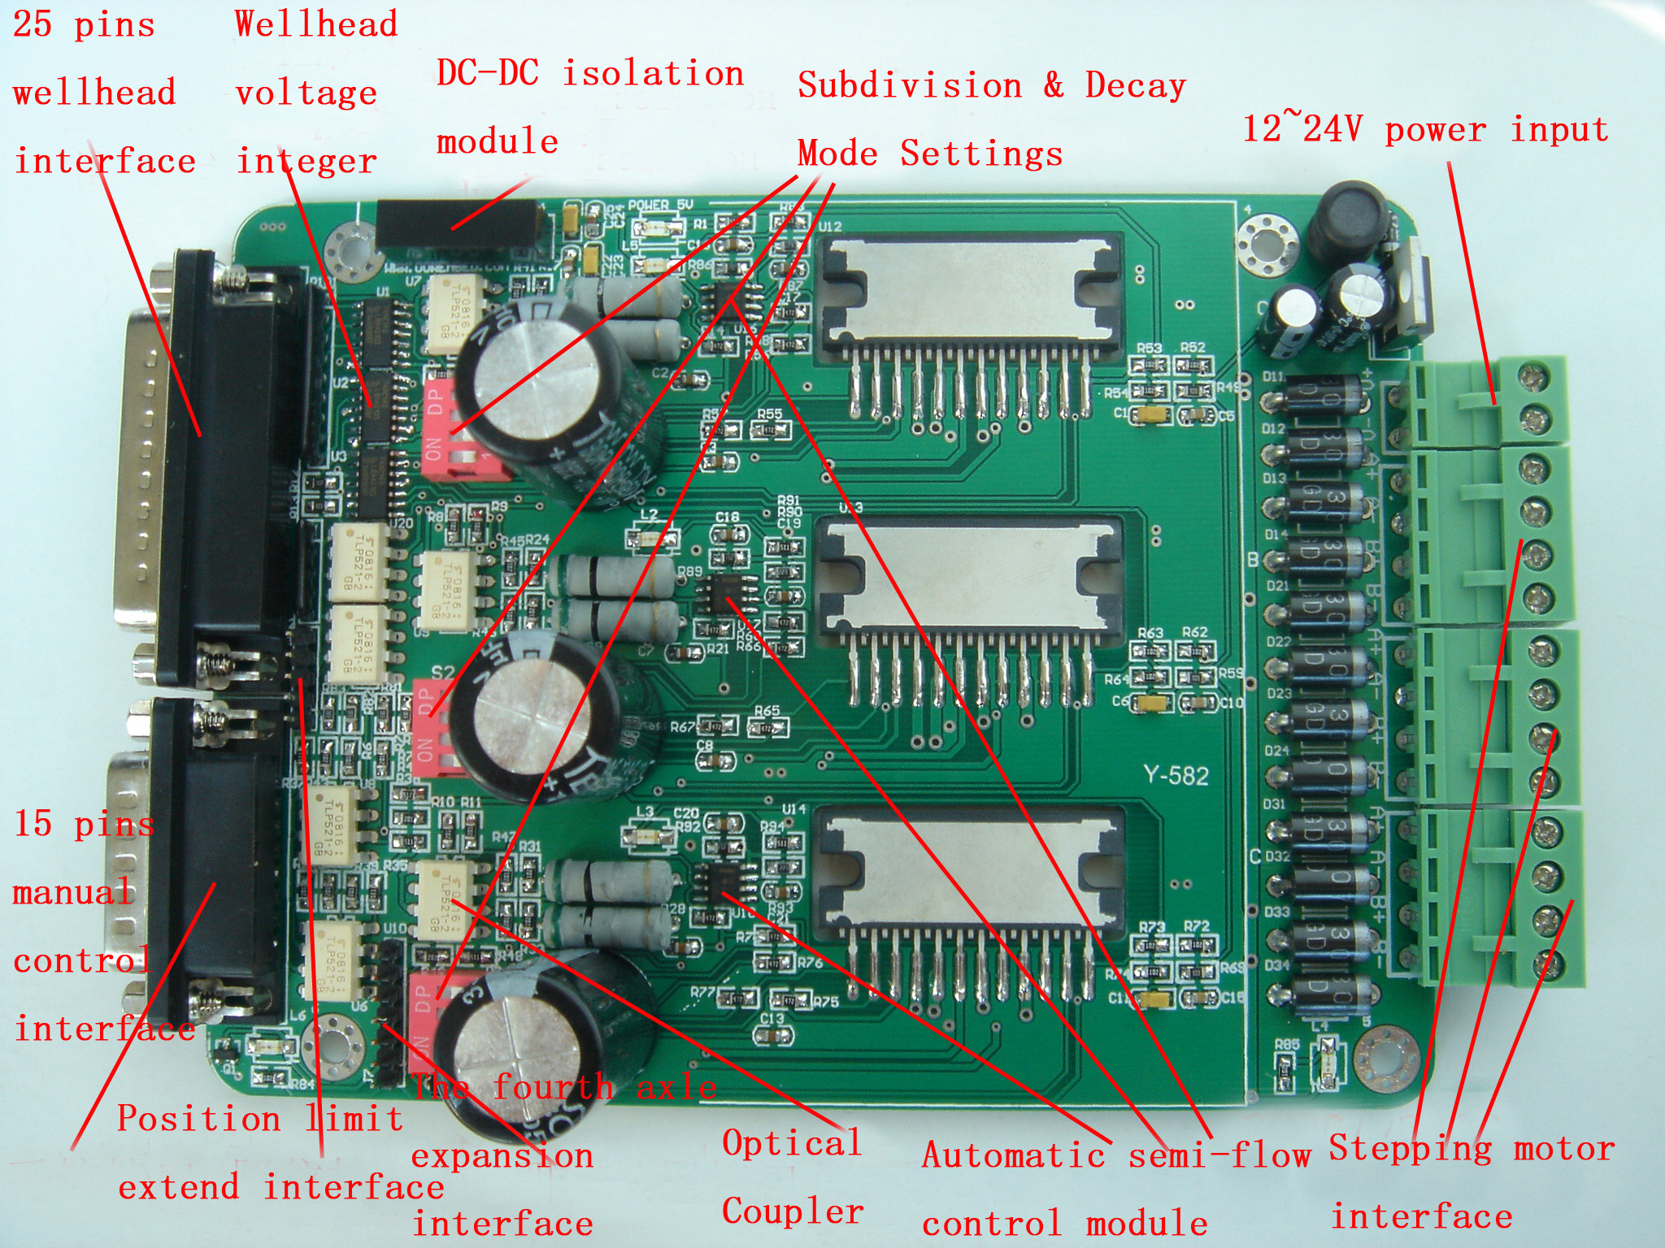

Basic Functions:
- Whole double-bridge MOSFET drive, withstanding 40V voltage, current rating of the drive is 3A, peak value is 3.5A, and there is temperature protection and over current protection in it.
- To output the standard Three-axial drives, and there is a fourth axle expansion interface, it supplies freedom for users to expand fourth axle.
- There is a 15 pins manual control interface; you can connect a manual control handle convenient.
- The function of the automatic semi-flow control can lock the motor when there isn’t drive pulse. So that the motor can be effectively protected, saving electric energy, and increase of its service life.
- Four grade subdivision setting: Synchronizing, 1/2, 1/4, 1/16. There are three Dial Switches; they can respectively set the subdivision step numbers.
- The position limit extended interface can connect with the limit switch, they can automatically sudden stop when anyone of the axle reach the limit position, so you can use it relieved and don’t care about to damage the Engraving Machine.
- The spindle controls the interface, it can OFF/ON the Spindle Relay, so then the start or stop of the spindle.
- Single power supply, they can work just input a set of 12~40V power, there is a 5V power convert circuit integrated on the board.

Special Configurations:
- The ability about parallel ports signal drive is feeble, the output level is instability and the higher level voltage that output from different main board is disunity. This drive board can reshape the parallel ports signal by 74HC14 chip, make the output level unite and increase the drive ability, to avoid the motor’s desynchronizing, the situation of no response and so on.
- There is an Optical Coupler to separate the parallel ports and the drive power, to prevent the drive power flow into the computer and damage the main board, cup and hard disk.
- In the front and back of the Optical Coupler, there is a DC-DC isolator to separate power, so that they can prevent your computer from damage of high voltage efficaciously.
- With the huge, black certified goods fin, they can solve the heating problem of the TA8435 chip efficaciously.
- Except three large capacity heteropolarity capacitance, others are all tantalum capacitors, they can ensure stable performance and long service life.

Interface and their definition:

- The 25 legs use parallel ports control definite below:
PIN1: CKE E axle pulse
PIN2: CKA A axle pulse
PIN3: CWA A axle direction
PIN4: CKB B axle pulse
PIN5: CWB B axle direction
PIN6: CKC C axle pulse
PIN7: CWC C axle direction
PIN8:
PIN9:
PIN10: DIN1 positive stop 1
PIN11: DIN2 positive stop 2
PIN12: DIN3 positive stop 3
PIN13: DIN4 positive stop 4
PIN14: CWE E axle direction
PIN15:
PIN16: EN All axle enable
PIN17: RLY Relay control
PIN18~25: GND grounding

- Manual control 1~PIN15 definite below:
PIN1: CKA A axle pulse
PIN2: CWA A axle direction
PIN3: CKB B axle pulse
PIN4: CWB B axle direction
PIN5: CKC C axle pulse
PIN6: CWC C axle direction
PIN7:
PIN8:
PIN9: CKE E axle pulse
PIN10: CWE E axle direction
PIN11: EN All axle enable
PIN12: MOTO
PIN13: VCC
PIN14:
PIN15: GND

- Please connect dc power larger than 12~24V 5A for stepper motor drive power, the positive and negative electrode are signed on the board.

- The fourth axle expansion interface is definite from the top down: EN, CW, CK, VCC, GND, Main axle relay control, VCC.

- Positive stop interface definition: the 5-leg-contace pin nearby the manual control interface is 1-leg, removed are 2~5 pins. And 1-pin is GND, 2~5 pins respective 13, 12, 11, 10.

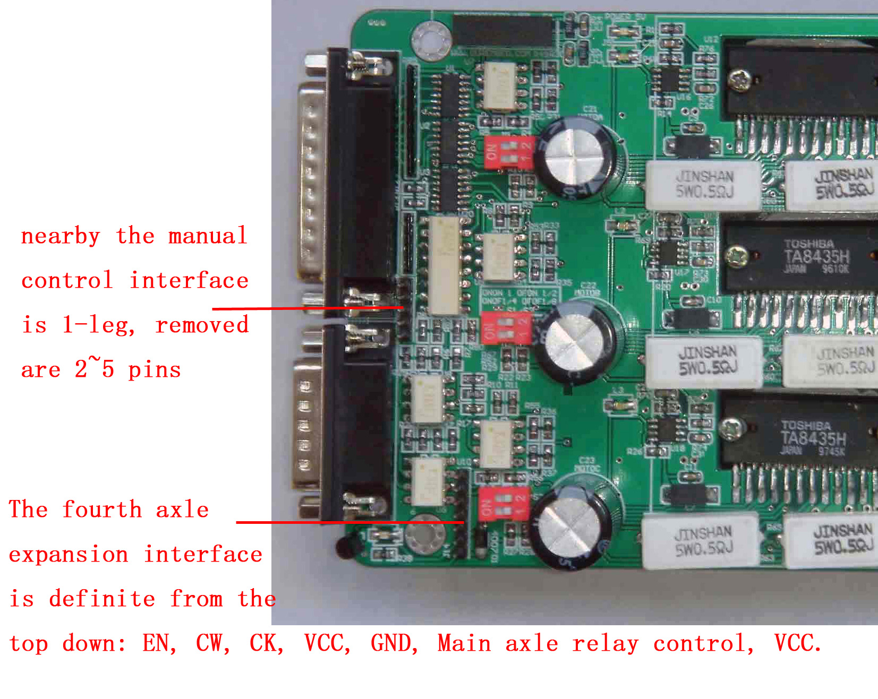

Excitation settings:

S1/S2： ON/ON 2Phase、 ON/OFF 1-2Phase、OFF/ON 4W1-2Phase、OFF/OFF 2W1-2。

Decay Mode Settings:

S3/S4： ON/ON Normal 0%、ON/OFF 25%Decay、OFF/ON 50%Decay、OFF/OFF Decay

