Windows Update USB 2.0 Host Controller Driver Download Procedure v1.0
ALi Corporation 2002/9

1. On the Windows Update web page, click “Personalize Windows Update”.
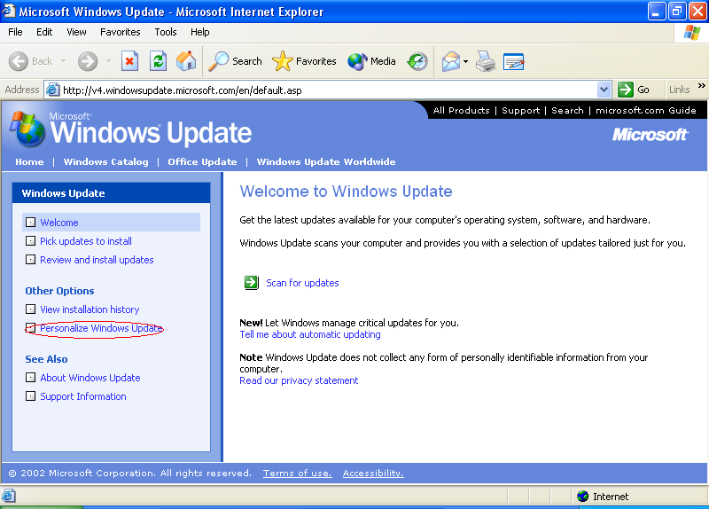

2. Select “Display the link to the Windows Update Catalog” checkbox. Save the setting.
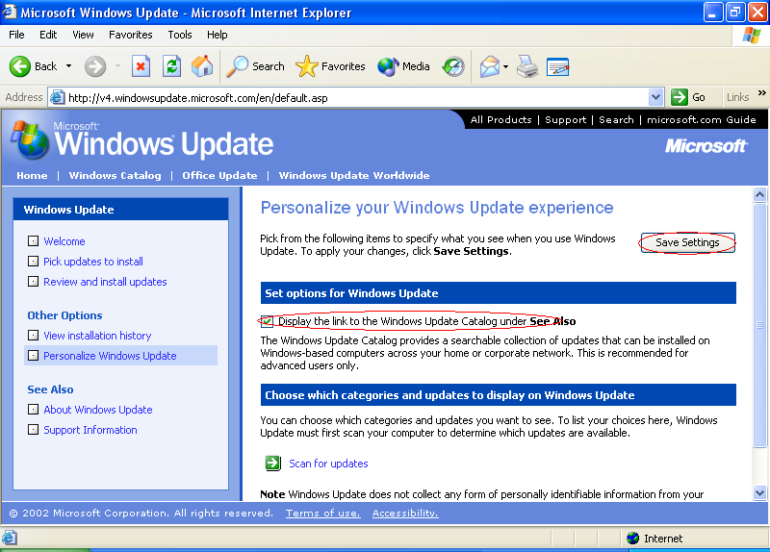

3. Click “Windows Update Catalog” under “See Also”.
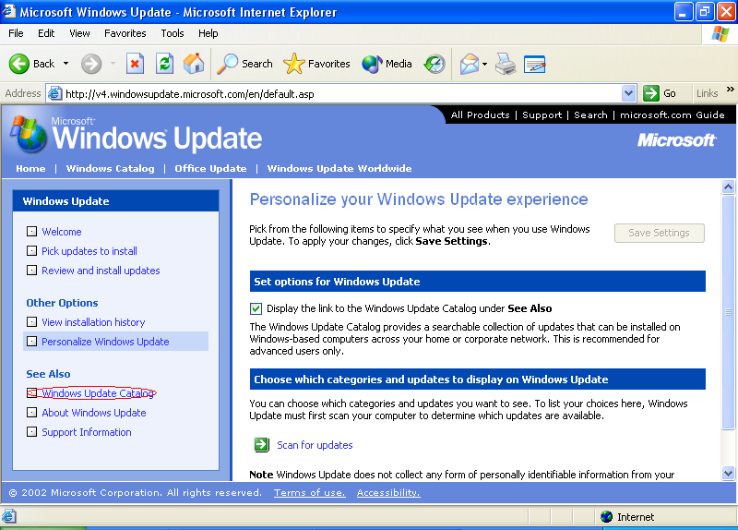
4. Click “Find driver updates for hardware devices”.
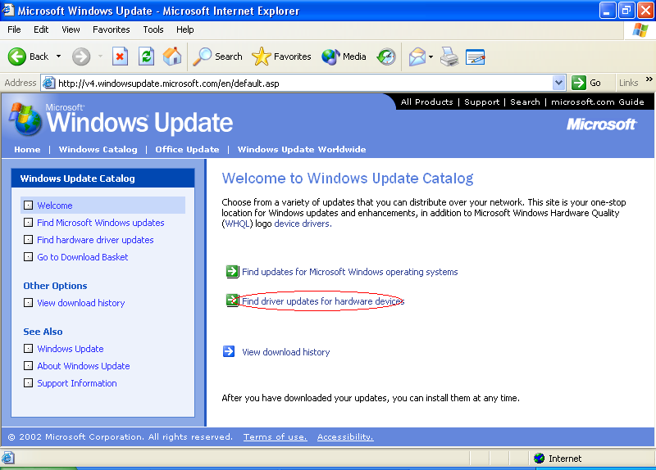

5. Select “Other Hardware”.
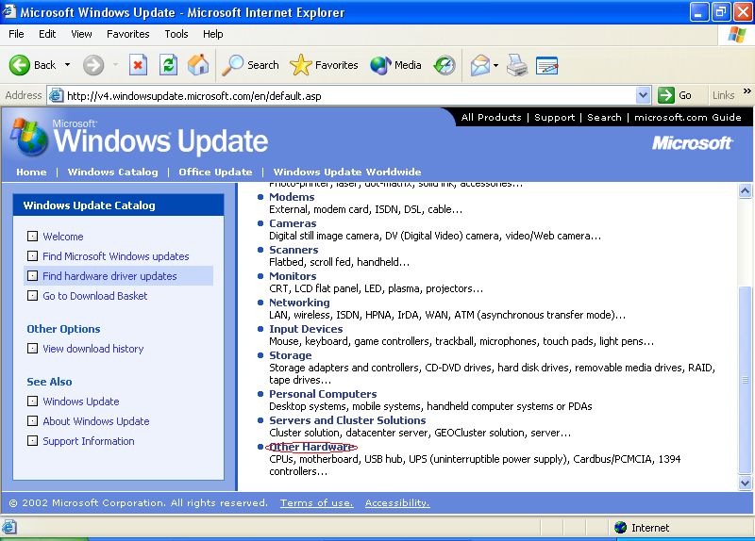

6. Select “Microsoft Corporation” from “Manufacturer name” menu, “Windows XP Professional” or “Windows XP Home” from “Operating system” menu, enter “USB” in “Contains these words” field, then click “Search”.
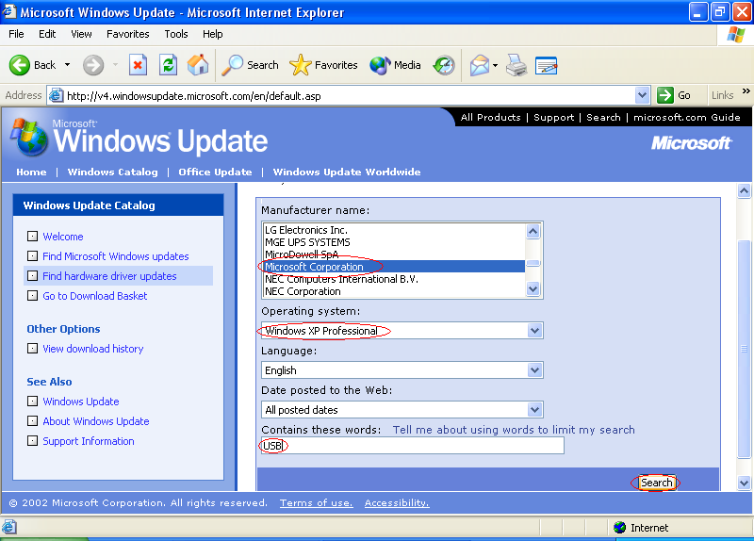
7. Click “Add” to add Microsoft USB Driver into Download Basket, then click “Go to Download Basket”.
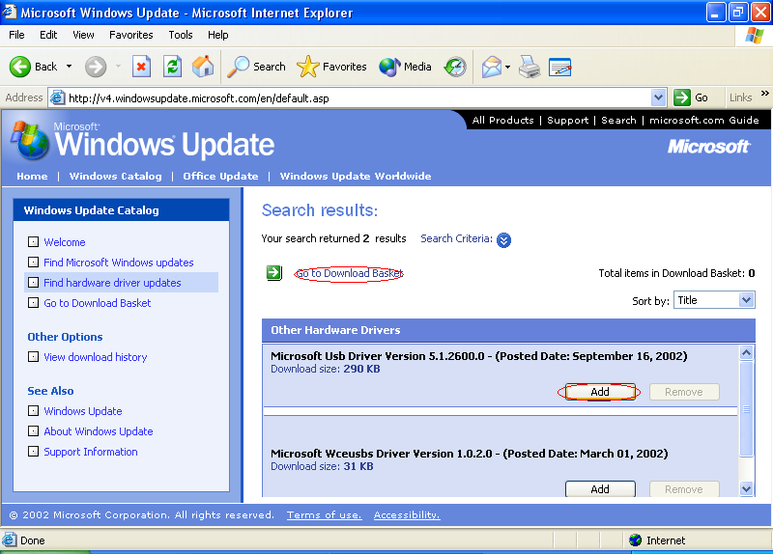

8. Enter an existing download location, then click “Download Now”.
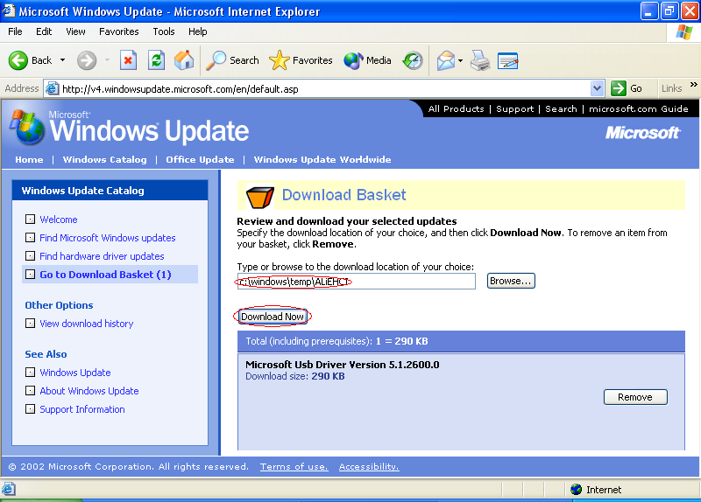
9. Click the download location link, which leads you to the downloaded USB 2.0 driver package. Extract all files and follow the instructions in the warning message which will pop up during ALi EHCI driver installation or you can find the warning message in readme.txt included in the driver package.
