◆ INTRODUCTION 3
◆ RECORD OF CHANGES 6
◆ WINDOWS 95 / 98 7
1. Windows 98 Driver Installation 7
2. How to check your Win98 installation 11
3. How to Configure COM port 11
4. Windows 98 uninstall guide 13
5. How to connect your peripheral to SUNIX LPT device 13
6. How to connect your peripheral to SUNIX COM device 15
◆ WINDOWS NT 18
1. Windows NT 4.0 Driver Installation Guide 18
2. How to configure your ISA Multi I/O Card 19
3. Check Your Windows NT 4.0 Installation 22
4. Windows NT 4.0 Uninstall Guide 22
◆ LINUX 24
1. LINUX Installation Guide for ISA Serial Ports 24
2. LINUX Installation Guide for ISA Parallel Ports 25
◆ Windows 2000 27
1. Windows 2000 Driver Installation Guide 27
2. Check Your Windows 2000 Installation 31
3. How to Configure COM port 31
4. Windows 2000 Uninstall Guide 32

- INTRODUCTION
The ISA 16 bit Multi I/O series cards are equipped with High-Speed Standard Serial-Interface and/or IEEE 1284 Parallel Interface.

- Commercial Cards

Model | Function | Connector
4001A | 1P(SPP/BPP) | 1 DB25F
4003A | 1P(ECP/EPP) | 1 DB25F
4011A | 2P(SPP/BPP) | 1 DB25F  1 3x2Header
4013A | 2P(ECP/EPP) | 1 DB25F  1 3x2Header
4015A | 3P(SPP/BPP) | 1 DB25F  2 3x2Header
4017A | 3P(ECP/EPP) | 1 DB25F  2 3x2Header
4021A | 1S(16FIFO) | 1 DB9M
4022A | 1S(32FIFO) | 1 DB9M
4023A | 1S(64FIFO) | 1 DB9M
4031A | 2S(16FIFO) | 2 DB9M
4032A | 2S(32FIFO) | 2 DB9M
4033A | 2S(64FIFO) | 2 DB9M
4061A | 4S(16FIFO) | 1 DB37F
4042A | 4S(32FIFO) | 1 DB37F
4043A | 4S(64FIFO) | 1 DB37F
4044I | 4S(64FIFO),IRQ can be shared | 1 DB37F
4045I | 4S(64FIFO),IRQ can be shared | 1 DB37F
4046I | 4S(64FIFO),IRQ can be shared | 1 DB37F
4062A | 8S(16FIFO) | 1 DB37F  1 20x2Header
4063A | 8S(32FIFO) | 1 DB37F  1 20x2Header
4064A | 8S(64FIFO) | 1 DB37F  1 20x2Header
4062I | 8S(16FIFO),IRQ is shared | 1 DB37F  1 20x2Header
4063I | 8S(32FIFO),IRQ is shared | 1 DB37F  1 20x2Header
4064I | 8S(64FIFO),IRQ is shared | 1 DB37F  1 20x2Header
4072A | 2S(16FIFO) + 1P(SPP/BPP) | 2 DB9M  1 13x2Header
4072U | 2S(32FIFO) + 1P(SPP/BPP) | 2 DB9M  1 13x2Header
4072U2 | 2S(64FIFO) + 1P(SPP/BPP) | 2 DB9M  1 13x2Header
4076A | 2S(16FIFO) + 1P(ECP/EPP) | 2 DB9M  1 13x2Header
4076U | 2S(32FIFO) + 1P(ECP/EPP) | 2 DB9M  1 13x2Header
4077A | 2S(64FIFO) + 1P(ECP/EPP) | 2 DB9M  1 13x2Header
4074A | 2S(16FIFO) + 1P(ECP/EPP) | 1 DB9M  1 DB25F  1 5x2Header
4074B | 2S(32FIFO) + 1P(ECP/EPP) | 1 DB9M  1 DB25F  1 5x2Header
4074C | 2S(64FIFO) + 1P(ECP/EPP) | 1 DB9M  1 DB25F  1 5x2Header
4085A | 2S(16FIFO) + 2P(SPP/BPP) | 1 DB9M  1 DB25F  1 5x2Header  1 13x2Header
4086A | 2S(32FIFO) + 2P(SPP/BPP) | 1 DB9M  1 DB25F  1 5x2Header  1 13x2Header
4087A | 2S(64FIFO) + 2P(SPP/BPP) | 1 DB9M  1 DB25F  1 5x2Header  1 13x2Header
4082A | 2S(16FIFO) + 2P(ECP/EPP) | 1 DB9M  1 DB25F  1 5x2Header  1 13x2Header
4083A | 2S(32FIFO) + 2P(ECP/EPP) | 1 DB9M  1 DB25F  1 5x2Header  1 13x2Header
4084A | 2S(64FIFO) + 2P(ECP/EPP) | 1 DB9M  1 DB25F  1 5x2Header  1 13x2Header
4090I | 4S(16FIFO) + 3P(ECP/EPP),IRQ is shared | 1 DB62F  3 13x2Header
4091I | 4S(32FIFO) + 3P(ECP/EPP),IRQ is shared | 1 DB62F  3 13x2Header
4092I | 4S(64FIFO) + 3P(ECP/EPP),IRQ is shared | 1 DB62F  3 13x2Header

- Industrial RS422/485 Cards

Model | Function | Connector
8131 | 2S(16FIFO) | 2 mini block
8131S | 2S(16FIFO),surge | 2 mini block
8132 | 2S(32FIFO) | 2 mini block
8132S | 2S(32FIFO),surge | 2 mini block
8133 | 2S(64FIFO) | 2 mini block
8133S | 2S(64FIFO),surge | 2 mini block
8134 | 2S(16FIFO) | 2 DB9M
8134S | 2S(16FIFO),surge | 2 DB9M
8135 | 2S(32FIFO) | 2 DB9M
8135S | 2S(32FIFO),surge | 2 DB9M
8136 | 2S(64FIFO) | 2 DB9M
8136S | 2S(64FIFO),surge | 2 DB9M
8141 | 4S(16FIFO) | 4 mini block
8141S | 4S(16FIFO),surge | 4 mini block
8142 | 4S(32FIFO) | 4 mini block
8142S | 4S(32FIFO),surge | 4 mini block
8143 | 4S(64FIFO) | 4 mini block
8143S | 4S(64FIFO),surge | 4 mini block
8144 | 4S(16FIFO) | 4 RJ45
8144S | 4S(16FIFO),surge | 4 RJ45
8145 | 4S(32FIFO) | 4 RJ45
8145S | 4S(32FIFO),surge | 4 RJ45
8146 | 4S(64FIFO) | 4 RJ45
8146S | 4S(64FIFO),surge | 4 RJ45

- Industrial Current Loop Cards

Model | Function | Connector
8231 | 2S(16FIFO) | 2 mini block
8231S | 2S(16FIFO),surge | 2 mini block
8232 | 2S(32FIFO) | 2 mini block
8232S | 2S(32FIFO),surge | 2 mini block
8233 | 2S(64FIFO) | 2 mini block
8233S | 2S(64FIFO),surge | 2 mini block
8234 | 2S(16FIFO) | 2 DB9M
8234S | 2S(16FIFO),surge | 2 DB9M
8235 | 2S(32FIFO) | 2 DB9M
8235S | 2S(32FIFO),surge | 2 DB9M
8236 | 2S(64FIFO) | 2 DB9M
8236S | 2S(64FIFO),surge | 2 DB9M
8241 | 4S(16FIFO) | 4 mini block
8241S | 4S(16FIFO),surge | 4 mini block
8242 | 4S(32FIFO) | 4 mini block
8242S | 4S(32FIFO),surge | 4 mini block
8243 | 4S(64FIFO) | 4 mini block
8243S | 4S(64FIFO),surge | 4 mini block
8244 | 4S(16FIFO) | 4 RJ45
8244S | 4S(16FIFO),surge | 4 RJ45
8245 | 4S(32FIFO) | 4 RJ45
8245S | 4S(32FIFO),surge | 4 RJ45
8246 | 4S(64FIFO) | 4 RJ45
8246S | 4S(64FIFO),surge | 4 RJ45

➢ The driver put in CD-ROM sub-dir. /IO/ISA IO/
➢The serial ports can support up to 921600 baud and autoflow control except the COM1 ~ COM4 (3F8h, 2F8h, 3E8h, 2E8h) in Windows NT.
➢For Serial Card, after you install, Please you check Device manager successful or not, If found install failure (Yellow Point), Please you check you IRQ is enough or not, because normal RS-232 card isn’t INTERRUPT SHARING, each port’s IRQ must have free used, If your system aren’t enough free IRQ, Please select INTERRUPT SHARING card to install.
➢When you install Internal Software Modem, please first install Internal Software Modem then install our Com port and driver.
➢When you set more than Lpt4, please you only use the driver of NT(or 98) supporting. Please do not use the driver of printer company supporting.

- RECORD OF CHANGES

- Add new models
- Multi-port cards use IRQ sharing to solve the lack of IRQ resources.
- Industrial RS422/485 cards
- Industrial Current Loop cards

- WINDOWS 95 / 98

Windows 98 Driver Installation

➢ Turn off the power of your computer.
➢ Plug-in the SUNIX Multi I/O card to ISA bus of your computer
➢ Add-on the peripheral（Modem, Printer, Scanner… etc.）that you need to this card
➢ Turn on the power of your computer

Step 1:
- Run the setup.exe program in ISA Multi I/O card Installation CD.

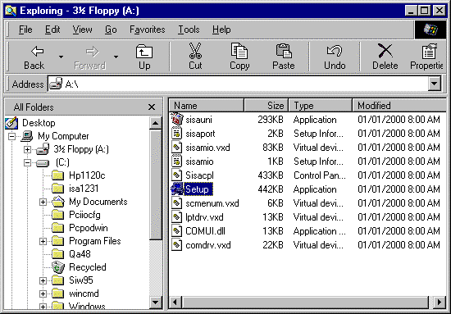
Step 2:
➢ Click [Ok] to install the driver.
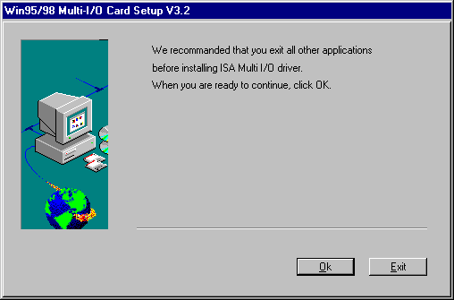

Step 3:
➢ Click [Next] to begin.
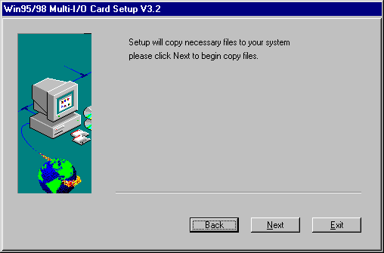
Step 4:
➢ Click [OK] and [Finish].

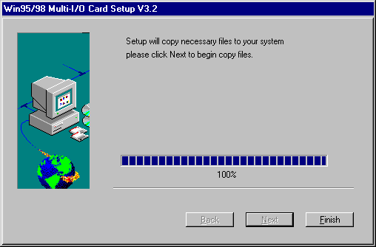
Step 5:
➢ Double click Multi-I/O Card Configuration in Control Panel.

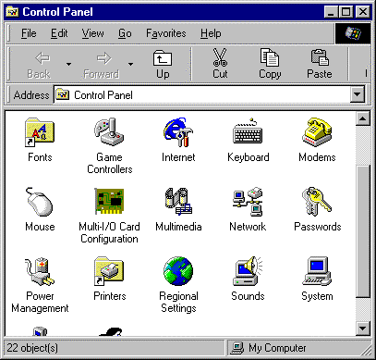

Step 6:
➢ Press [Add] to add new model.
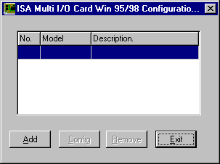
Step 7:
➢ Select the model (for example 4084A) and press [Select].
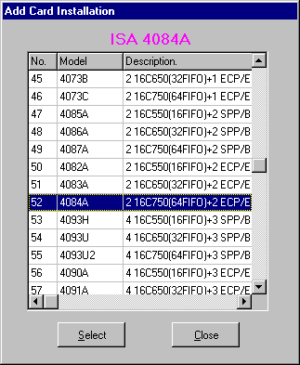
Step 8:
➢ Set the Interrupt and I/O Address as the hardware jumper setting and press [Install].
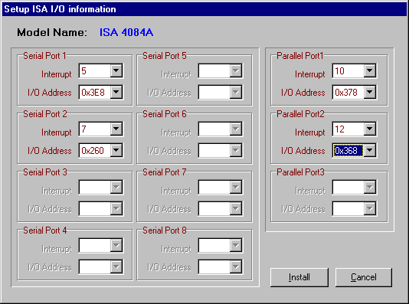

Step 9:
➢ Click [Close] if the installation is finished. If you have another ISA card to install, select the card modem and click [Select] and go to step5.
Step 10:
➢ You can find the 4084A installed.
Click [Add] to install another card.
Click [Config] to view or change the setting.
Click [Remove] to remove the selected card installation.
Otherwise click [Exit].
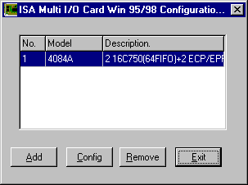
Step 11:
➢ Please restart your computer.

How to check your Win98 installation
Step 1:
➢ Double click System icon in Control Panel.
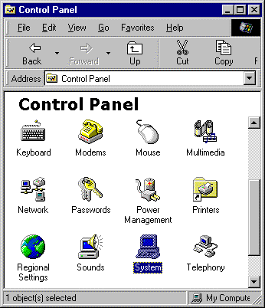
Step 2:
➢ Press MultiIO Controller and Ports [COM & LPT]. You can find two ISA ECP/EPP Ports and two Serial Ports.
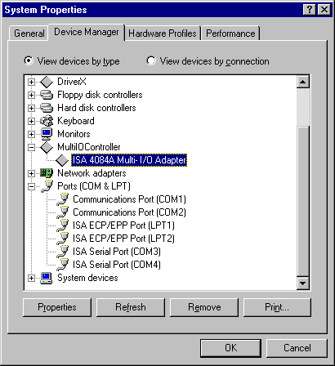

How to Configure COM port
Step 1:
Select the ISA Serial Port you want to configure for example COM3.
Press the [Properties].

Step 2:
Click the [Sunix Port Settings].
Configure the Bits per second, Data bits, Parity, Stop bits and Flow control if you want to change.
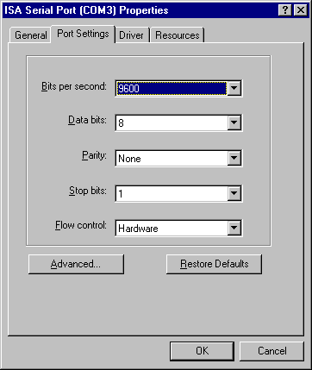
There are three kinds of flow control: Xon/Xoff, Hardware and None. The Xon/Xoff is using software protocol. The Hardware means the flow control is using RTS/CTS, but the RTS/CTS is controlled by software. The None means there is no flow control.
Click the [Advanced] if you want to set more advanced features.

Step 3:
Configure the Enable Auto CTS/RTS Flow Control, 16/32/64 bytes FIFO length, Receive/Transmit Buffer trigger level if you want to change.
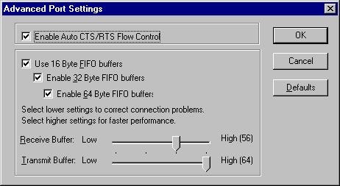
Enable Auto CTS/RTS Flow Control means the CTS/RTS flow control is controlled by hardware automatically. System will be more stable if the function is enabled.

If your card can support 64 (32) bytes FIFO, you can use 16 or 32 or 64 (16 or 32) bytes FIFO. The default value is Use 16 Byte FIFO buffers.

Set the Receive/Transmit Buffer to higher value will get faster performance because the interrupts will be reduced, but the time for interrupt service routine will become shorter. The receive buffer overflow will be easily happened if the CPU speed is not enough to handle. If the system is not stable, select the lower value to correct problems.

Windows 98 uninstall guide
- Double click Add/Remove Programs in Control Panel.
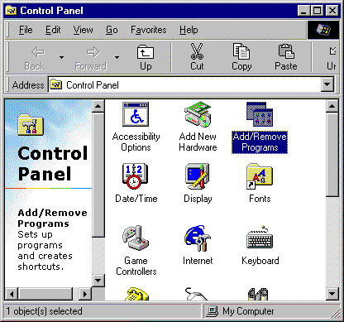
- Choose ISA Multi-I/O Card.
Click [Add/Remove].
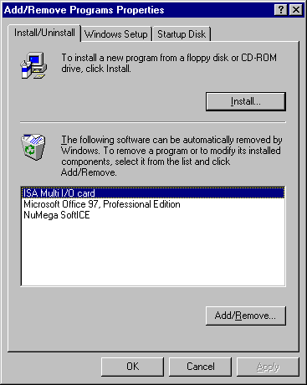

How to connect your peripheral to SUNIX LPT device
Step 1:
Be sure your printer or other parallel peripheral had connected to SUNIX ISA Multi I/O card.
Step 2:
Double click my computer icon, Double click Printers icon
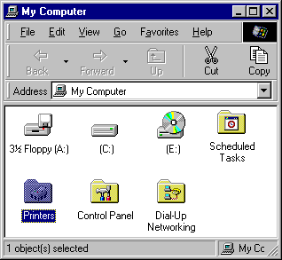

Step 3:
Double click Add Printer icon.
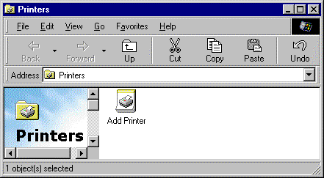
Step 4:
Click [Next].
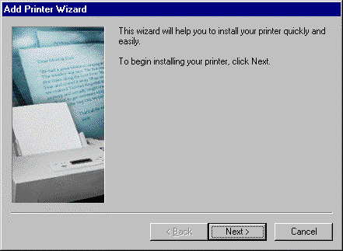
Step 5:
Install Printer (for example HP DeskJet 1120C) driver from CD.
Click [OK].
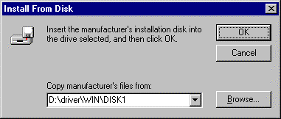
Step 6:
Select HP DeskJet 1120C Printer.
Click [Next].
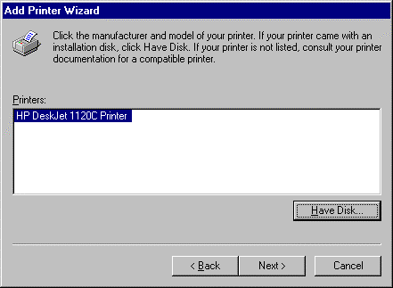

Step 7:
If you want to connect the printer to your ISA Multi I/O Card, select ISA ECP/EPP Parallel Port to your device.
Click [Next]
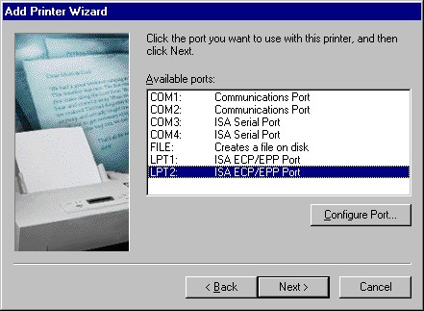
Step 8:
Type the printer name then click [Finish].
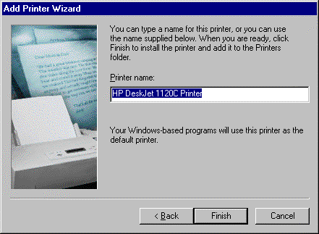

How to connect your peripheral to SUNIX COM device
Step 1:
Be sure your modem or other serial peripheral had connected to SUNIX ISA Multi I/O card.
Step 2:
Double click my computer icon, Double click Control Panel icon
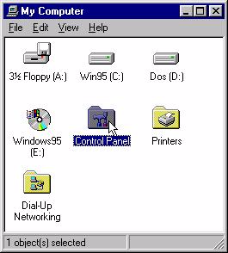

Step 3:
Here will take modem for example.
Click Modem icon
Step 4:
Then Windows 98 will start modem install wizard , click 【Next】.
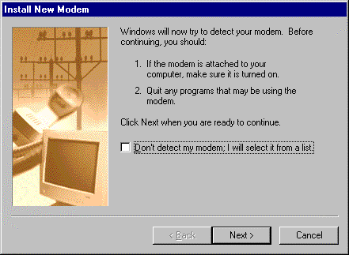
Step 5:
Please wait a moment, Windows 98 will search you modem.
If display standard modem or other modem type, then click 【Next】.
Otherwise, please check your modem. (Power on? Connect right? Telephone line?)

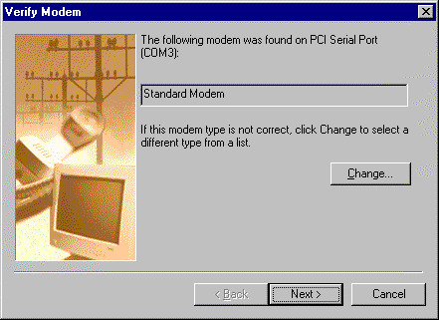

Step 6:
Click 【Finish】
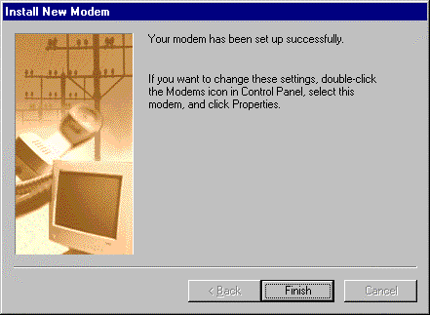
Step 7:
You can find Standard Modem in Modems Properties.
The installation finishes.

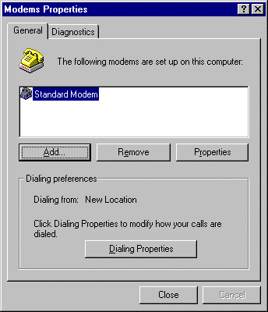
- WINDOWS NT

Windows NT 4.0 Driver Installation Guide
Step 1:
Run the setup.exe program in ISA Multi I/O card Installation CD.
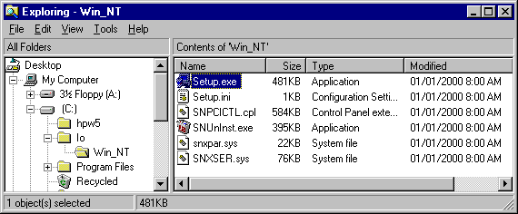
Step 2:
Press [Continue] to install the driver.
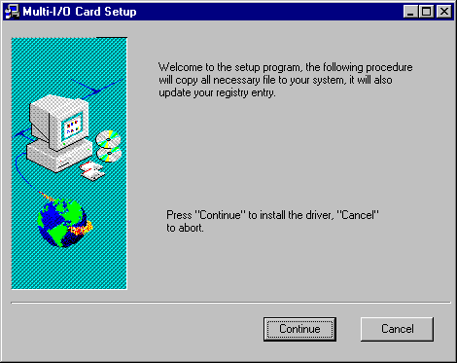
Step 3:
Click 【OK】to reboot computer to load the new installed driver to NT.
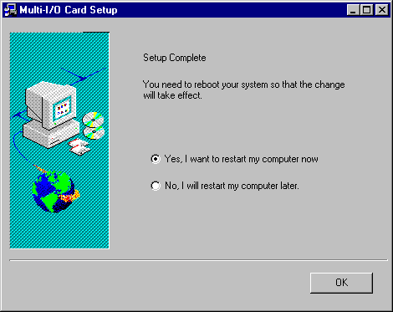

How to configure your ISA Multi I/O Card
- Double click Multi-I/O Card Configuration icon.
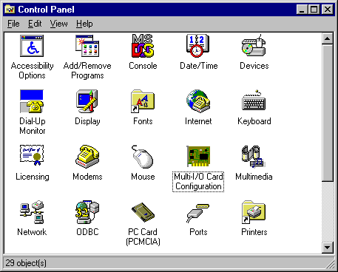
- Press [ISA Multi-I/O Setup].
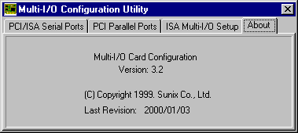
- Press [Add] to add new model.
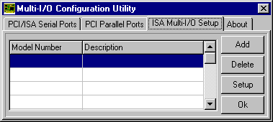
➢ Select the model (for example 4084A) and press [Ok].
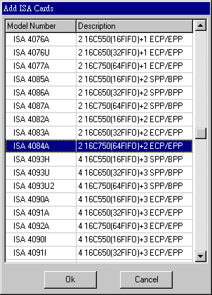

➢ Set the Interrupt and I/O Address as the hardware jumper setting and press [Ok].
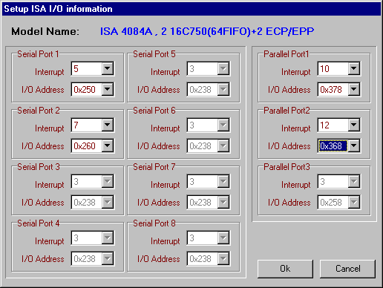
➢ You can find the 4084A installed.
Click [Add] to install another card.
Click [Delete] to remove the selected card installation.
Click [Setup] to view or change the setting.
Otherwise click [Ok].
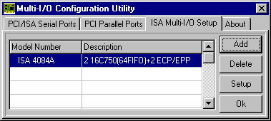
➢ Restart your computer.
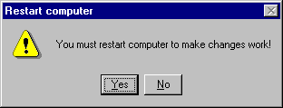
- If you want to configure the serial ports, press [PCI/ISA Serial Ports] and select the COM port you want to configure.
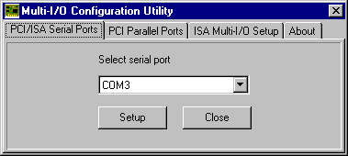

- Set the 32 byte FIFO or Auto Flow Control or Receive Trigger Level, click [Ok].
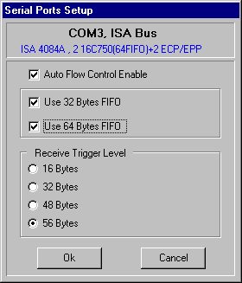
If your card can support 64 (32) bytes FIFO, you can use 16 or 32 or 64 (16 or 32) bytes FIFO. The default value is Use 16 Byte FIFO buffers.

Auto Flow Control Enable means the CTS/RTS flow control is controlled by hardware automatically. System will be more stable if the function is enabled.

Set the Receive Trigger Level to higher value will get faster performance because the interrupts will be reduced, but the time for interrupt service routine will become shorter. The receive buffer overflow will be easily happened if the CPU speed is not enough to handle. If the system is not stable, select the lower value to correct problems.

Note:
- If you stall the modem-using auto detect by Windows NT, the Auto Flow Control Enable shall be disabled.
- When the serial I/O is 3F8, 2F8, 3E8, 2E8, the port driver is using WinNT default driver and can support 115200. When using other address, the driver will be Sunix’s driver and can support 921600. If you install 4S card, the order of S1 - S4 should be following the sequence of 3F8, 2F8, 3E8, 2E8, others, otherwise you may have trouble to identify port number.
- When using IRQ sharing, you cannot set 3F8, 2F8, 3E8, 2E8 and other address in one card, because two different driver can not apply in one card. The 3F8, 2F8, 3E8, 2E8 is not enough to support 4S, 4S/3P and 8S. So when using IRQ sharing the 3F8, 2F8, 3E8, 2E8 is not allowed to use and can support to 115200.

Check Your Windows NT 4.0 Installation
- Click [Start] → [Programs] → [Administrative Tools [Common] ] → [Windows NT Diagnostics]
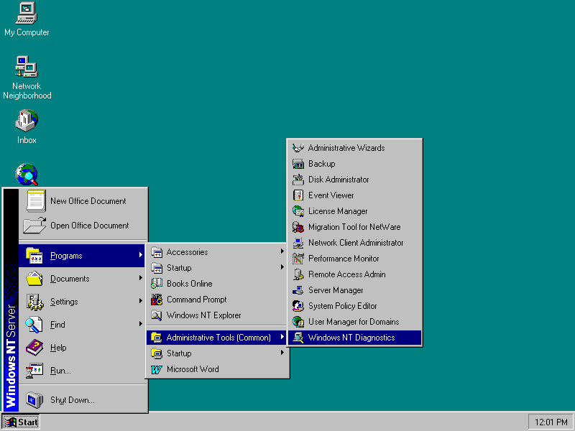
- Press Resources then press I/O port.
You can find the I/O address of two parallel port (SNXPAR and Parport) and two serial ports (SNXSER).
You can find the IRQ information by press [IRQ].
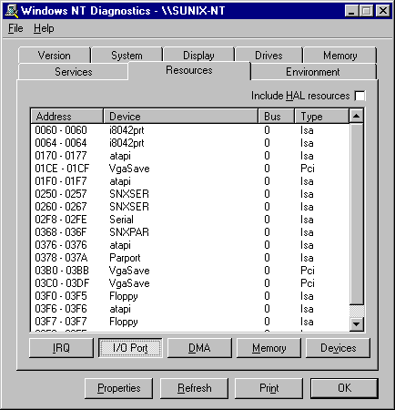

Windows NT 4.0 Uninstall Guide
- Double click Add/Remove Programs in Control Panel.
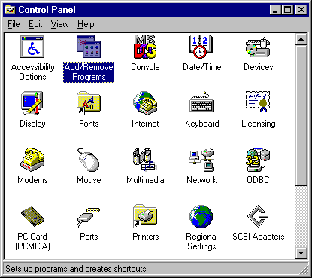
- Select Multi-I/O Card Uninstall, press [Add/Remove].
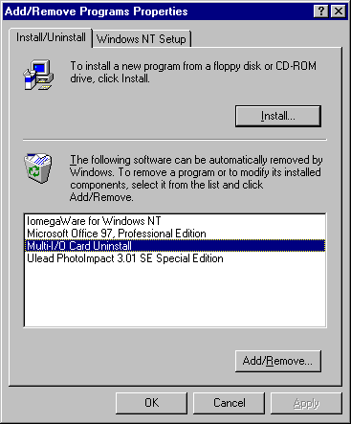
- Press [OK] to remove Multi-I/O card driver.
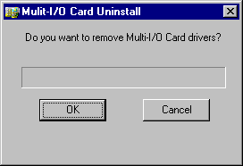
- Click [OK] to reboot the computer.
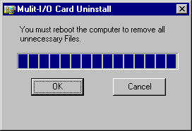

- LINUX

LINUX Installation Guide for ISA Serial Ports
This installation guide describes the procedure to install SUNIX ISA serial ports in Linux platform.

[Linux Platform]

- Operating System : RedHat V6.0/V5.2 (Kernel 2.2.5 / 2.0.36)
- Terminal Emulation AP : minicom
- Internet Dialer : Kppp

[Installation Steps]

- Find the available serial ports

Since Linux only support 4 serial ports (ttyS0, ttyS1, ttyS2, ttyS3) under the default condition. Most likely, ttyS0 & ttyS1 are supported by mother board's built-in 16550 controllers and ttyS2 & ttyS3 are free for additional I/O card. (Note that ttyS2: S is upper case)

It could be checked by the following commands.

#setserial /dev/ttyS0 -a (COM1)
#setserial /dev/ttyS1 -a (COM2)
#setserial /dev/ttyS2 -a (COM3)
#setserial /dev/ttyS3 -a (COM4)

If COM1 is used by mouse, the response is similar to
/dev/ttyS0 : Device or resource busy
If the COM1 does not attach any device, the response is similar to
/dev/ttyS0, Line 0, UART: 16550A, Port: 0x3f8, irq: 4
Baud_base: 115200, clos_delay: 50, divisor: 0
closing_wait: 3000, closing_wait2: infinite
Flags: spd_normal skip_test
In case ttyS2 (COM3) is free, the response for command # setserial /dev/ttyS2 -a is shown below.
/dev/ttyS2, Line 2, UART: unknown, Port: 0x3e8, irq: 4
Baud_base: 115200, clos_delay: 50, divisor: 0
closing_wait: 3000, closing_wait2: infinite
Flags: spd_normal skip_test
(note that UART: unknown)
In case ttyS3 (COM4) is free, the response for command # setserial /dev/ttyS3 -a is shown below.

/dev/ttyS3, Line 3, UART: unknown, Port: 0x2e8, irq: 3
Baud_base: 115200, clos_delay: 50, divisor: 0
closing_wait: 3000, closing_wait2: infinite
Flags: spd_normal skip_test
(note that UART: unknown)

Finally, the /dev/ttyS2 & /dev/ttyS3 are free for ISA serial ports.

- Check the ISA serial port's jumper setting ( I/O port address & IRQ)

All SUNIX ISA serial port I/O address is allowed to be one of the following location.
3F8h 2F8h 3E8h 2E8h
230h 238h 240h 248h
250h 258h 260h 268h

All SUNIX ISA serial port interrupt is allowed to be one of the following IRQ.
IRQ 3, 4, 5, 7, 9, 10, 11, 12,15

- Configure the parameters for ttyS2 & ttyS3

for SUNIX 4021A/4022A/4023A card (16 bit ISA 1S), please enter (if ttyS2 is free and jumper setting is 3E8h / IRQ10)
# setserial /dev/ttyS2 port 0x3E8 UART 16550A
irq 10 Baud_base 115200

for SUNIX 4031A/4032A/4033A card (16 bit ISA 2S), please enter (if ttyS2 & ttyS3 are free and jumper setting are 3E8h / IRQ10 & 2E8 / IRQ11)
# setserial /dev/ttyS2 port 0x3E8 UART 16550A
irq 10 Baud_base 115200
# setserial /dev/ttyS3 port 0x2E8 UART 16550A
irq 11 Baud_base 115200
- Check the setting for ttyS2 & ttyS3

Please enter # setserial /dev/ttyS2 -a
The Linux's response look likes below
/dev/ttyS2, Line 2, UART: 16550A, Port: 0x3E8, irq: 10
Baud_base: 115200, clos_delay: 50, divisor: 0
closing_wait: 3000, closing_wait2: infinite
Flags: spd_normal skip_test
(5) Then the ttyS2 & ttyS3 are ready for application
(eg. minicom or Kppp ...)

LINUX Installation Guide for ISA Parallel Ports
This installation guide describes the procedure to install SUNIX ISA parallel ports in Linux platform.

[Linux Platform]

- Operation System: RedHat V6.0/V5.2 (Kernel 2.2.5 / 2.0.36)
- "AnotherLevel menu -> administration -> printtool" in X windows.

[Installation steps]

Linux kernel provide a 'parport' code to support parallel port (/dev/lp0, /dev/lp1, /dev/lp2). This code provides the ability to share one port between multiple devices. And it is loadable when kernel is running.

The 'parport' code is split into two parts : generic (which deals with port sharing) and architecture-dependent eg. X86, SPARC. (which deals with actually using the port). Thus, please take the following steps to install 'parport' module!

- Check the on-board parallel port's hardware resources

Most likely each motherboard has a built-in parallel port. And its hardware resources are settable with BIOS utility.

(for example, on-board parallel is in 0x378 port, IRQ7 )

- Check the ISA parallel port's jumper's setting( IO port address & IRQ)

All SUNIX ISA parallel port I/O address is allowed to be one of the following location.
3BCh 378h 278h
258h 268h 358h 368h

All SUNIX ISA parallel port interrupt is allowed to be one of the following IRQ.
IRQ 3, 4, 5, 7, 9, 10, 11, 12,15
- Install 'parport' module

If the card is 4011A / 4013A (ISA 2 parallel ports), and jumper setting are 278h / IRQ5 and 268h /IRQ11. then
<step I> to load the generic 'parport' code
# insmod parport.o

<step II> to load the architecture-dependent code to tell 'parport' code

# insmod parport_pc.o io=0x378,0x278,0x268
irq=7,5,11

that you have three PC-style ports, one at 0x378 with IRQ 7 (on board), one at 278 with IRQ5, one at 0x268 with IRQ11.

- Check the attached printer device [optional]

once the architecture-dependent part of the paraport code is loaded into the kernel. You could enter the following command

# insmode parport_proble.o

to check any attached devices and log a message similar to

parport0: Printer, BJC-210 (Canon)

- Then /dev/lp0, /dev/lp1 and /dev/lp2 are ready for service

(eg. "AnotherLevel menu -> administration -> printttool" in X windows environment)

- Windows 2000

Windows 2000 Driver Installation Guide
- Run the setup.exe program in ISA multi-I/O card Installation Disk.

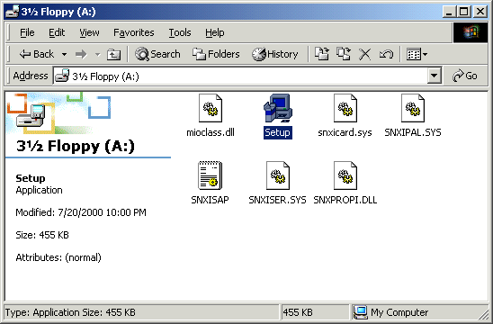
- Select a model (for example 4076A) and press【OK】.
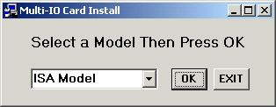

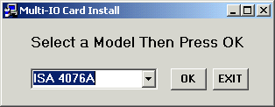

Note: If you want to install 4090I (4091I, 4092I), you shall install twice.
Please select model 4090IS (4091IS, 4092IS) to install serial port and 4090IP (4091IP, 4092IP) to install parallel port.
- Set the Interrupt and I/O Address as the hardware jumper setting and press [OK].
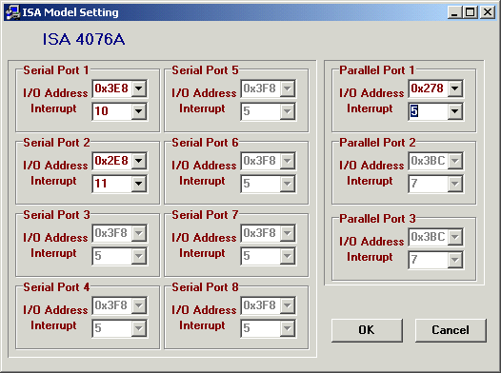
- Press [Ok].
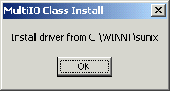
Note: The ISA Win2000 driver is copied to “C:\WINNT\SUNIX”.

- Press [Next] to continue.

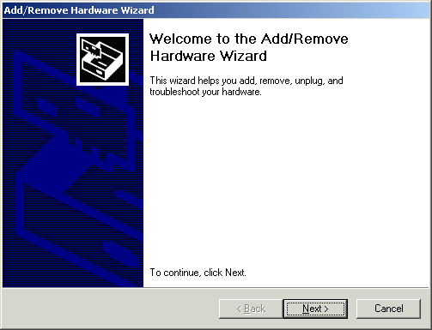

- Select “Add/Troubleshoot a device” and press [Next] to continue.

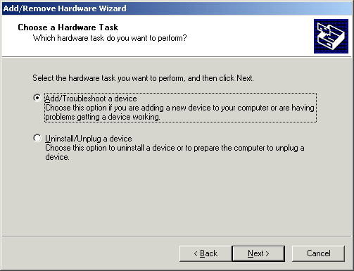
- Select “Add a new device” and press [Next] to continue.
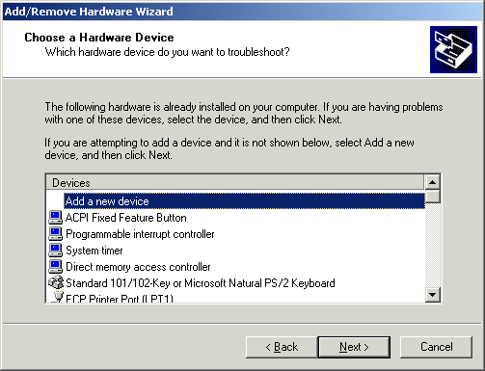
- Select “No” and press [Next] to continue.
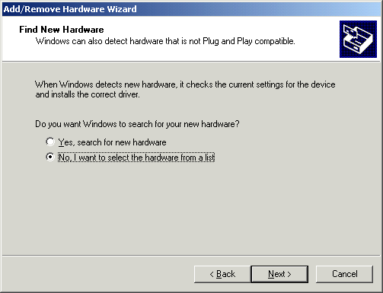
- Select “Other devices” and press [Next] to continue.
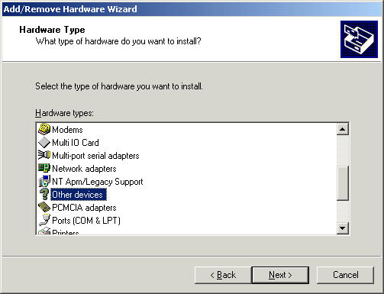
- Press “Have Disk…”.
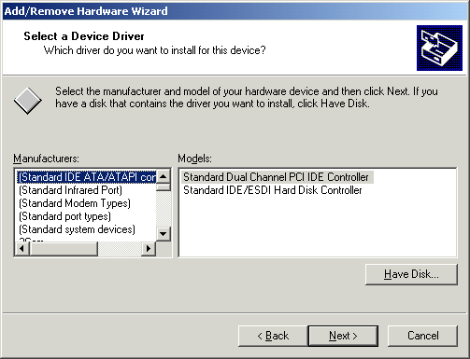
- The driver is located on “C:\\WINNT\SUNIX”, please type directly or use the browse. Press [OK] to continue.
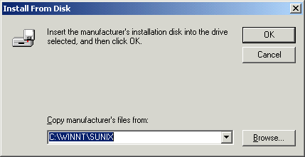
- Select the device driver and press [Next] to continue.
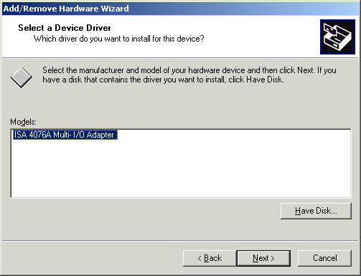
- Press [Next] to start hardware installation.
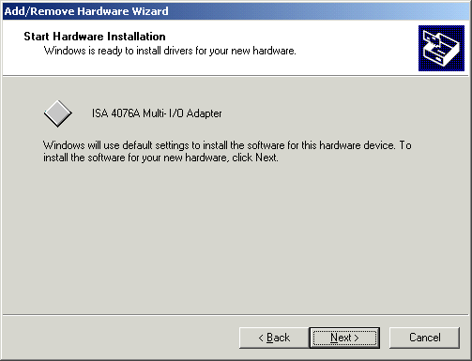
- The installation is completed. Press [Finish] to close the wizard.
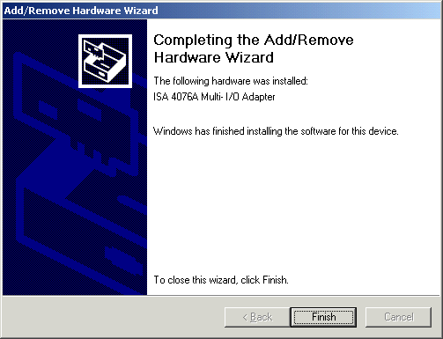

Check Your Windows 2000 Installation
- Select the “Hardware” in system properties and click the “Device Manager”.
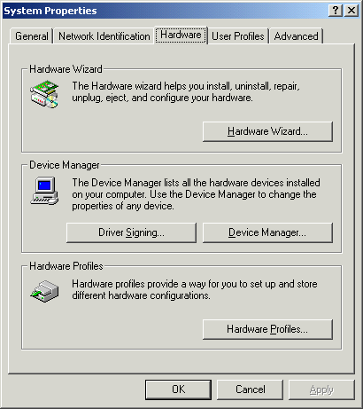
- After install ISA multi I/O card (for example 4076A), you will find three ports added (COM3, COM4, LPT2).
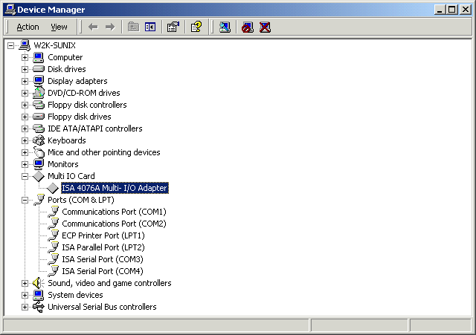

How to Configure COM port
- Click the [Port Settings].
Configure the Bits per second, Data bits, Parity, Stop bits and Flow control if you want to change.
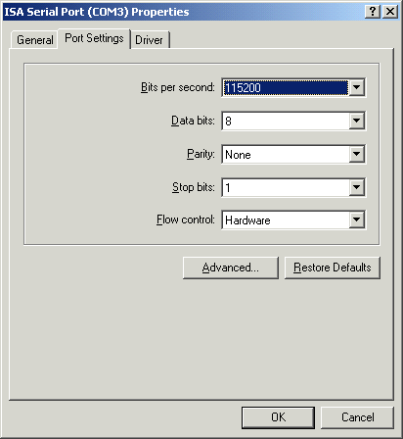
- Click the [Advanced…]. Configure the Enable Auto CTS/RTS Flow Control, 16/32/64 bytes FIFO length, and Receive/Transmit Buffer trigger level if you want to change.
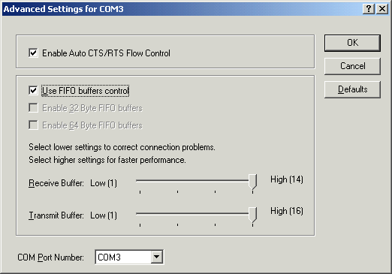

Windows 2000 Uninstall Guide
- Select the card that you want to remove and press the right button of the mouse and select the “uninstall”.
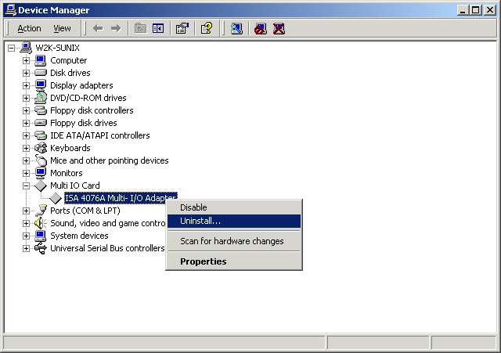
- Press [OK] to uninstall the selected ISA multi-I/O card.
