 | TECHNICAL MEMORANDUM

Title: Windows over NGST detectors |  | TM:  Date:  Rev.: | STScI-NGST-TM-2002-0013  5 June 2002  A
Authors: D. Figer & G. A. Kriss | Phone:  (410) 338-4377 | Approvals:

1. Introduction

The purpose of this memo is to recommend whether windows should be used over NGST detectors. We assume that such a window would have maximum transmission over the operational waveband for the detector that it covers. Further, we assume that the window might serve as a pressure barrier separating vacuum and 1 atm of pressure.

2. Considerations

A window has the following advantages:

- reduces atmospheric contamination during pre-launch activities, i.e. hygroscopic effects
- reduces potential “gettering” effect
- protects against random mechanical damage, i.e. from dropped nuts/bolts, etc.
- helps in associating secondary with primary radiation

A window has the following disadvantages:

Optical performance
reduces throughput (7% for NIR, 20% for MIR)
increases possibility of ghosts
increases possibility of fringing
reduces wavefront quality
induces chromatic focus shift
Program
increases interface complexity
increases cost and schedule

noise are uncorrelated, these components add in quadrature and the required gain is about 1.66 e-/ADU. The full well value of 2x10⁵ e- corresponds to 1.2x10⁵ ADU, which cannot be represented with less than 17 bits. Adding 1 bit for ADC uncertainty yields the =18 bit guideline.

Correlated Double Sampling

Correlated Triple Sampling

Fowler Sampling

Sampling-Up-the-Ramp

$t_{\text{min}}\text{ =}[(K×p×D^{2})/S]^{1/2}\text{.}$Loss in throughput is the primary consideration in using a window. The minimum thickness for a window that is stable against a pressure difference of 1 atm is:
Reasonable values for calcium fluoride (CaF₂) are: K = 0.866, S = 5300 psi (the apparent elastic limit), and p = 14.7 psi (the pressure differential). D is the unsupported diameter. To be conservative, one should specify a thickness twice this value for safety. So, t_{min} = 10 mm*(D/100 mm). At this thickness, and with this material, we can expect very little absorption, so the primary reduction in throughput will come from reflection. The curves below give reasonable throughput expectations for CaF₂ or similar materials.
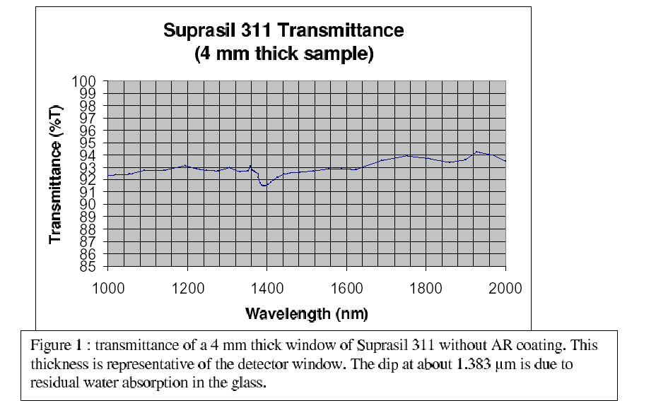
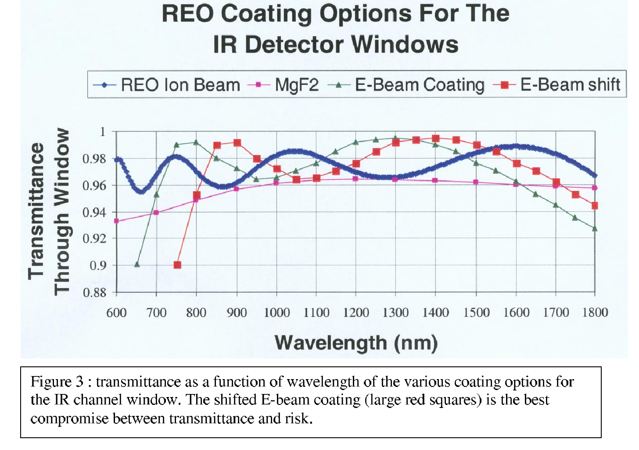
3. Other Missions

Very few missions have detector/instrument requirements similar to those for NGST. Indeed, there are no missions that are currently operating with cryogenic infrared detectors and a cold telescope; IRAC/SIRTF will be the first. The following instrument/telescopes were studied to determine how others have addressed the question of putting windows over detectors. References are included in parentheses.

a. NICMOS/HST (Colleen Townsley, NICMOS project drawing 517389)

1) Has windows (one per each of three cameras)
2) 10-25 mm clear aperture, by 5 mm thick
3) Warm
4) Vacuum seal pre-orbit
5) Qualified to meet specs after 5 krad (SI) over 5 years
6) Material is fused silica or quartz

b. IRAC/SIRTF (Steve Willner, Joe Hora, Peter Love, Craig McCreight, Judy Pipher)

1) Does not have windows
2) Performed a 1-2 year humidity study of flight-like detectors and found no deterioration
3) The IRAC detectors are not the coldest part of the instrument,at least when in operation
- In practice, there is no evidence of any contamination problems with the flight detectors after exposure to atmosphere.

c. WFC3/IR (Massimo Stiavelli, WFC3 ISR 2001-18 http://www.stsci.edu/instruments/wfc3/ISRs/WFC3-2001-18.pdf
)

1) Has a window
2) 22 mm in diameter, by 4 mm thick Suprasil 311
3) 93 per cent throughput when uncoated

- MODIS

1) Does not have windows
2) Did not keep detectors under vacuum/cryo conditions on ground

- TES (Carl Bruce)

1) Does not have a window
2) The first lens is very close to the detector with no direct path into the space in between. It is not hermetic but no particles can get inside because the detector is maintained under a dry nitrogen purge at all times and the mount is assembled in a clean environment.

4. Recommendations

We suggest that NGST not have windows over its detectors because the disadvantages of a window outweigh the advantages presented in section 2. The biggest drawback in using windows is reduced throughput, as shown in the figures taken from the WFC3/IR project documents. Although antireflective coatings can increase throughput to 98% per surface, such coatings cannot deliver this throughput over the decade of wavelength covered by the NGST NIR detectors; perhaps the performance would be better over the more limited wavelength range of the MIR detector. The advantages for having a window can be obtained in ways other than using a window, i.e. by being careful not to drop objects on the detector on the ground; note also, that some of the advantages (contamination, handling/damage risk) that a window provides in protecting the detector must also be guarded against in handling an optical-quality transmissive window. Also, hygroscopic effects are likely to be minimal, given today’s detector passivation designs.

6. Products

This document, and supporting materials, can be found at:

http://idtl.stsci.edu/products/windows/

