Superb Detectors for JWST
After a challenging and highly successful detector development and testing programs, JWST is poised to benefit from the best infrared array detectors ever made. The University of Arizona chose HgCdTe detectors made by Rockwell Scientific Company for use in the NIRCam. NASA/JPL chose Si:As detectors made by Raytheon Vision Systems for use in the MIRI (quantity=3). The final selections for the NIRSpec and FGS will soon be made.
Both Raytheon and Rockwell were funded by the JWST Project to produce infrared array detectors for evaluation against the challenging requirements of the NIRCam, NIRSpec, and FGS; these instruments require 10, 3, and 4 2048X2048 array detectors, respectively. The development program, led by Craig McCreight (NASA/ARC), provided the resources for the vendors to build a series of progressively more capable devices, and culminated in the deliveries of 2K² "home run" devices for comparative testing. Given the original milestone of developing demonstrated technology options by September 2003, this program has been a great success.
In parallel with the detector development program, NASA funded a detector testing program, again led by Craig McCreight, through a competitive proposal process. Three laboratories were chosen to evaluate the products of the development program in conditions similar to that expected for JWST, i.e. ultra-low backgrounds. The test groups, announced in January 2001, are:

Institution | Principal Investigator | Technology
University of Hawaii (UH) | Dr. Donald N. B. Hall | HgCdTe
University of Rochester (UR) | Dr. William J. Forrest | InSb
Space Telescope Science Institute (STScI) | Dr. Donald F. Figer | HgCdTe & InSb

NASA Ames (R. McMurray, M. McKelvey, & C. McCreight) was also a member of the JWST test network, with primary responsibilities for testing the MIR technology and performing radiation testing of the NIR devices.
In order to perform the challenging test program, STScI and JHU set up the Independent Detector Testing Laboratory (IDTL) with a general vision “to provide world class testing and development facilities for astronomical detectors and associated technology.” NASA selected the IDTL to fulfill the unique role amongst test labs of comparatively characterizing both the Raytheon and Rockwell detectors. From the IDTL proposal, “We will measure first-order detector properties (read noise, dark current, persistence, quantum efficiency, etc.) as functions of environmental parameters (radiation exposure, thermal conditions, operating modes) for both detector types, using the same procedures, setups, dewars, light sources, targets, electronics, acquisition software, analysis software, and staff.”
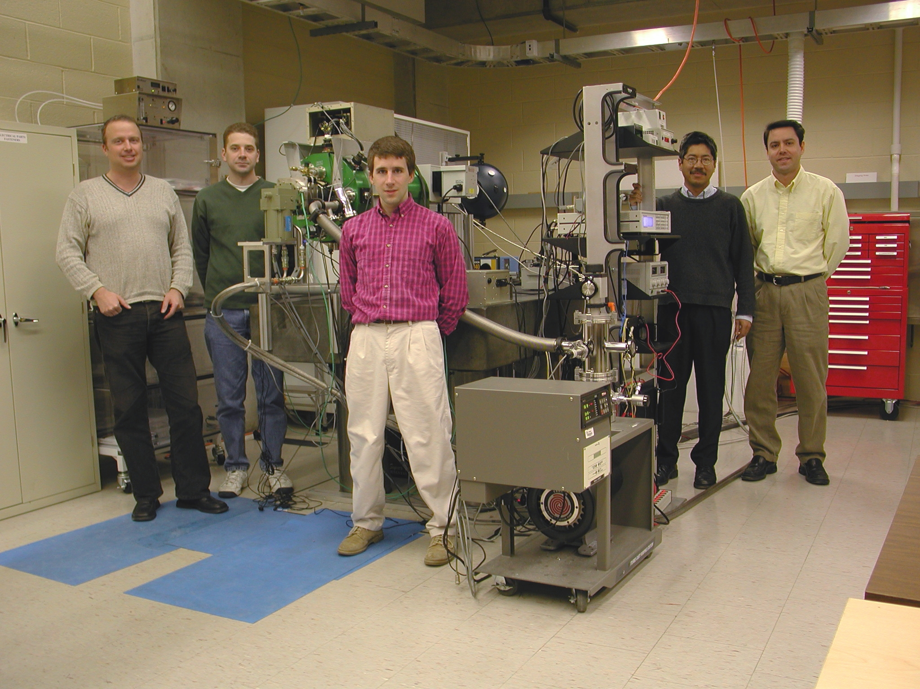
Figure 1. The IDTL test team in front of the test system. Pictured, left to right: Bernie Rauscher (Project Scientist), Ernie Morse (Data Analyst), Eddie Bergeron (Data Analyst), Sito Balleza (Project Engineer), and Don Figer (PI). Note pictured: Mike Regan (Project System Scientist).
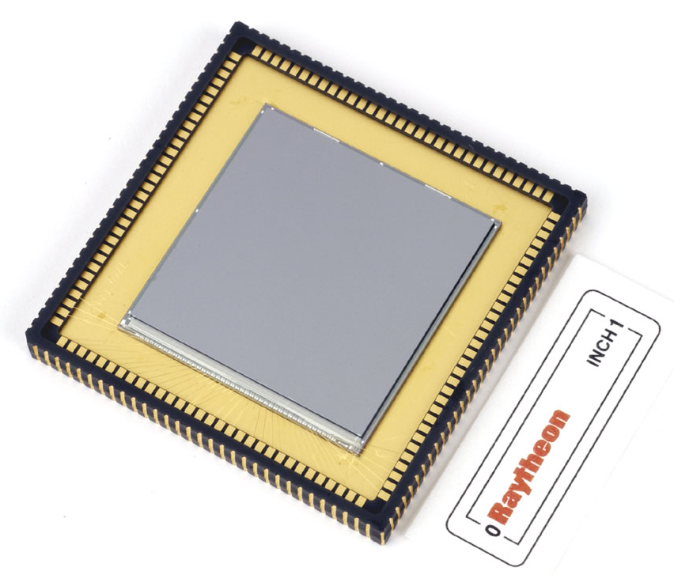
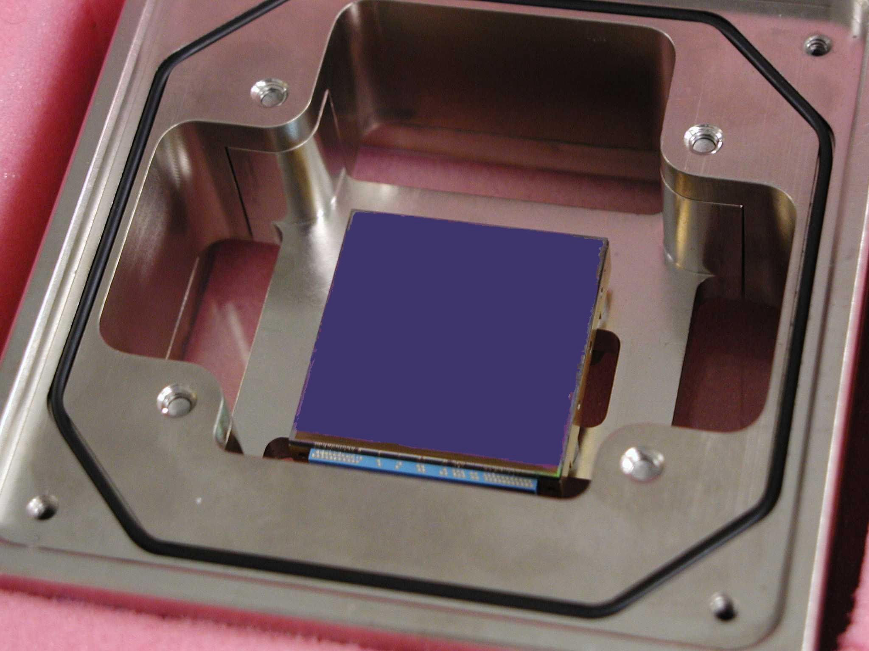
Figure 3. H2RG SCA.
Figure 2. Raytheon multiplexer for MIR detector.

In May of 2003, the IDTL successfully completed the JWST Detector Characterization project, after obtaining 2 Terabytes of data over 2 years from a half dozen prototype JWST detectors during 25 cooldowns. A summary of the measurements is given in the table.
The measured performance is impressive, with dark currents as low as 1.3 e⁻/1000 seconds/pixel, the lowest ever measured for an array having a long wavelength sensitivity cutoff at 5 μm. A typical data set is shown in the left panel of Figure 4. Equally impressive, the read noise for both vendors' devices was low, <10 e⁻ for a frame averaged over 8 non-destructive reads. See Figer et al. (2003) for more. All imaging devices trap charge that can appear later while imaging another object. We measured a very low "persistence" for the Rockwell devices in the IDTL, shown in the right panel of Figure 4, of ~0.03% total integrated charge over 2000 seconds after a saturating exposure to light.
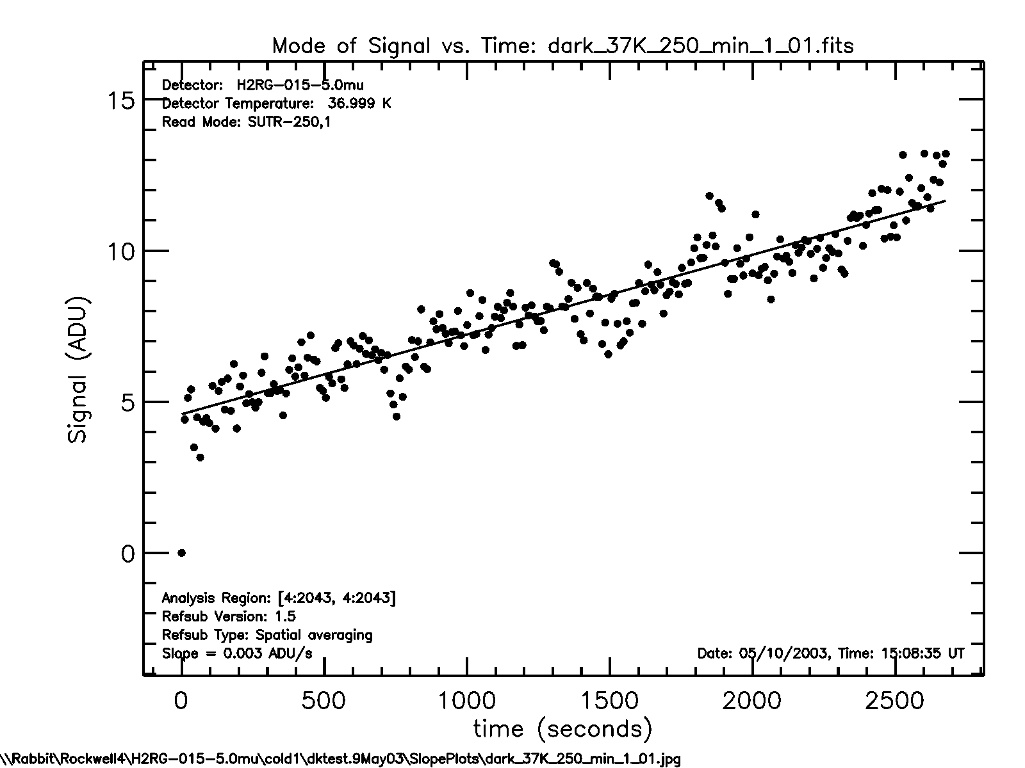
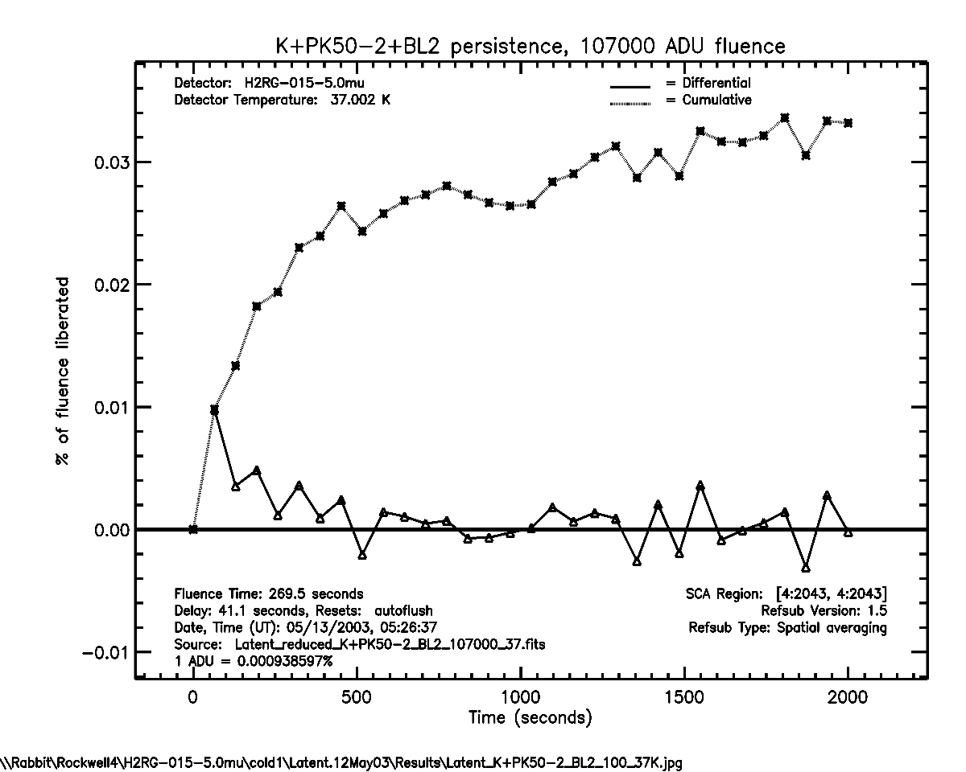
The future looks "dark" for JWST, thanks to the superb detectors produced in an excellent development program and characterized in a successful test program. The next major task at hand involves producing the many devices that will be needed over the next few years in order to support the successful integration of the instruments into JWST.
Figure 4. The plot on the left shows IDTL measurements of accumulating charge versus time for the H2RG detector; after applying the appropriate gain, the best fit gives 4 electrons/1000 seconds/pixel, or better than a factor of two less than the requirement. The plots on the right show IDTL measurements of integrated persistent charge (top) and differential persistent charge (bottom) after exposure to saturating fluence; the performance is at least a factor of 3 better than the requirement.

