NDC 2.4

Latent Charge/Persistence Experiment

Author: Ernie Morse

Initial release reviewed by: Don Figer
Latest revision: December 11, 2002

1. Introduction
This document describes the experiment for measuring latent charge. This description includes the definition of latent charge in the context of the NDC project, the required measurement accuracy, the experiment procedure, the hardware setups, and the steps necessary for acquiring and reducing data to the measurements.
2. Definition
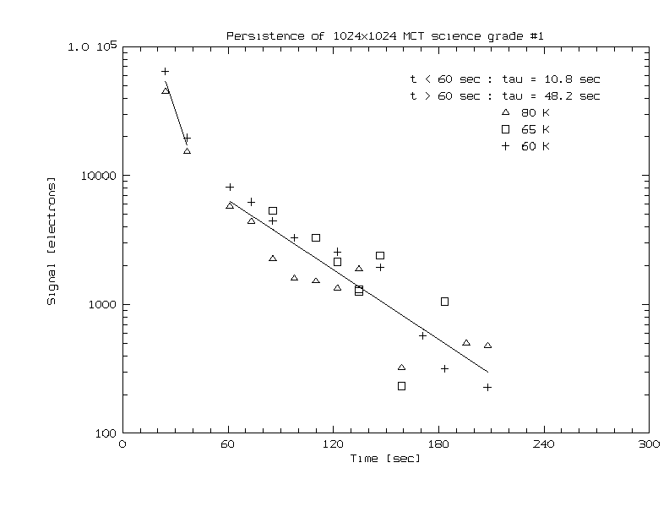
Latent charge, or “persistence,” is the portion of the signal that is produced by sources in previous images. Anything that liberates charge into the conduction band can result in latent charge, i.e. a bright star or a cosmic ray. Note that latent images are distinguished from spurious sources produced by settling effects in the post-detector analog electronics, i.e. electronic “ghosts” or crosstalk between electronic readout channels. Latent charge is a function of incident flux during a previous exposure, total charge collected during a previous exposure (fluence), the amount of time since the previous exposure, the applied reverse bias on the unit cell, and temperature. Figure 1 shows the effects of persistent charge (courtesy Gert Finger). Here, the array was illuminated, and then blanked off at time=0. Then, exposures were taken at various times (t) with exposure times of tau at 3 temperatures. The total integrated signal is plotted as a function of time since illumination. Note that the integrated charge is very large, and temperature doesn't seem to make much difference.
Figure 1. Persistent charge adds significant noise, even after waiting many minutes after the initial exposure.

Some experiments suggest that a fraction of the charge produced by light and/or cosmic rays incident on a detector migrates into charge traps, instead of flowing into the depletion region. In general, this charge is not liberated when the pixel is reset. Instead, it slowly escapes the trap according to an exponential profile, in time, and migrates to the PN junction during subsequent exposures. The charge appears as a latent image that grows fainter in successive exposures (see Solomon 1998 for more).

3. Required Measurement Accuracy
The NGST persistence requirement is “order of 0.1%, 1st read after saturating exposure”, and the goal is 0%. It is somewhat incompletely specified in the sense that persistence is dependent on many variables that are unspecified in the requirement. For instance, the requirement does not specify what delay can be tolerated after the focal plane is illuminated in order to allow for charge to liberate from charge traps. It also does not specify what ameliorating effects can be used to purge trapped charge, i.e. multiple resets or thermal annealing. In addition to the fact that the requirement is under-constrained, it also appears to be inconsistent with some other requirements. For instance, imagine the effects persistent charge might have on a science frame obtained immediately after a flat field frame that has signals near saturation. In this case, 0.1% equates to about 100 e⁻. If this is not accounted for in some way, then it represents noise and would violate the system noise requirement by a factor of 11.
We can derive a persistent charge requirement that is also consistent with other requirements. For instance, the requirement could be that "A science image obtained immediately after a saturating exposure (zero delay) shall not contain more signal than implied by the system noise requirement, i.e. no more than 9 e⁻ per pixel." Even this way of setting the requirement is a bit risky because it assumes that the total system noise budget can be taken up by effects due to persistent charge, although it does ignore any ability to subtract the effects of persistent charge from the measurements. A better way to set this requirement would be to trade the persistent charge requirement against requirements for other system noise contributors in a noise budget and to trade the requirement against operations implications of introducing delays or using post-processing.
Just for comparison, consider the persistent charge requirements for IRAC on SIRTF (Pipher et al. 2001). In this case, there are two parallel requirements. The first is that a 20 second dark exposure should not have more than 1 e⁻ per pixel of signal if it is started 200 seconds after an exposure that has 50,000 e⁻ per pixel due to a source flux of 2500 e⁻ per pixel and an exposure time of 20 seconds. The second requirement is set using almost identical conditions, except that the delay between the two images is 0 seconds and the allowed signal for the dark image is 10 e⁻ per pixel.
Taking the approach in NDC 2.1, we can require a measurement accuracy that produces no more than 10% error in our measurement in the case that the total system noise goal is dominated by error due to latent charge. In this case, latent charge would produce 2.5 e⁻ per pixel, and our measurement accuracy would have to be 1.2 e⁻ per pixel. Of course, it would be very challenging to make such precise measurements, given that this accuracy is 10% of the read noise goal (in quadrature).
4. Experiment Procedure
The experiment strategy involves exposing the detector array to various fluence levels and measuring the amount of persistent charge liberated in subsequent science exposures as a function of wavelength. Currently, these science exposures are taken in “sampled up-the-ramp” (SUTR) mode, wherein a series of nondestructive reads are obtained at equally spaced time intervals throughout the total selected exposure time. Exposures consisting of 16 reads in a 2000-second exposure time are typically used when performing this experiment in the IDTL. The current goal is to obtain such exposures after exposing the detector to fluence levels of 30%, 100% and 1000% of the detector full-well value. The wavelength dependence is ascertained through the use of a set of calibrated filters that can be placed in the beam. The desired filter list is set in a parameter file.
The data acquisition process begins with a series of dark exposures, taken with both of the IDTL dewar’s filter wheels commanded to the cold blank positions. These dark exposures are taken with the same read mode and exposure time that will later be used for the persistence exposures. In practice, the experiment is started at a point in time at which the detector has not been exposed to light for several hours, in order to minimize the effects of persistence from previous illumination on these dark exposures
The illumination source is then activated, and the filter wheels are commanded to place the first desired filter combination in the beam. A shortest-possible CDS (Fowler-1) is then taken. The signal level in this exposure is used to estimate the flux (in ADU/sec/pixel) produced by the illumination source through the filter combination. The flux and the detector full well value (supplied as an input parameter) are used to calculate the illumination exposure times required to produce the desired fluence levels at the detector array. This process is repeated with the remaining desired filter combinations.
The operations outlined in the previous paragraph involve exposing the array to illumination, and this may result in the retention of some persistent charge. Therefore, both filter wheels are closed and a waiting period (currently about 3 hours) is enforced in order to allow this charge to be liberated prior to resuming the experiment.
Next, the illumination source is activated and the filter wheels are commanded to place the first desired filter combination back into the light path. The detector is exposed to light for the amount of time calculated to produce the lowest desired fluence level. A SUTR image is obtained during the time of illumination; this involves a single row-by-reset of the detector array prior to the readout of the image. The illumination image is then written to disk in FITS format, the filter wheels are rotated to the cold blank positions, and a persistence exposure is obtained. There is a single row-by-row reset of the array at the beginning of the persistence exposure, and additional resets can be performed in the time between the end of the detector’s illumination and the start of the persistence exposure if desired. The fluence time (total time the detector was exposed to light) and the delay time (the time between the end of detector illumination and the beginning of the persistence exposure) are recorded in the FITS header of the persistence image. These steps are repeated to produce persistence exposures for the remaining fluence levels. After all fluence levels have been generated for the first filter combination, the process is repeated for the rest of the chosen filter combinations.
After all of the data have been acquired, the reduction process begins with operations on the dark exposures. For each dark exposure, the first read is subtracted from all subsequent reads to correct for bias effects. We subtract reference pixel data from the active pixel data (except for data in the first read) in order to remove drifts. A new dark image cube is created out of the median of each pixel’s value in all of the dark exposures in order to remove cosmic ray contamination. The first two steps are repeated on the persistence images. We remove dark current from the persistence images by subtracting the dark image cube.
These dark-subtracted persistence images have values that represent the amount of persistent charge liberated (in ADU/pixel) as of the time of that read. We convert these values into liberated charge per time interval (between reads) by subtracting values in neighboring reads. Finally, we take the mode of all such values for each interval and plot them.
The persistent charge amounts (in ADU/pixel) thus obtained are divided by the appropriate fluence level in order to express the results in terms of a percentage of the fluence generated prior to beginning the persistence exposure.

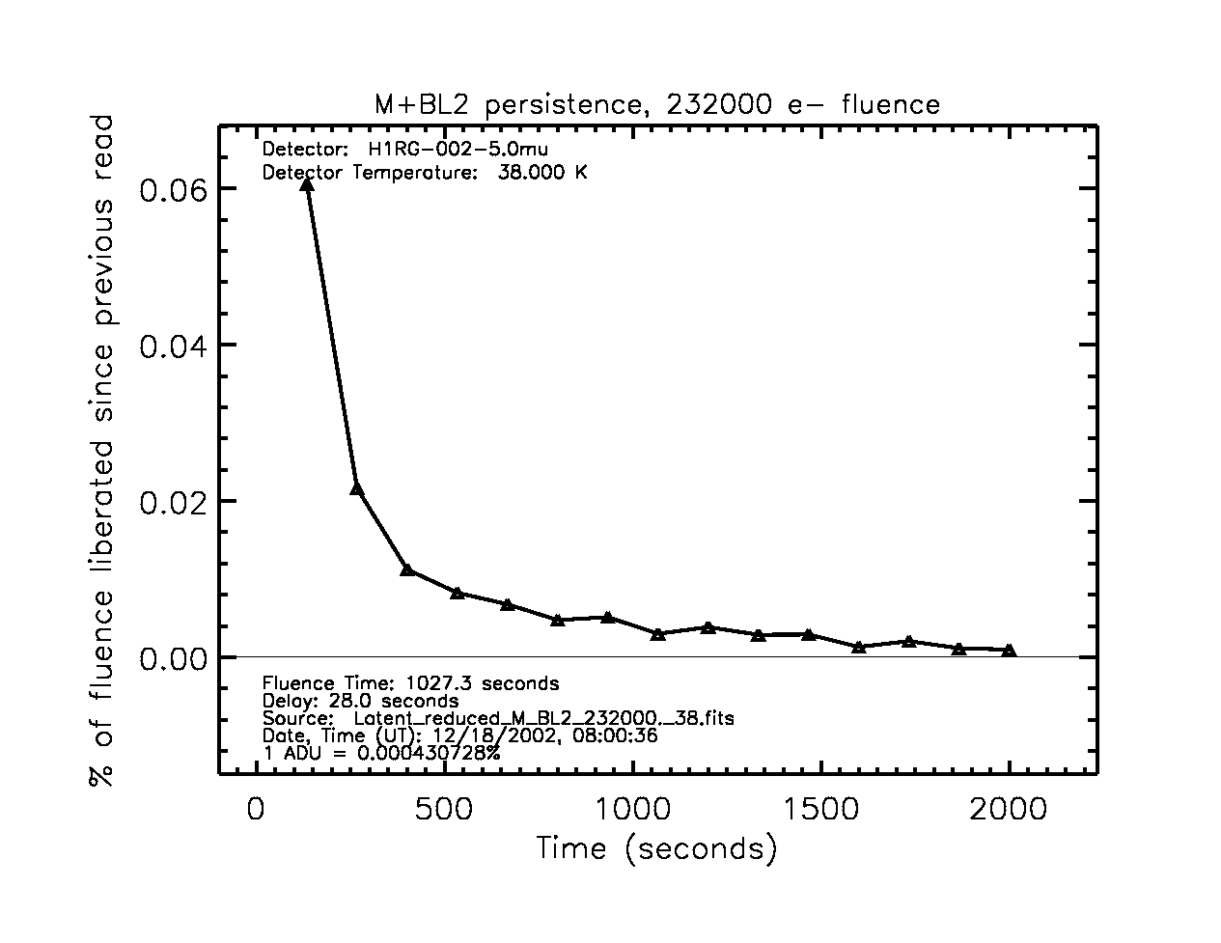
Figure 2: Typical result for persistence experiment. The detector was illuminated for 1027.3 seconds through a combination of an M-band filter and a sandwich of 0.1% and 1.0% neutral density filters (BL2) prior to taking the persistence image. There was a delay of 28.0 seconds between the end of detector illumination and the beginning of the persistence exposure, during which 3 complete row-by-row resets of the array were performed.

5. Hardware Setup
Our experiment uses an external incandescent light source. This source will be directed into an integrating sphere placed in front of the dewar window in order to provide uniform illumination of the detector. The IDTL dewar is equipped with two filter wheels, into which appropriate filters will have been previously loaded.

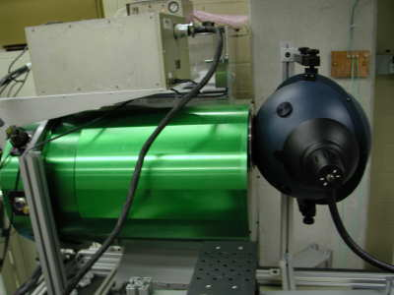
Figure 3: Side view of hardware setup.
Integrating sphere

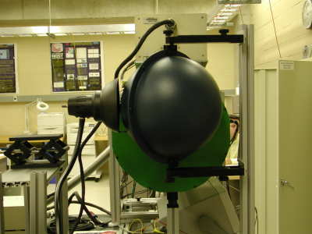
Figure 4: Front view of hardware setup.

Light source

Dewar

Light source

Integrating sphere
Dewar
6. References

Pipher, J. et al. 2001, “InSb Arrays for IRAC on SIRTF,” unpublished notes
Solomon, S. L. 1998, University of Rochester, PhD Thesis:
http://idtl.stsci.edu/solomon_thesis.pdf

